**REACT TOP 100 QUESTION**

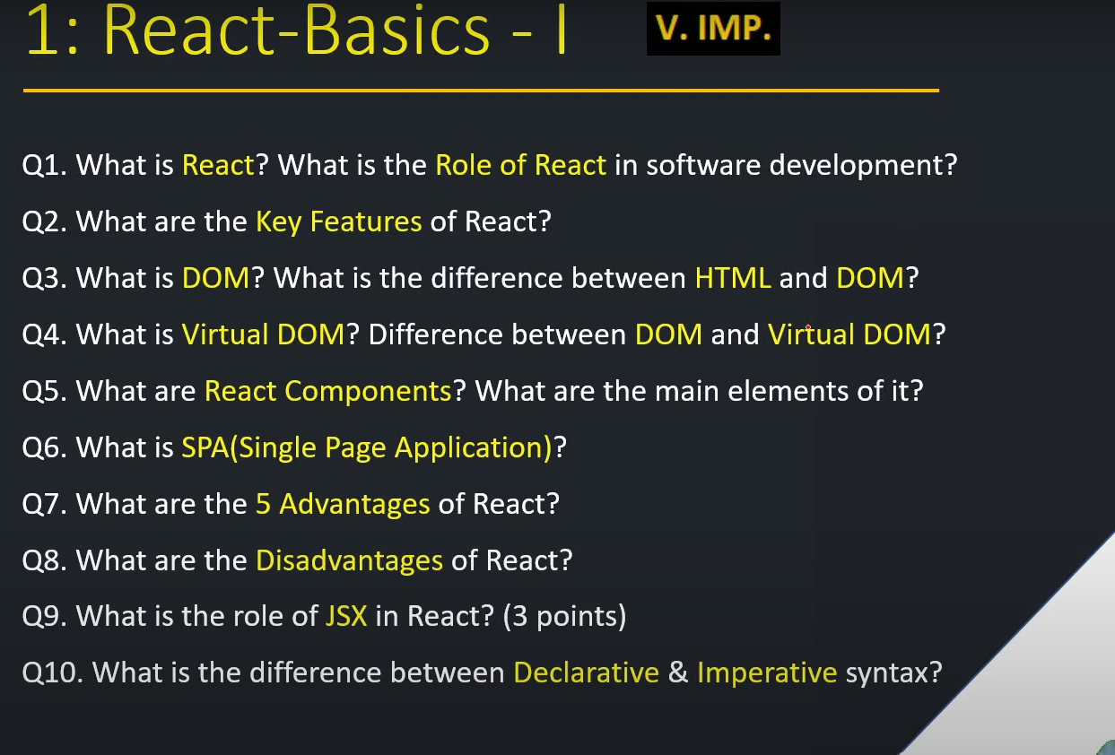

1. **What is React? What is the Role of React in software development?**

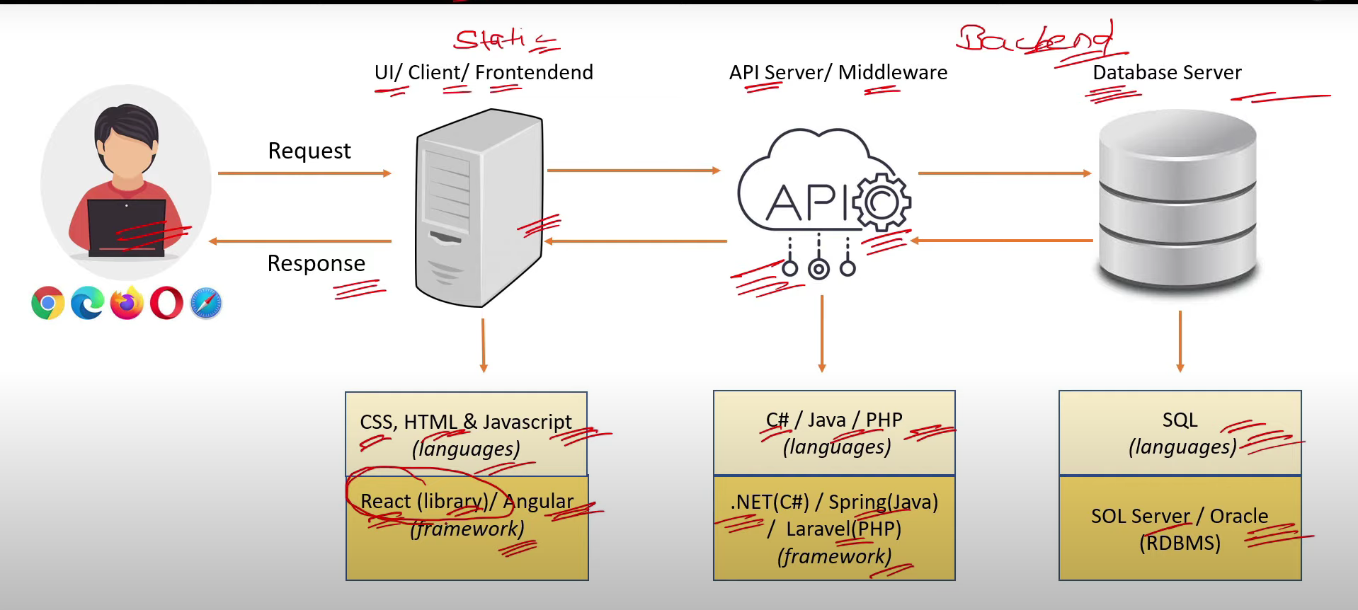

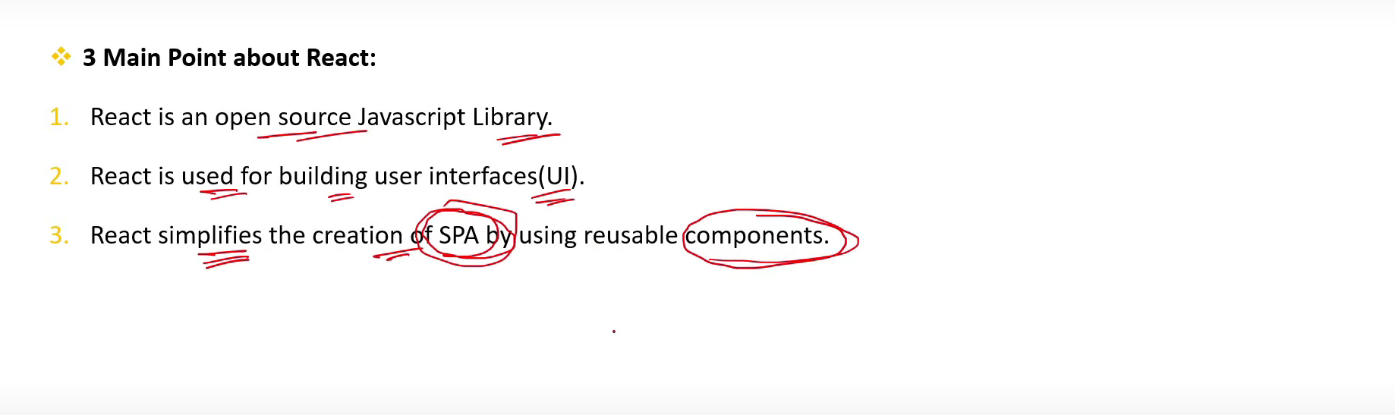

1. **What are the Key Features of React?**

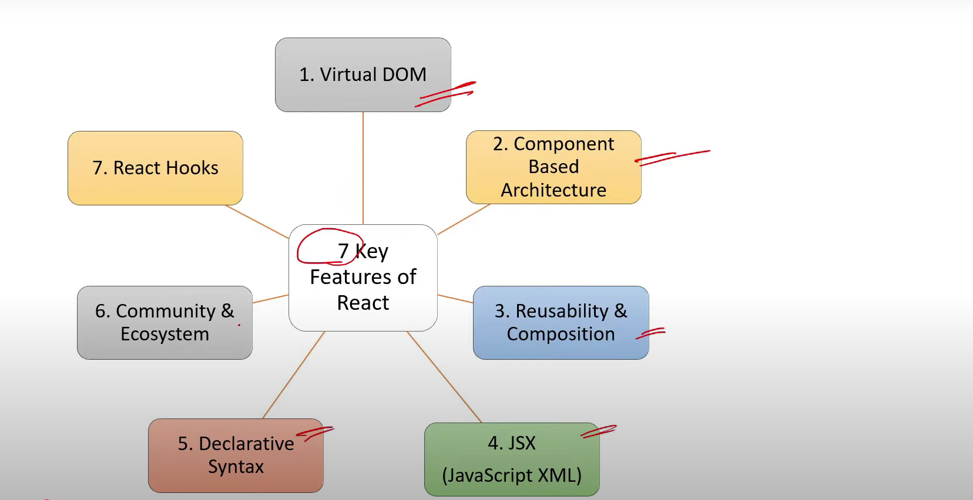

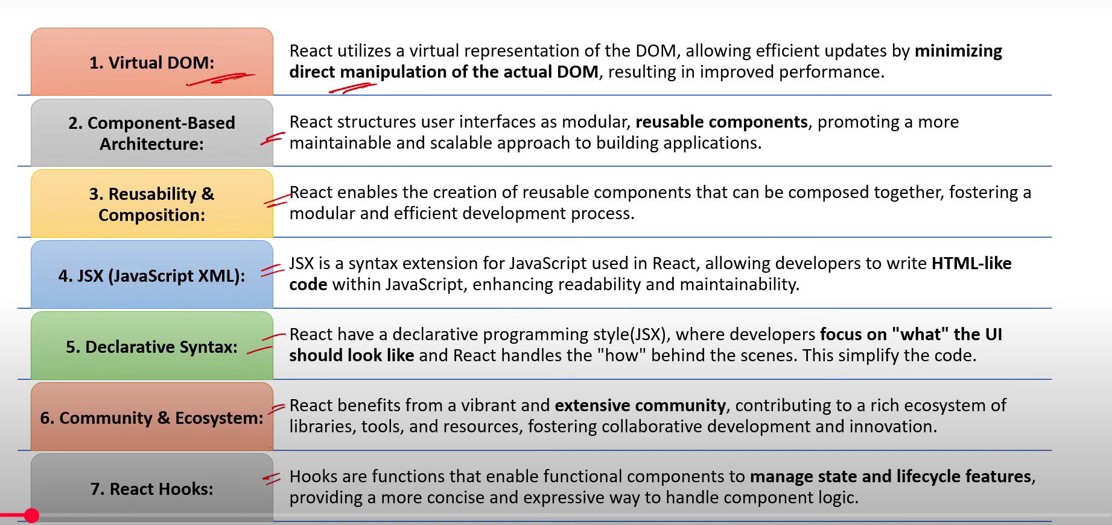

1. **What is DOM? What is the difference between HTML and DOM?**

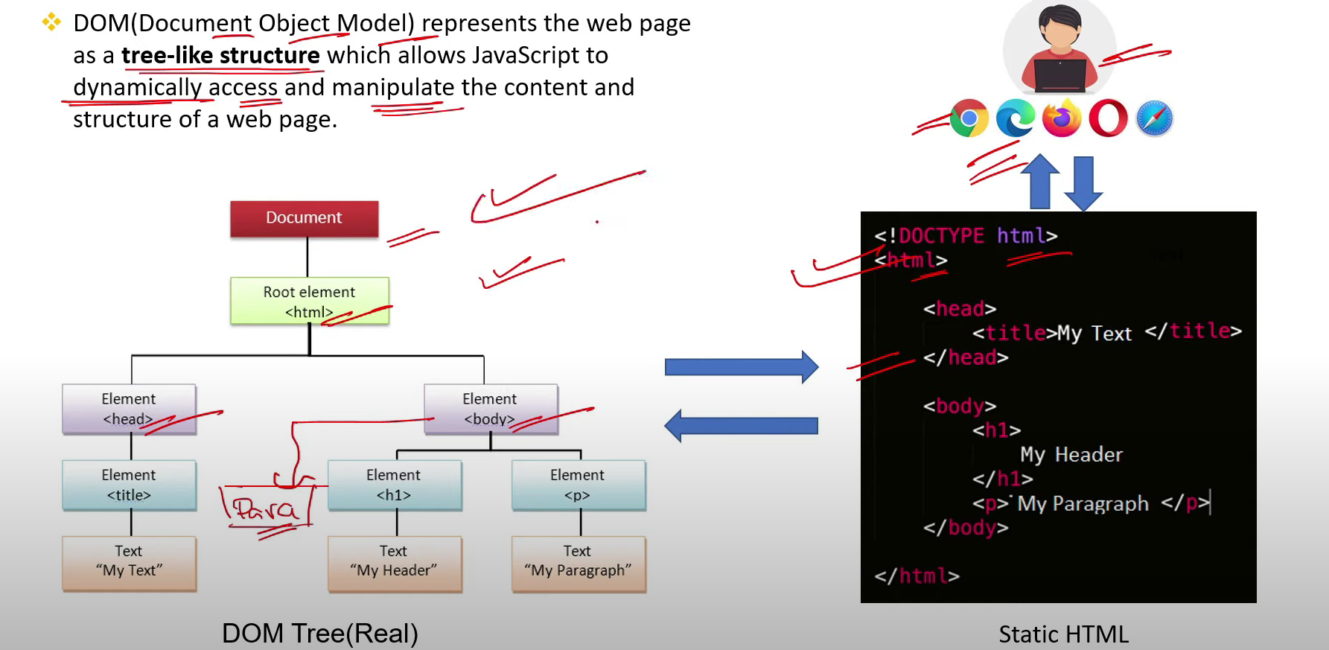

1. **What is Virtual DOM? Difference between DOM and Virtual DOM?**

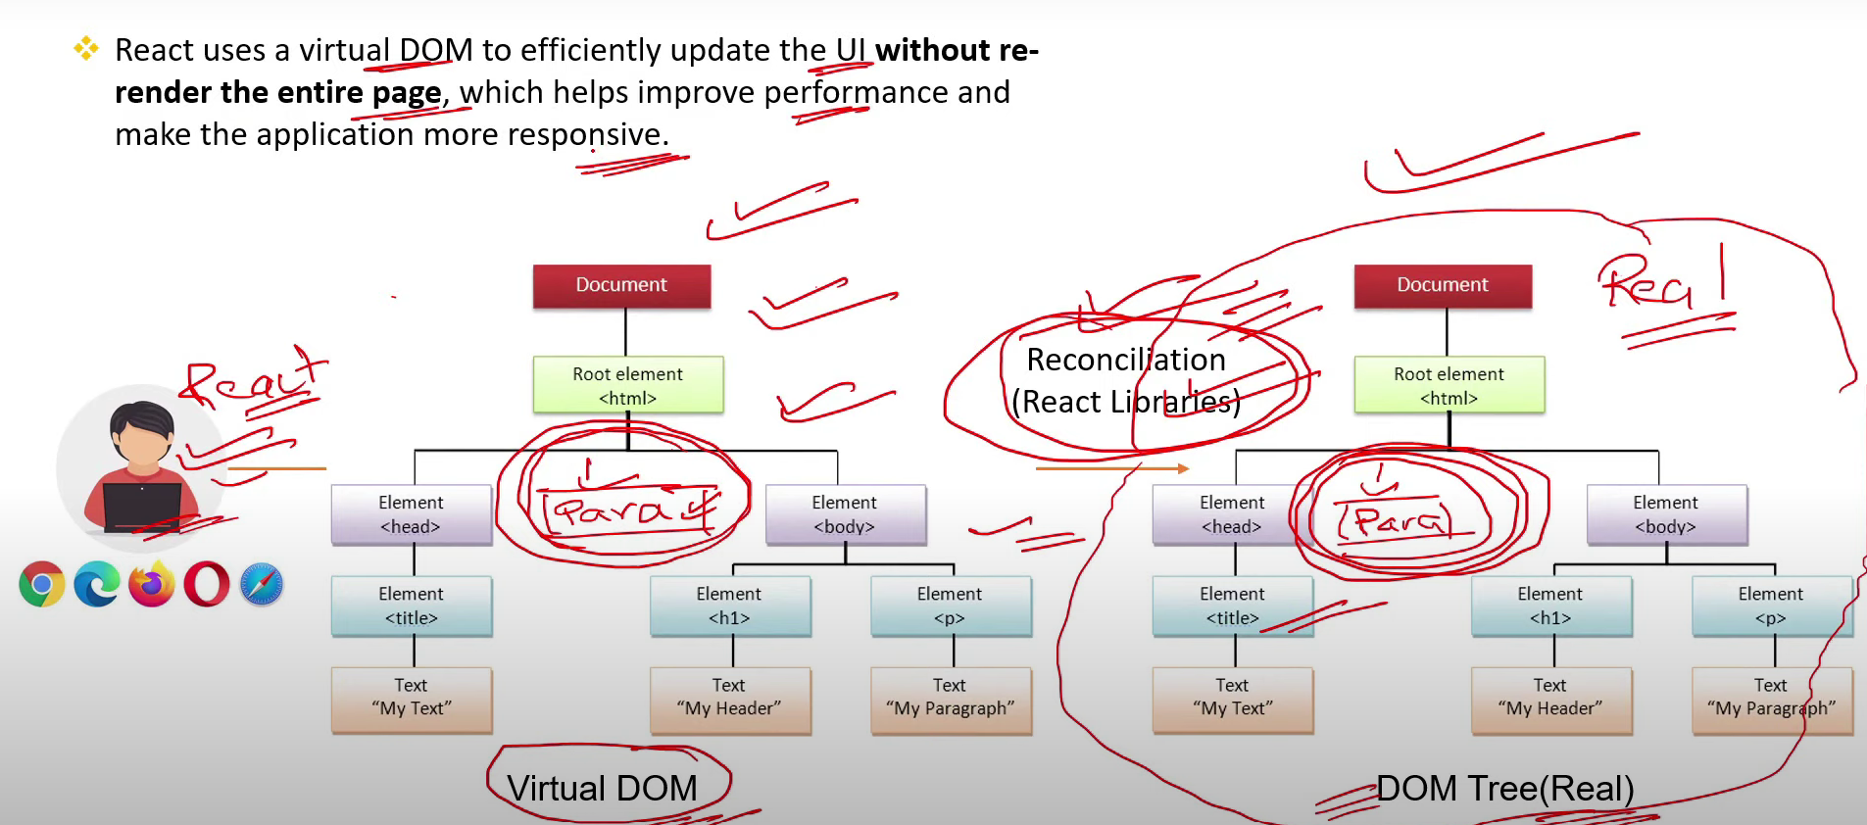

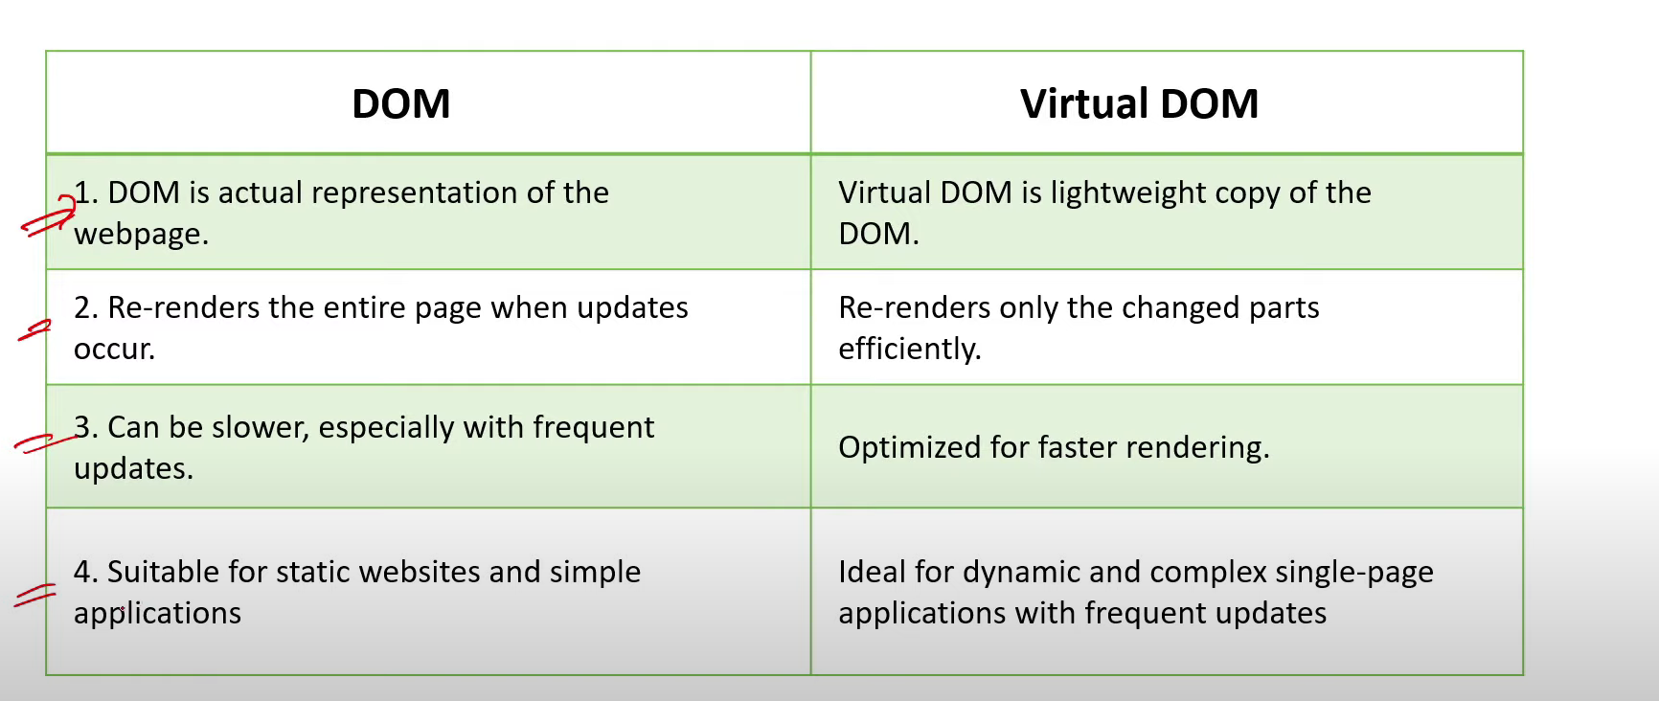

1. **What are React Components? What are the main elements of it?**

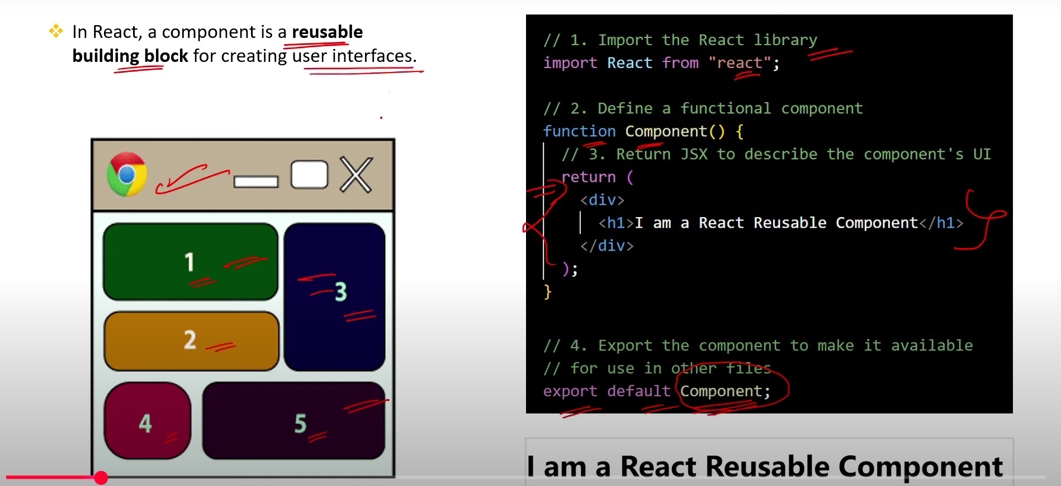

1. **What is SPA(Single Page Application)?**

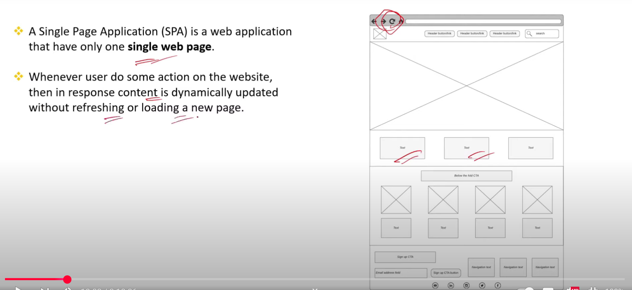

1. **What are the 5 Advantages of React?**

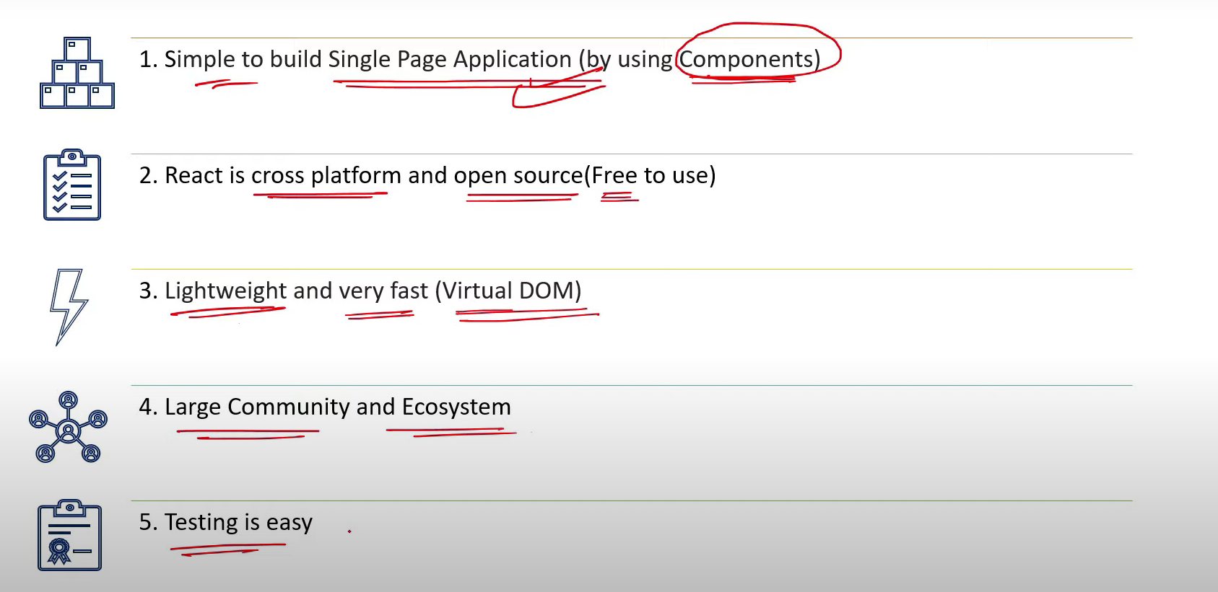

1. **What are the Disadvantages of React?**

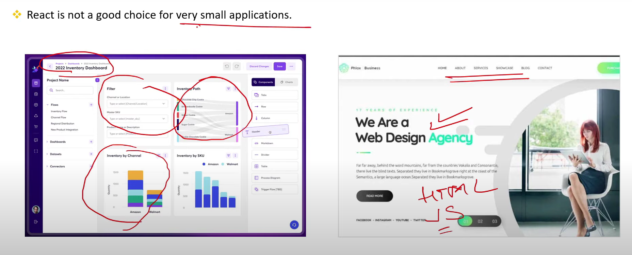

1. **What is the role of JSX in React? (3 points)**

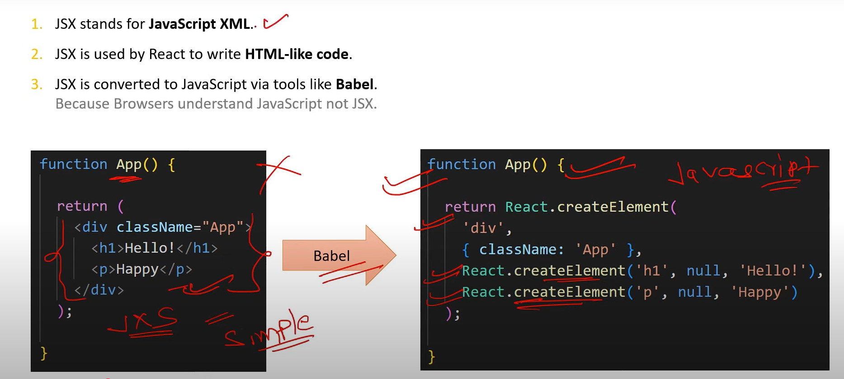

1. **What is the difference between Declarative & Imperative syntax?**

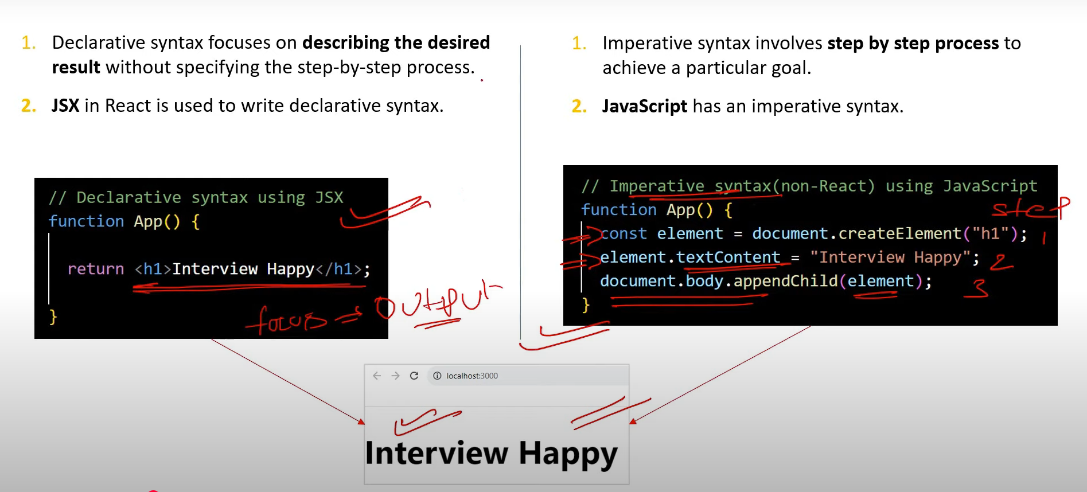

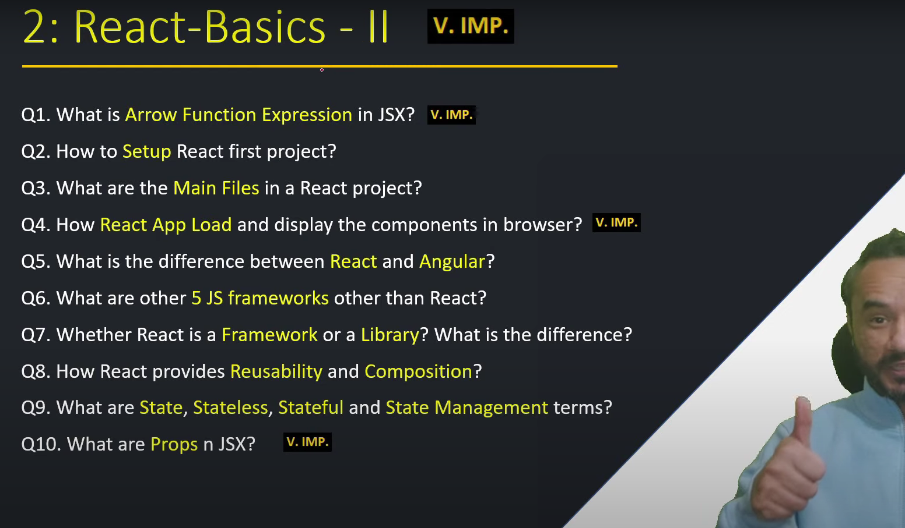

1. **What is Arrow Function Expression in JSX? [V. IMP.]**

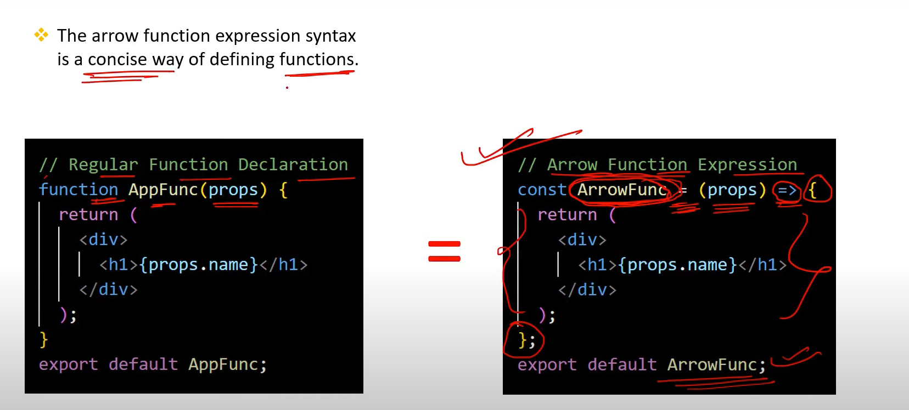

1. **How to Setup React first project?**

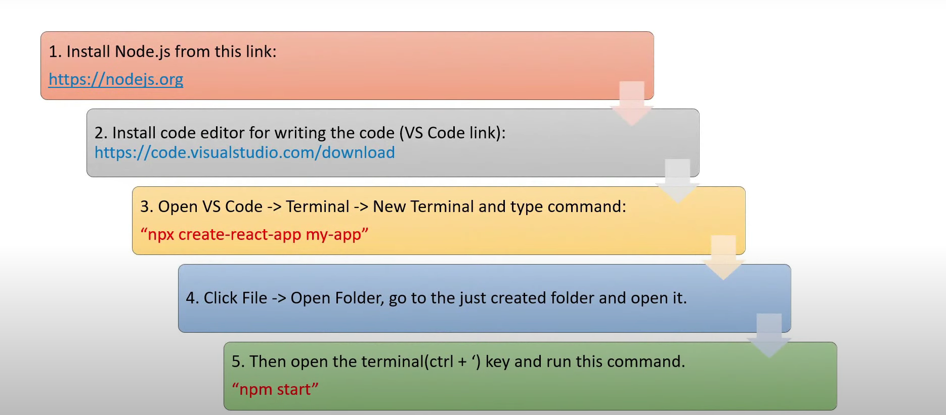

1. **What are the Main Files in a React project?**

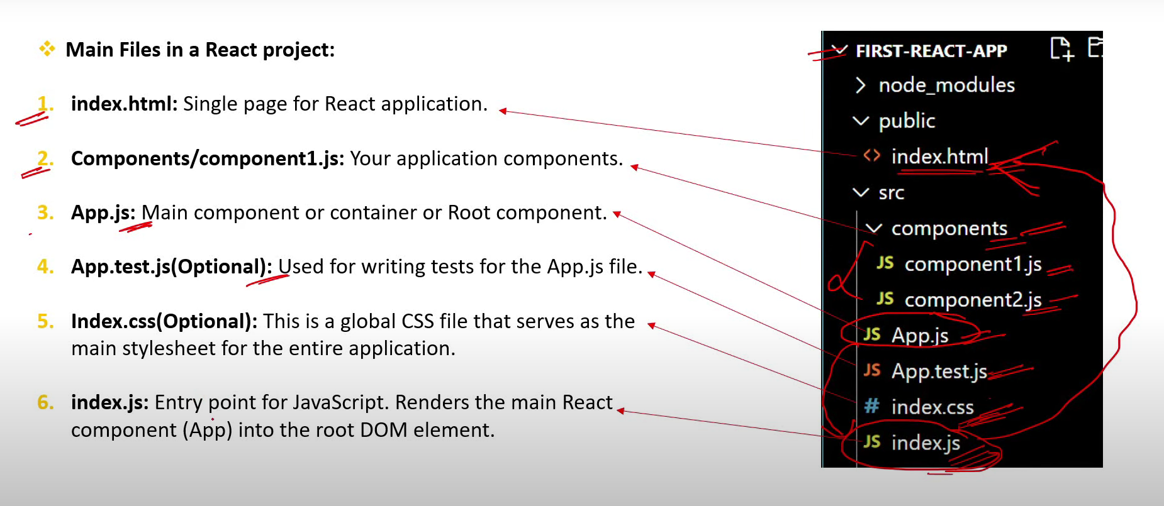

1. **How React App Load and display the components in browser?[ V. IMP.]**

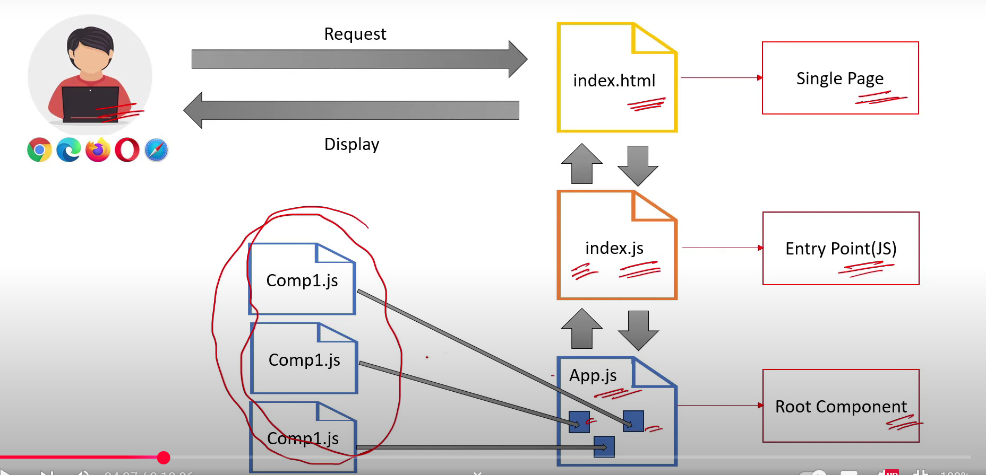

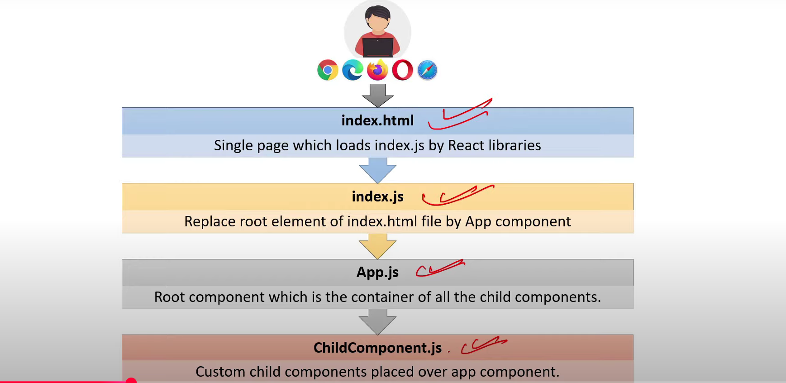

1. **What is the difference between React and Angular?**

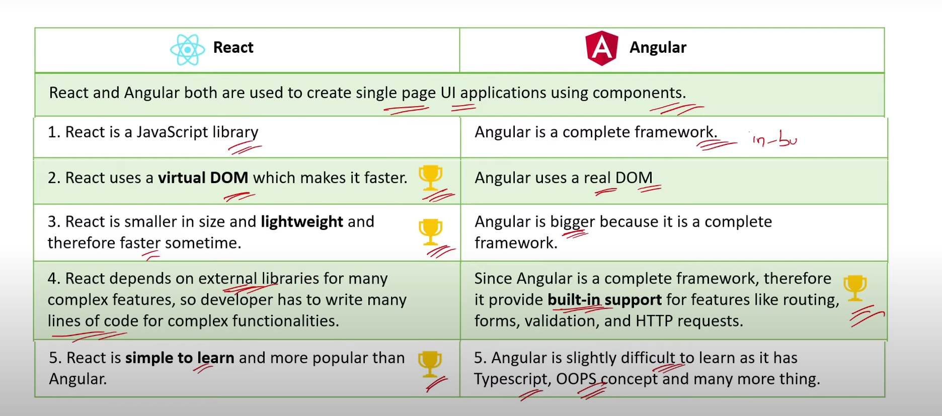

1. **What are other 5 JS frameworks other than React?**

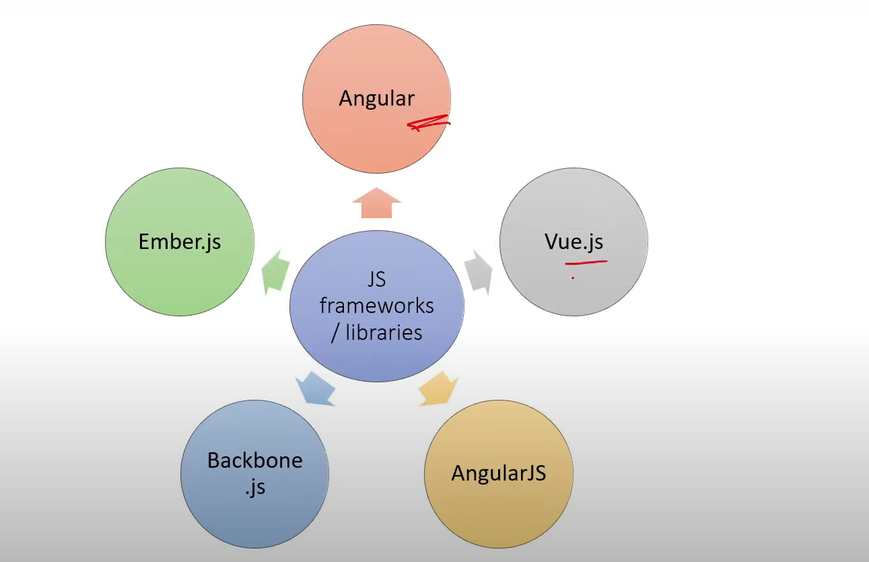

1. **Whether React is a Framework or a Library? What is the difference?**

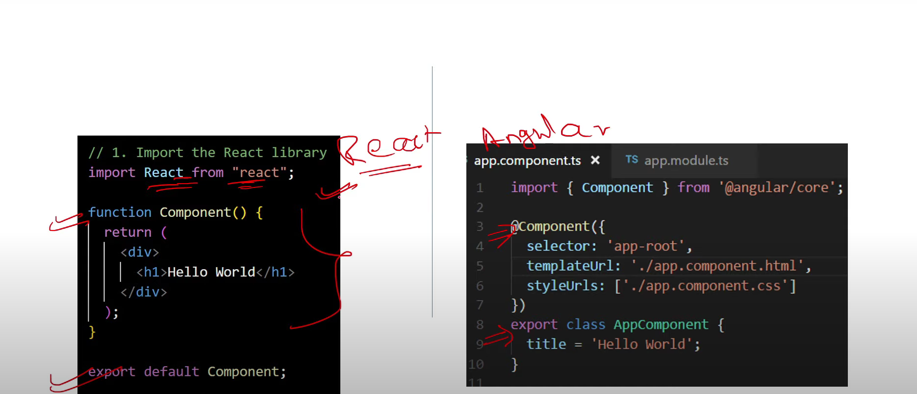

1. **How React provides Reusability and Composition?**

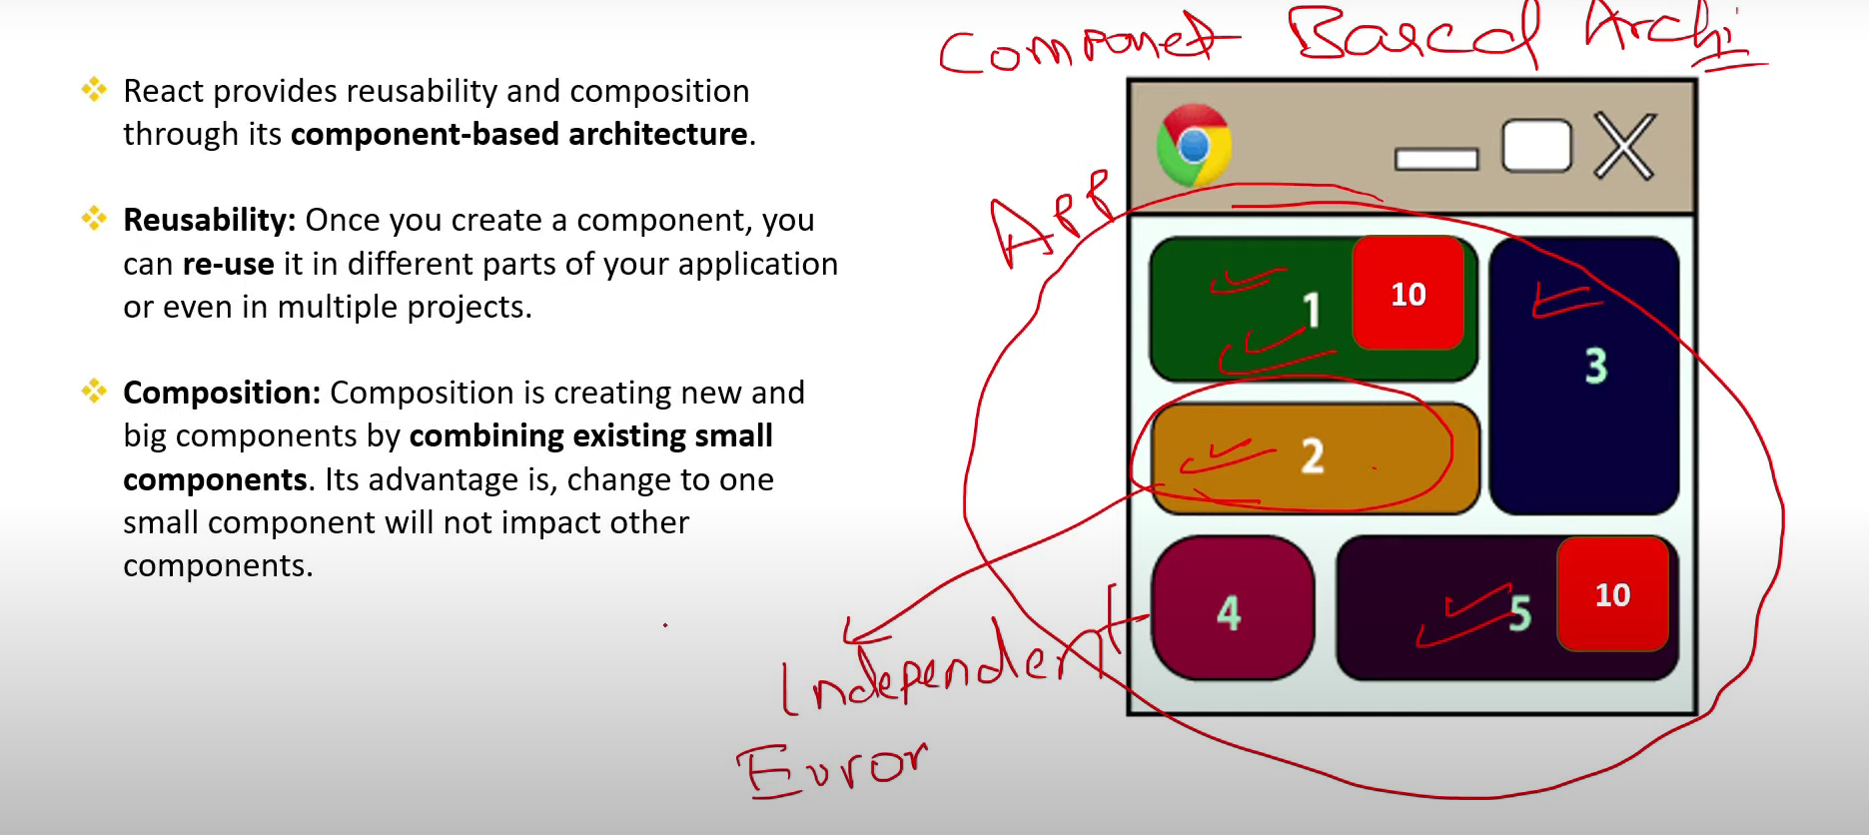

1. **What are State, Stateless, Sateful and State Management terms?**

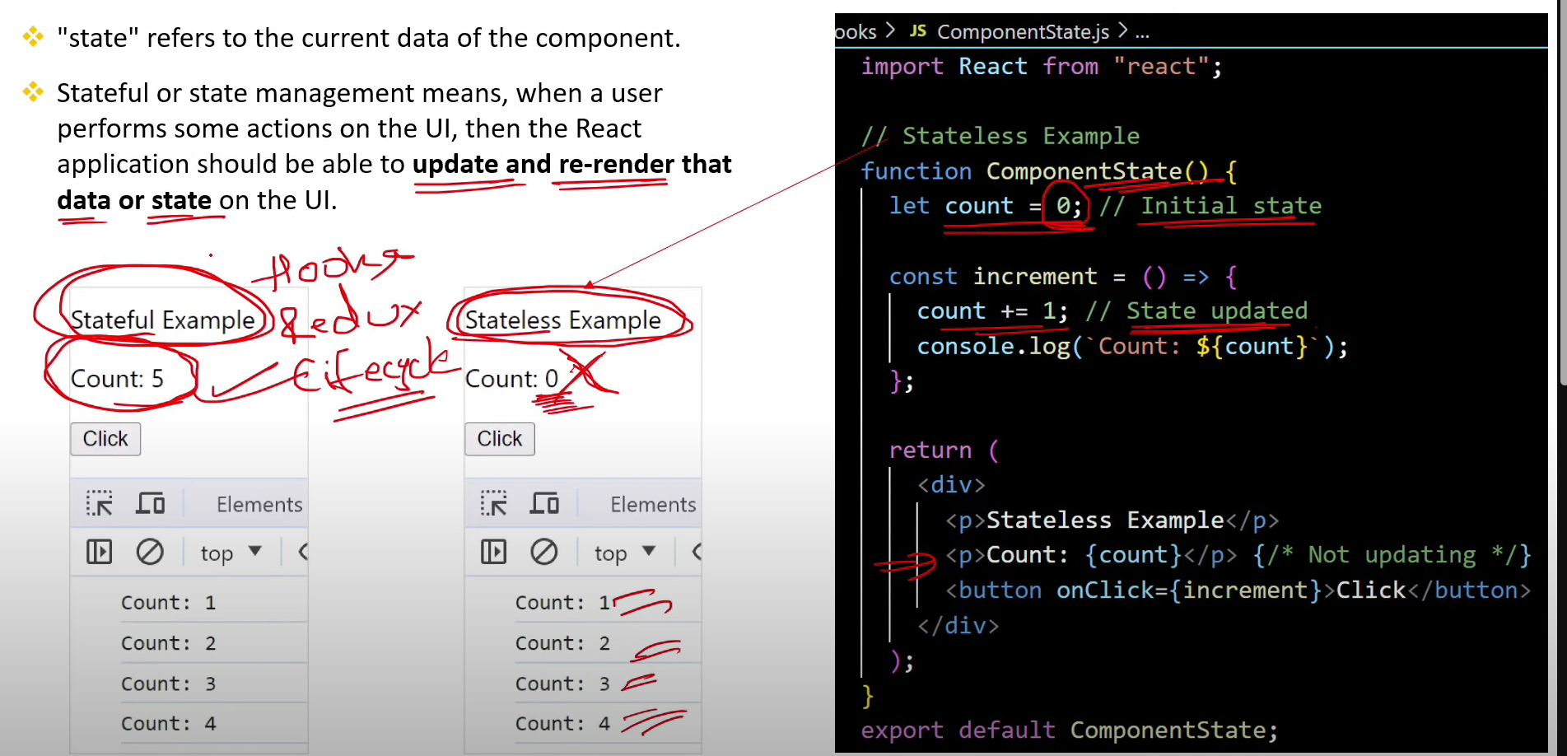

1. **What are Props n JSX? [V. IMP.]**

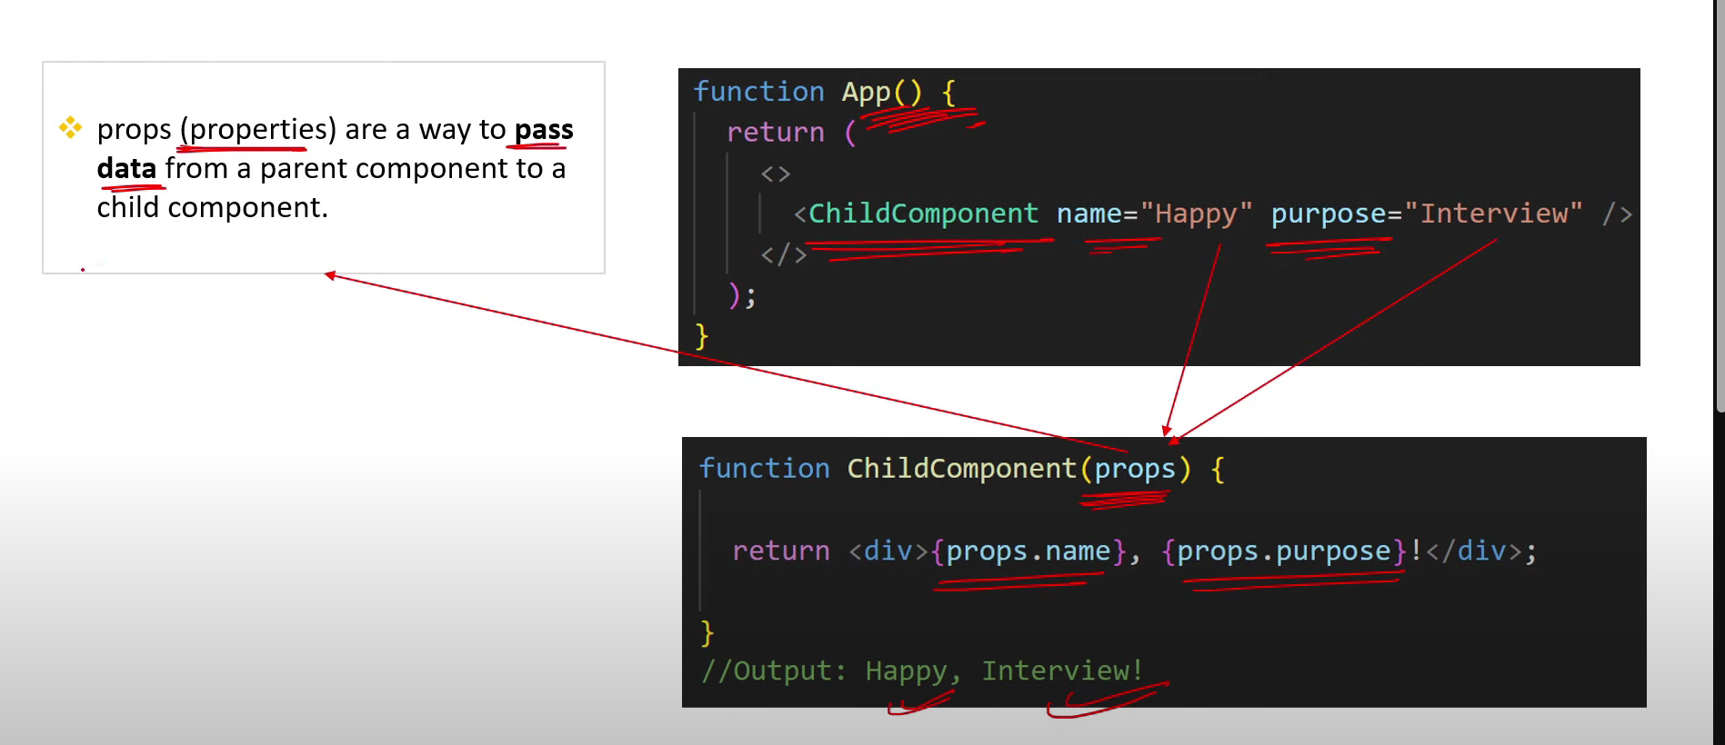

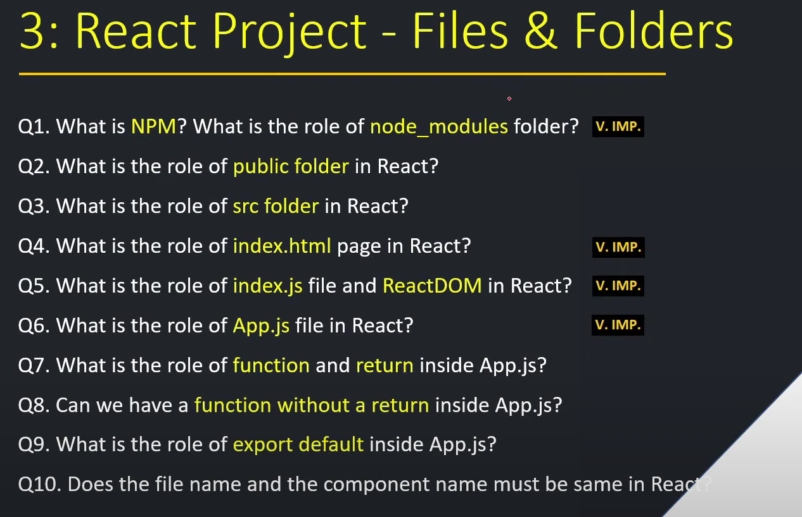

1. **What is NPM? What is the role of node_modules folder? [v. imp.]**

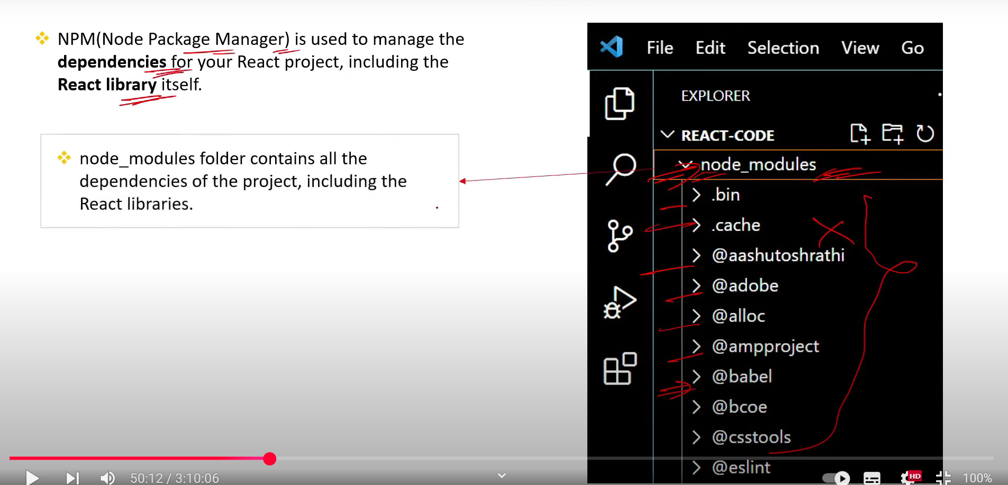

1. **What is the role of public folder in React?**

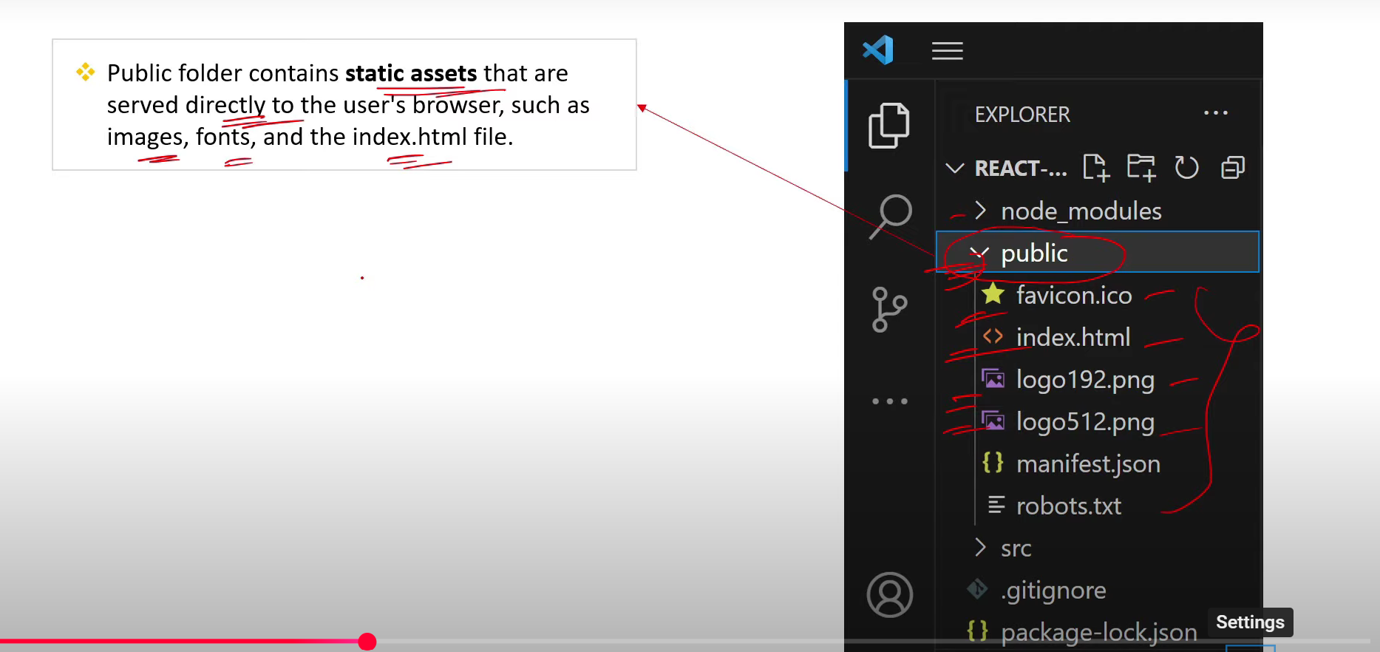

1. **What is the role of src folder in React?**

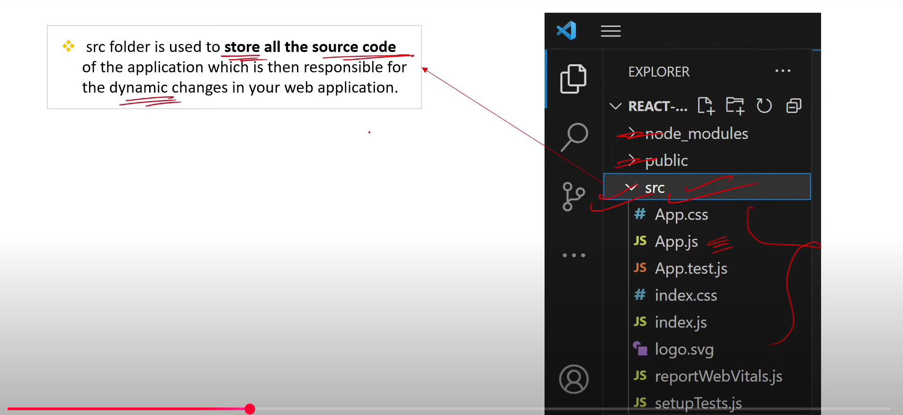

1. **What is the role of index.html page in React?[v.imp.]**

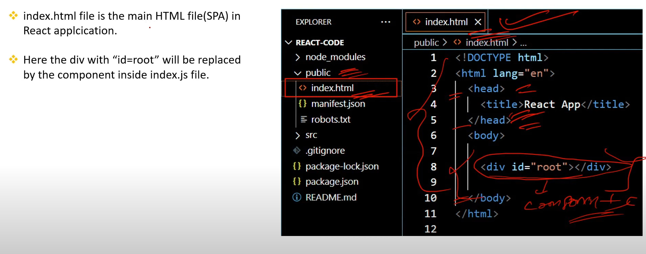

1. **What is the role of index.js file and ReactDOM in React?[v.imp.]**

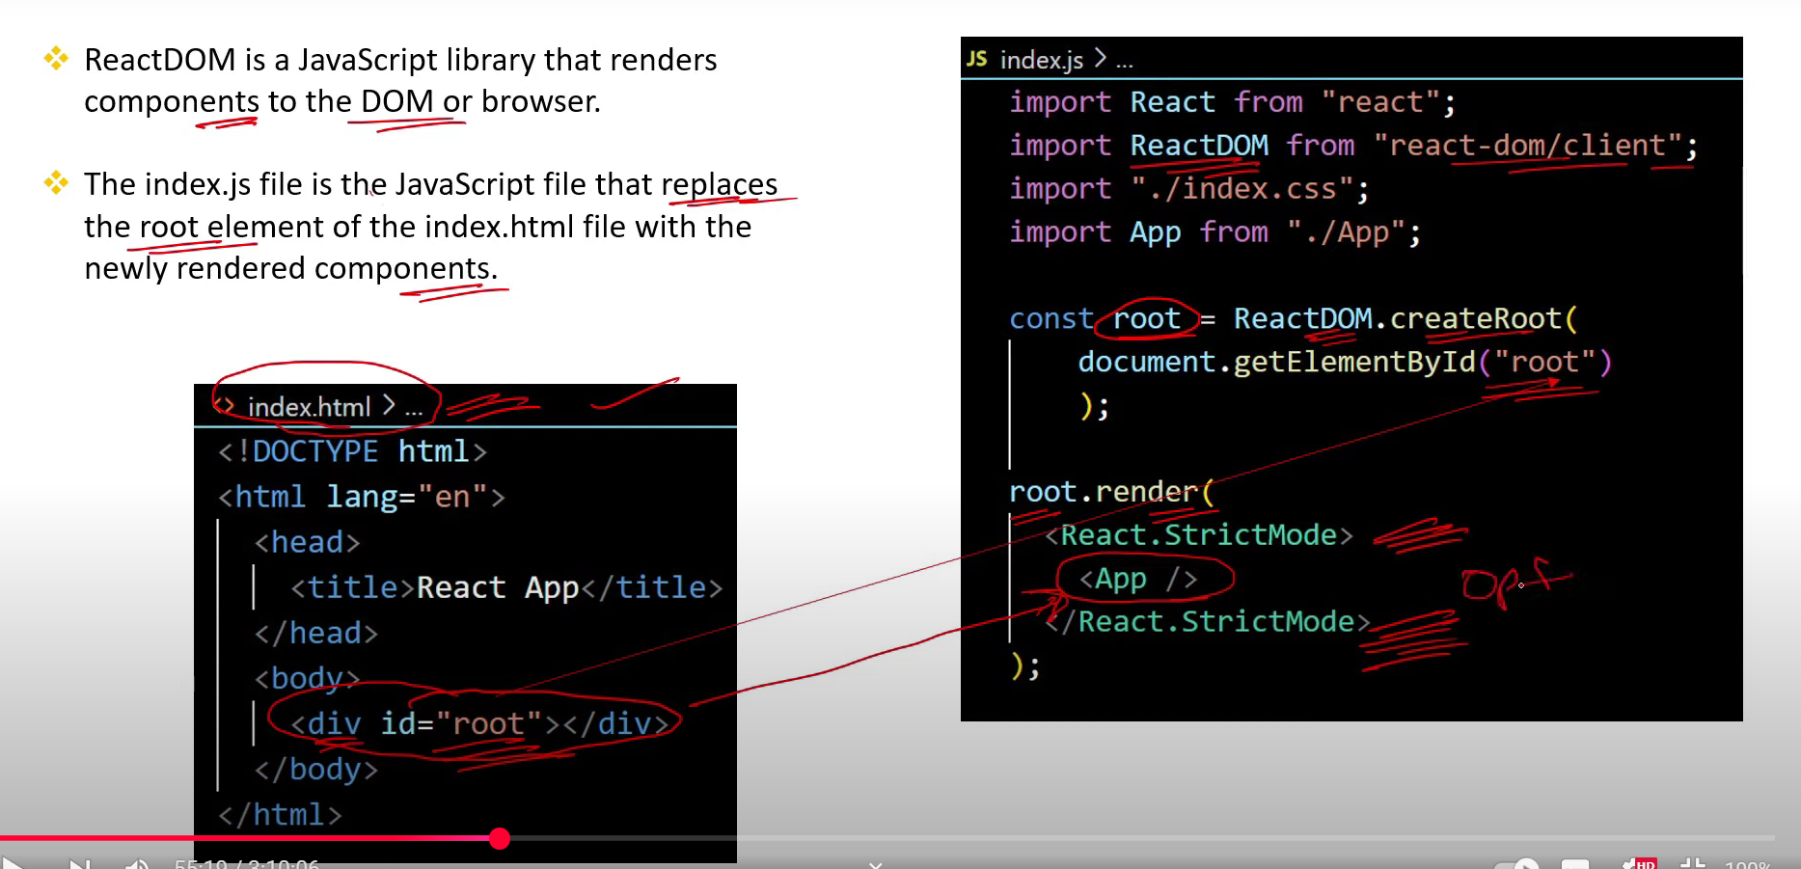

1. **What is the role of App.js file in React?[v.imp.]**

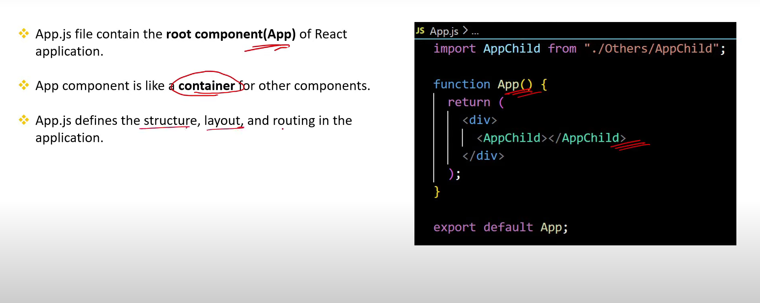

1. **What is the role of function and return inside App.js?**

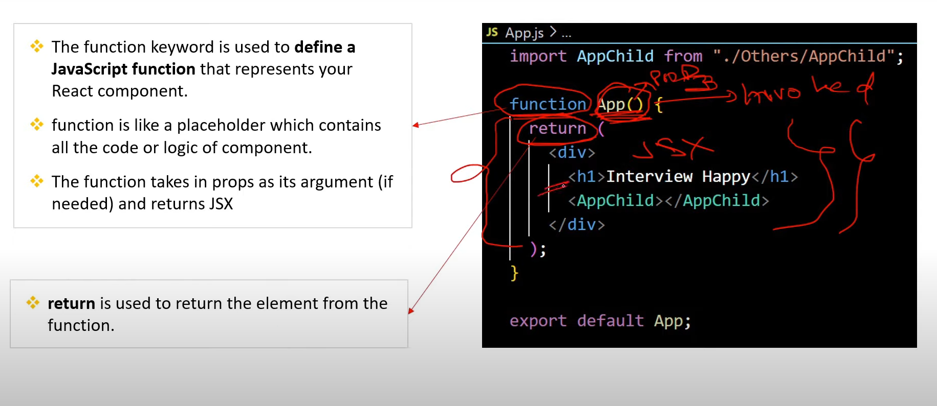

1. **Can we have a function without a return inside App.js?**

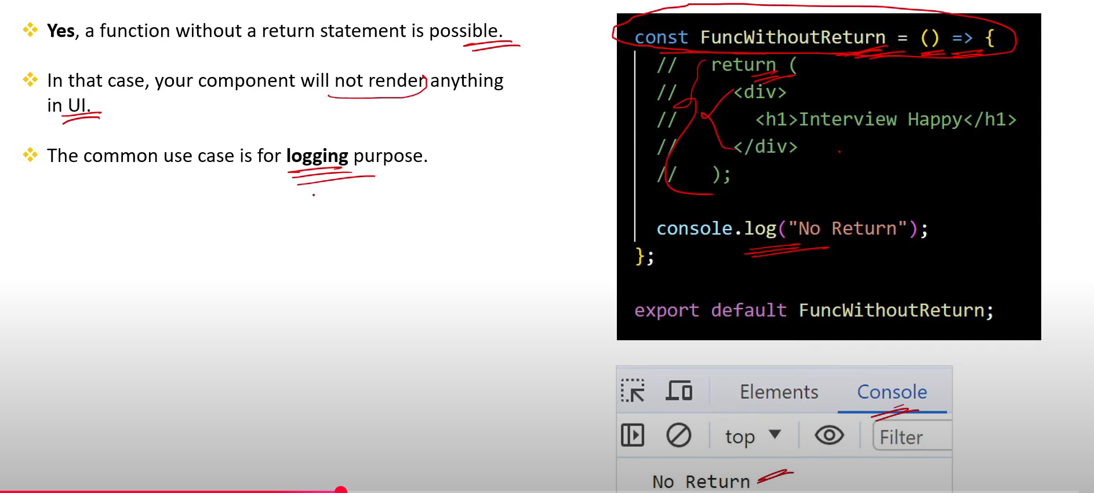

1. **What is the role of export default inside App.js?**

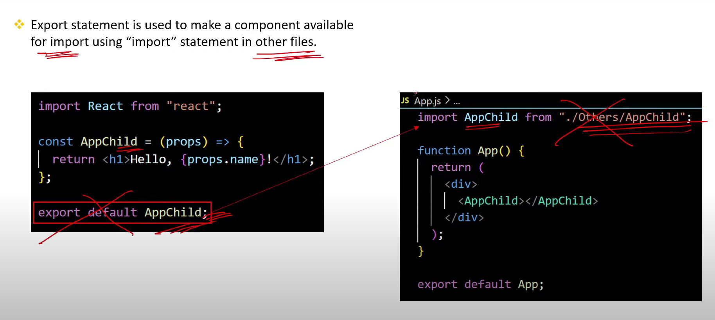

1. **Does the file name and the component name must be same in React?**

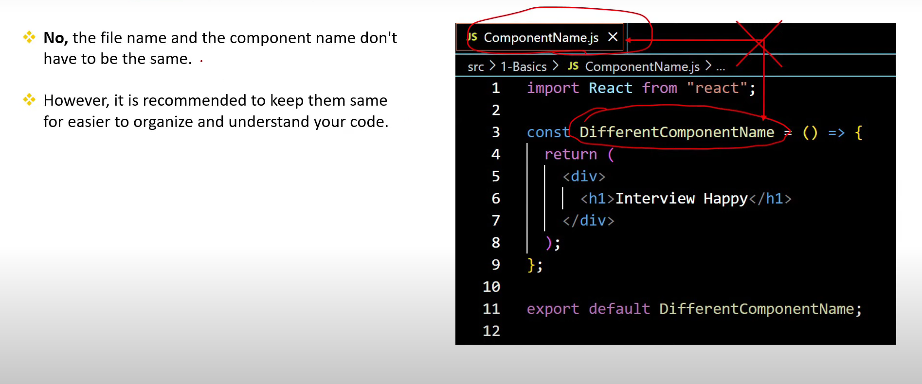

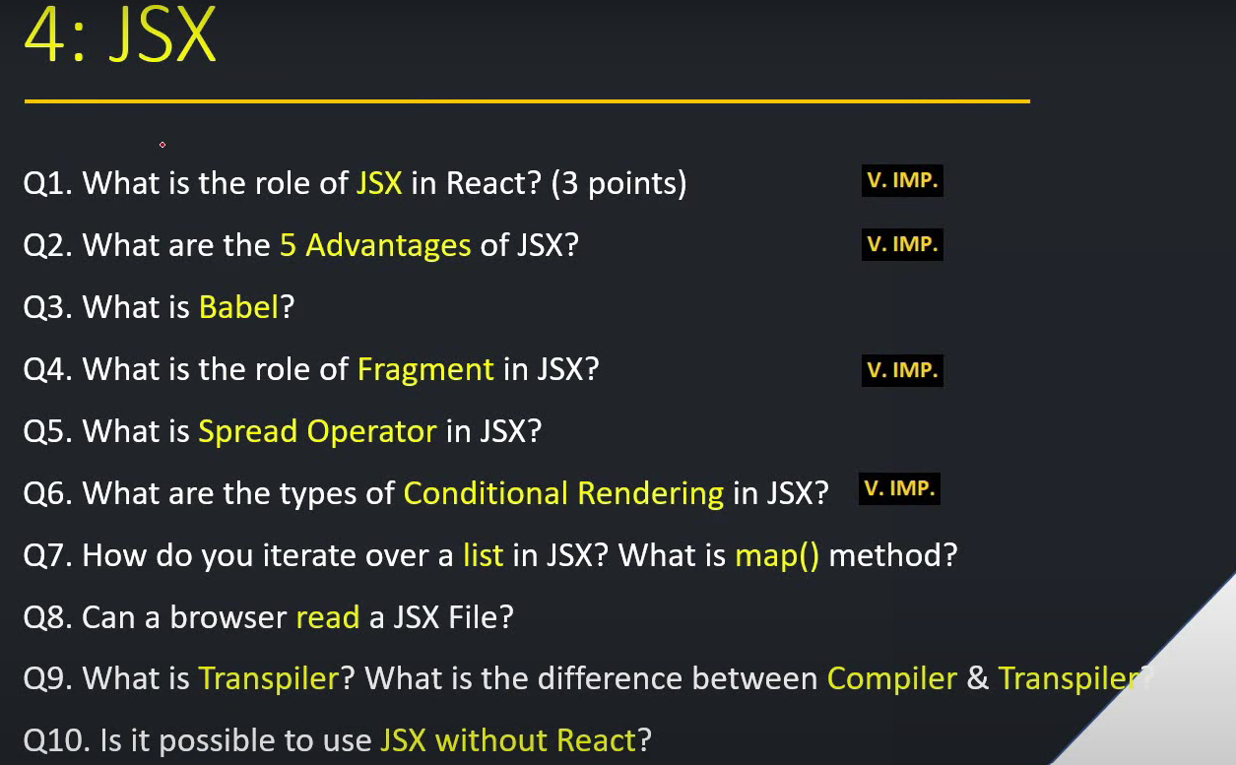

1. **What is the role of JSX in React? (3 points)[v.imp.]**

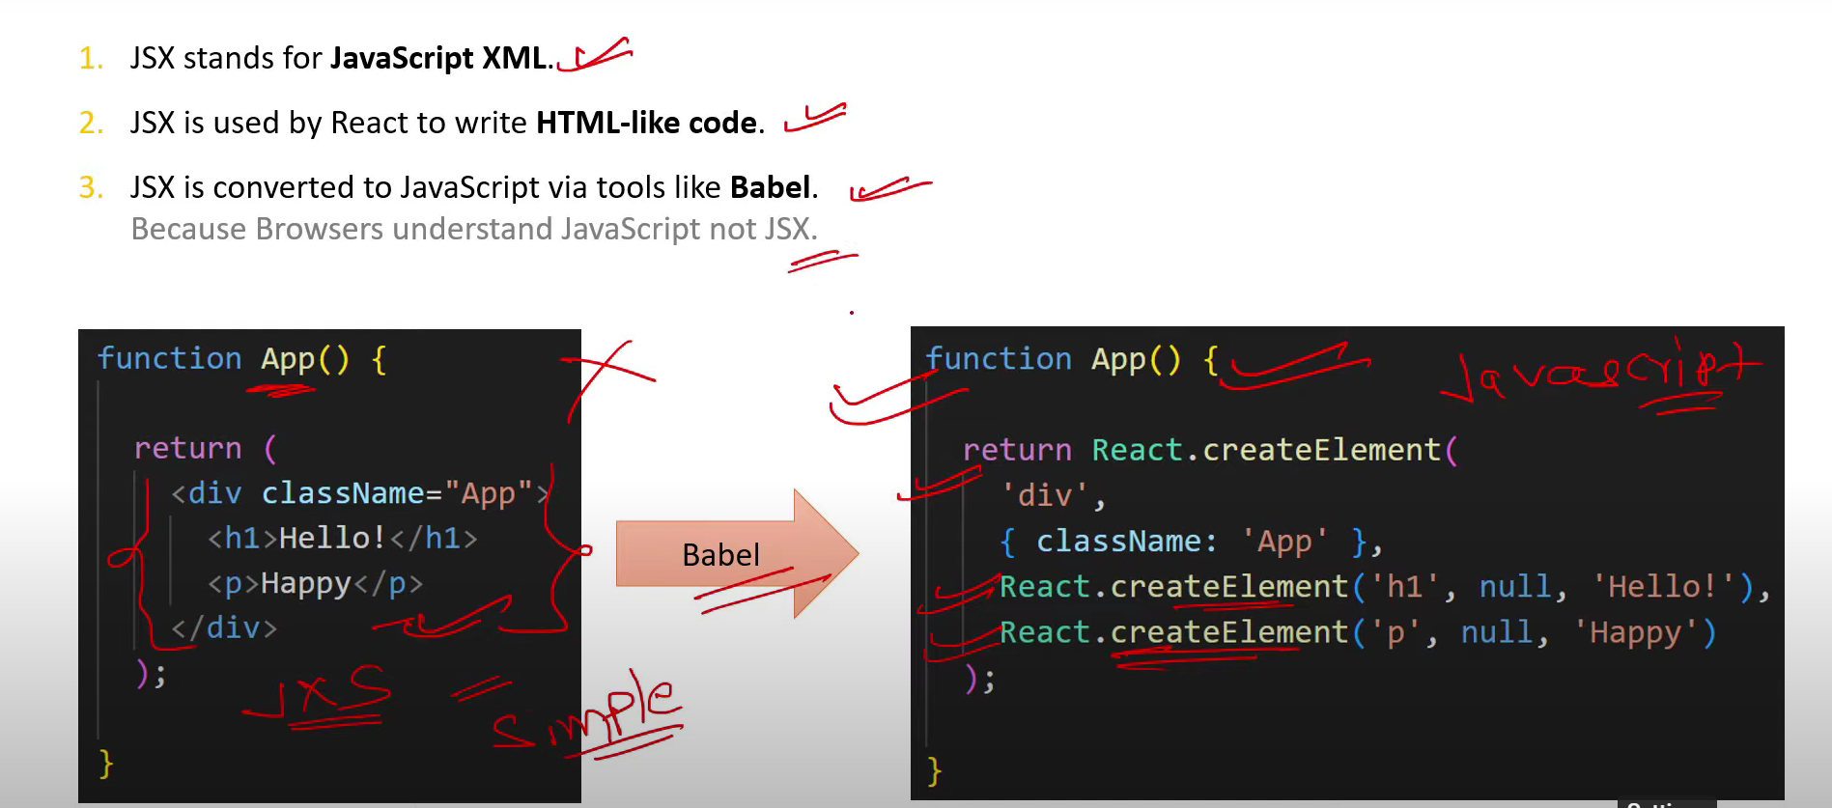

1. **What are the 5 Advantages of JSX?[v.imp.]**

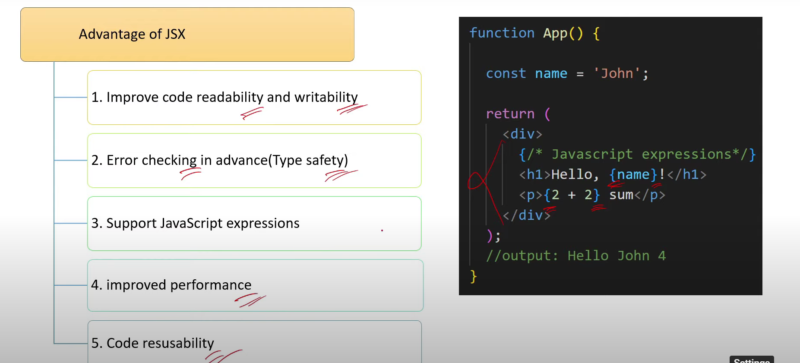

1. **What is Babel?**

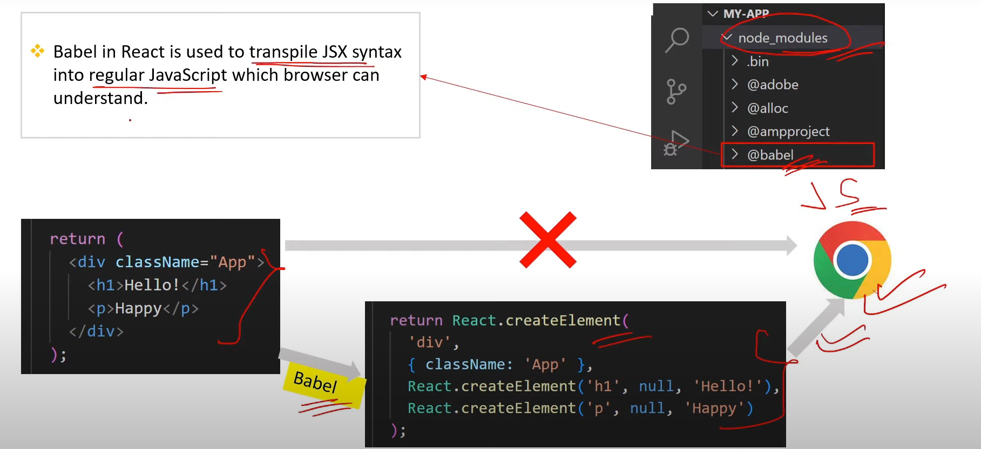

1. **What is the role of Fragment in JSX?[v.imp.]**

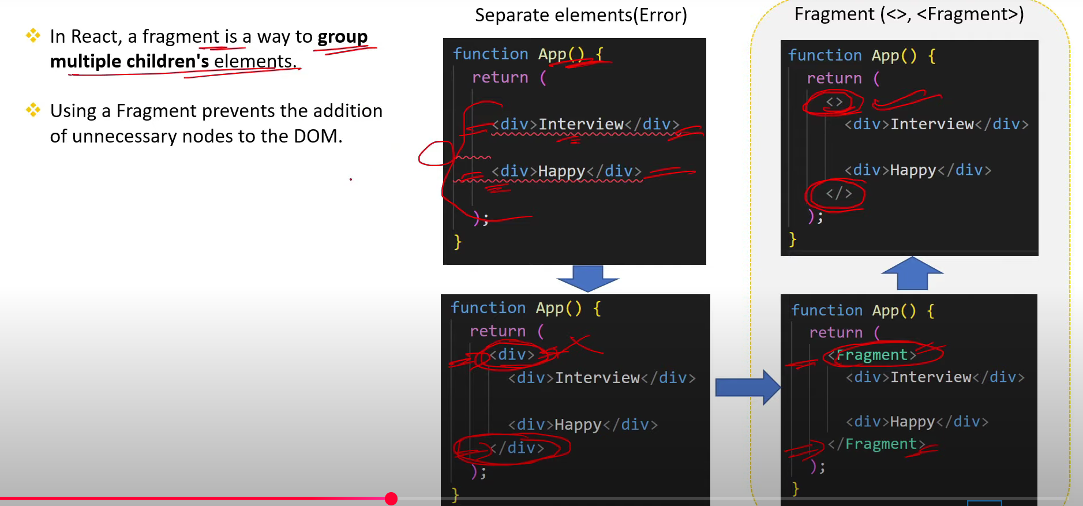

1. **What is Spread Operator in JSX?**

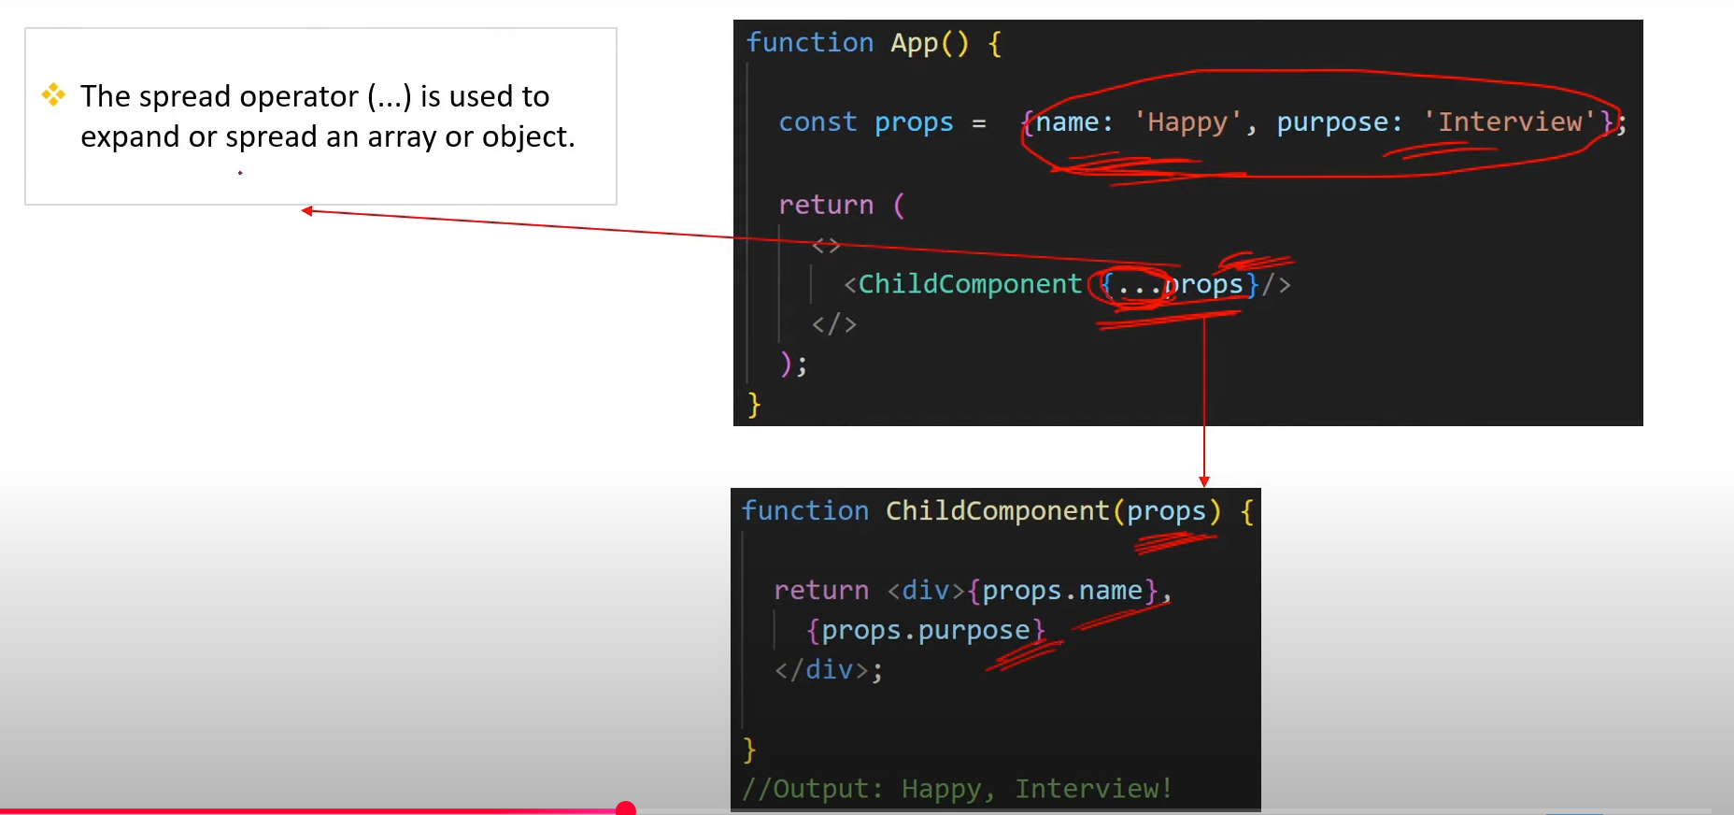

1. **What are the types of Conditional Rendering in JSX?[v.imp.]**

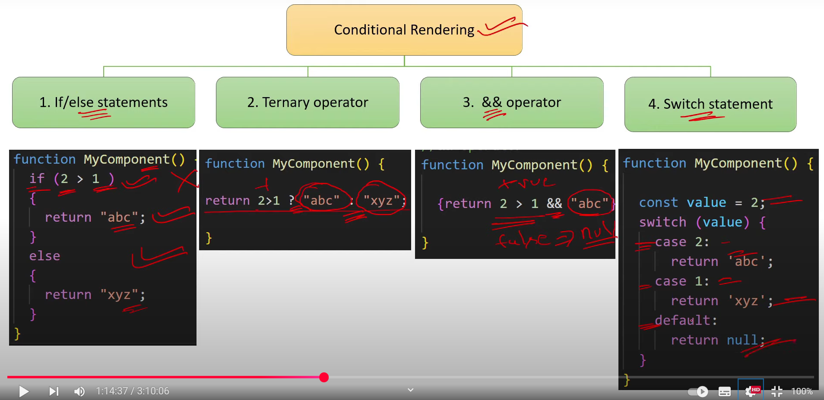

1. **How do you iterate over a list in JSX? What is map() method?**

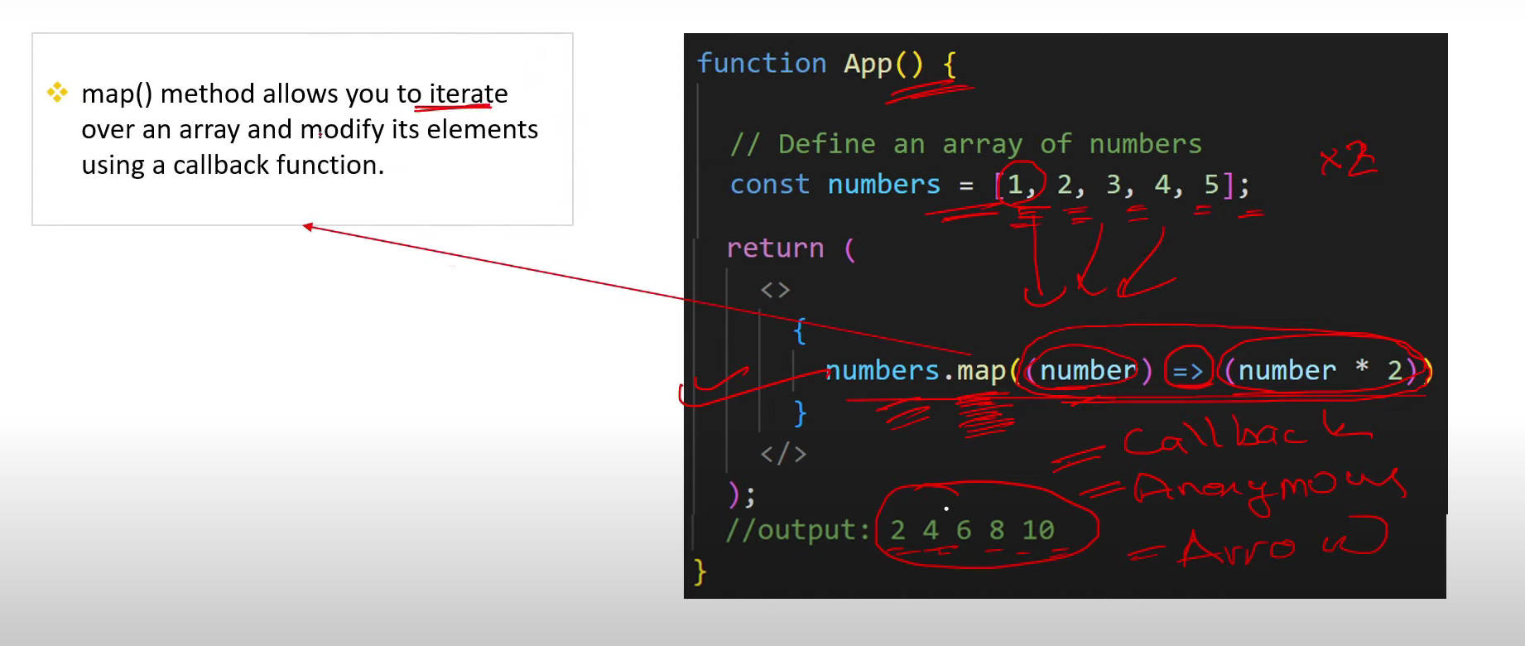

1. **Can a browser read a JSX File?**

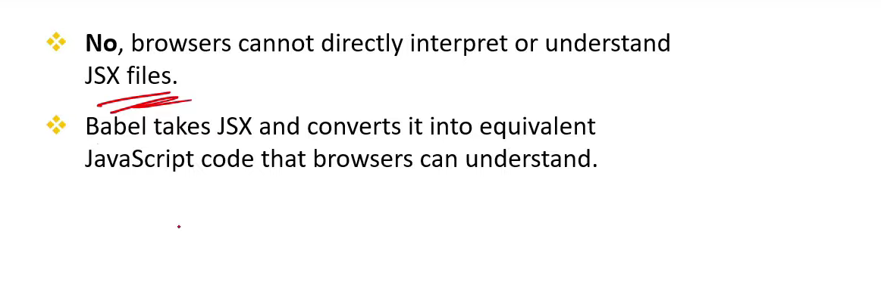

1. **What isTranspiler? What is the difference between Compiler & Transpiler?**

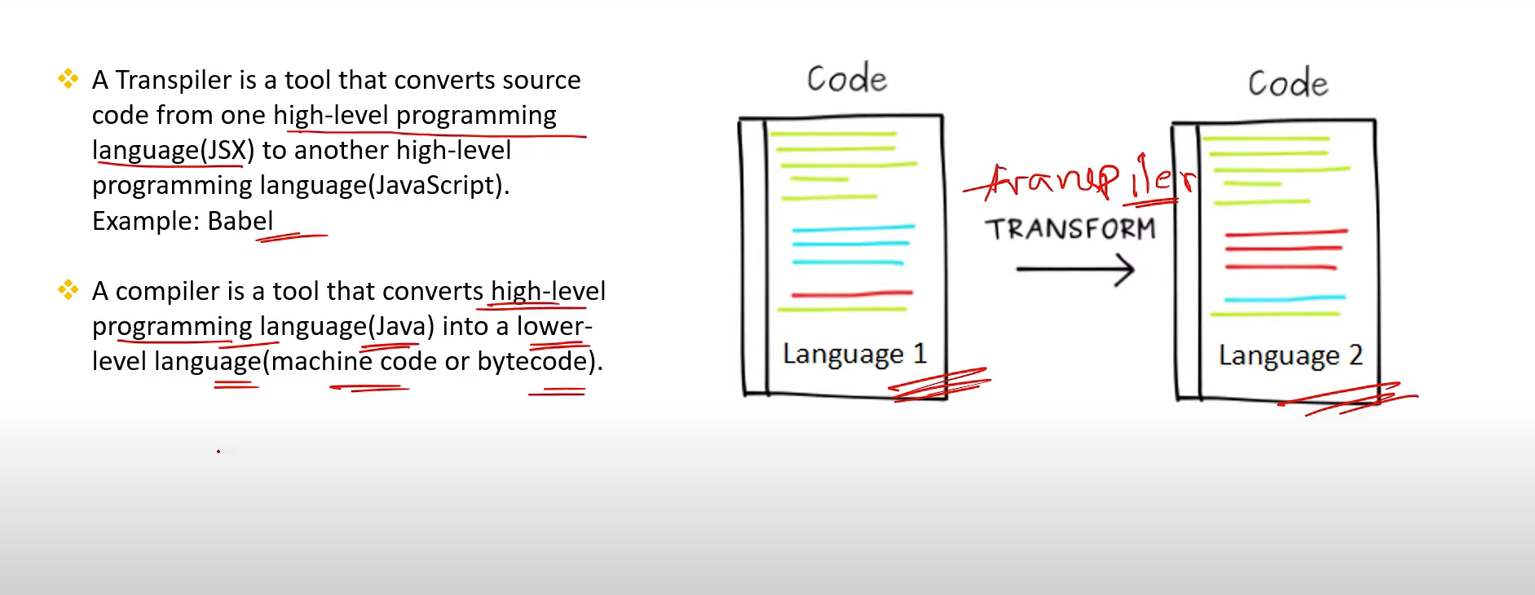

1. **Is it possible to use JSX without React?**

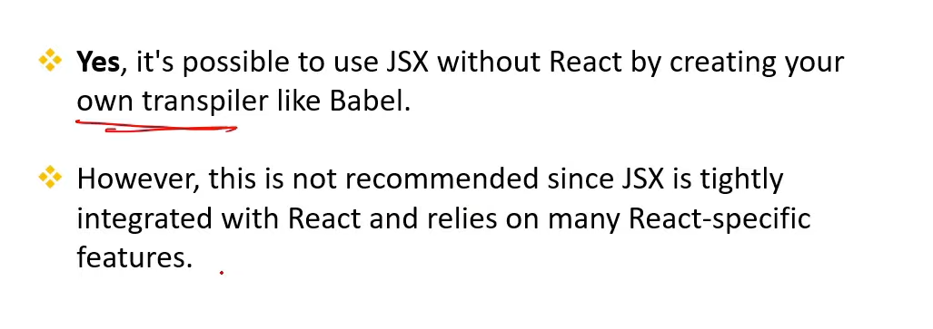

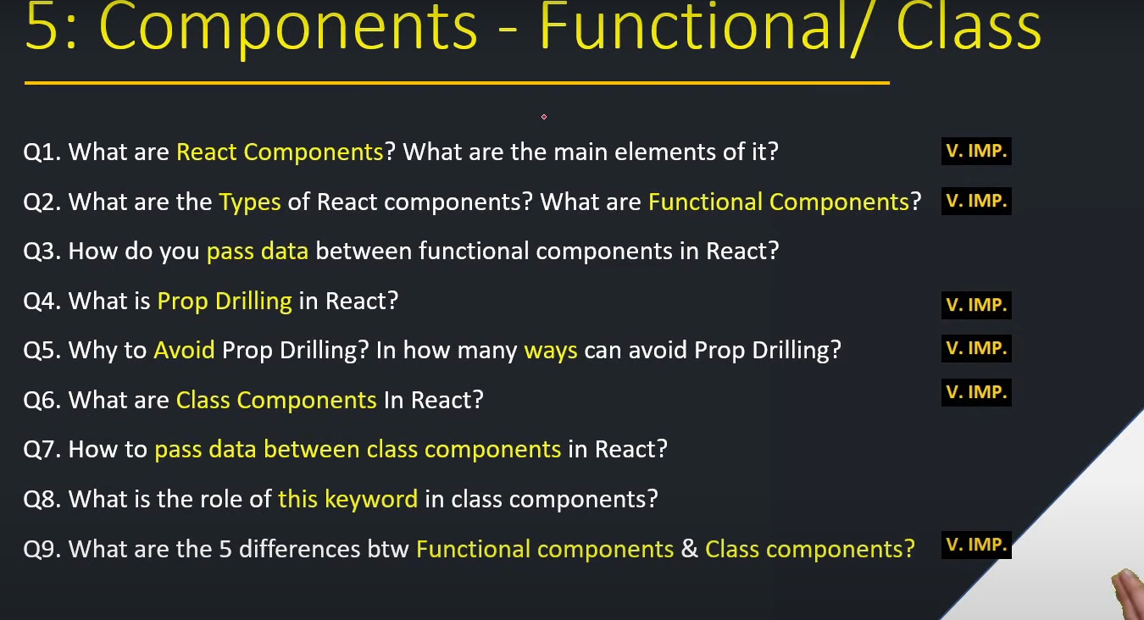

1. **What are React Components? What are the main elements of it?[v.imp]**

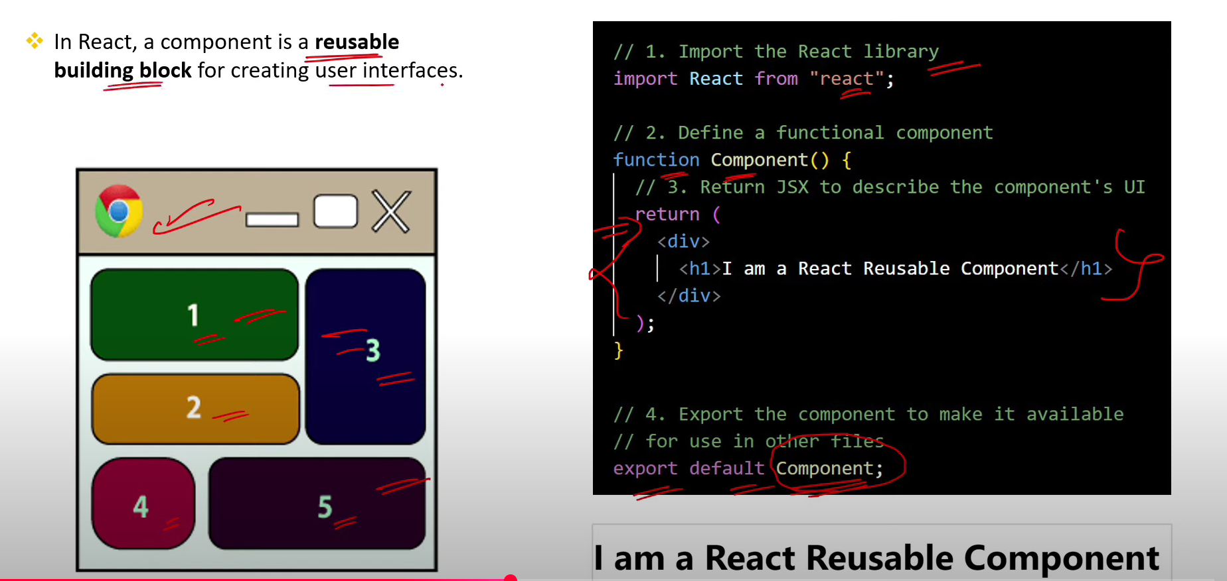

1. **What are the Types of React components? What are Functional Components?[ imp]**

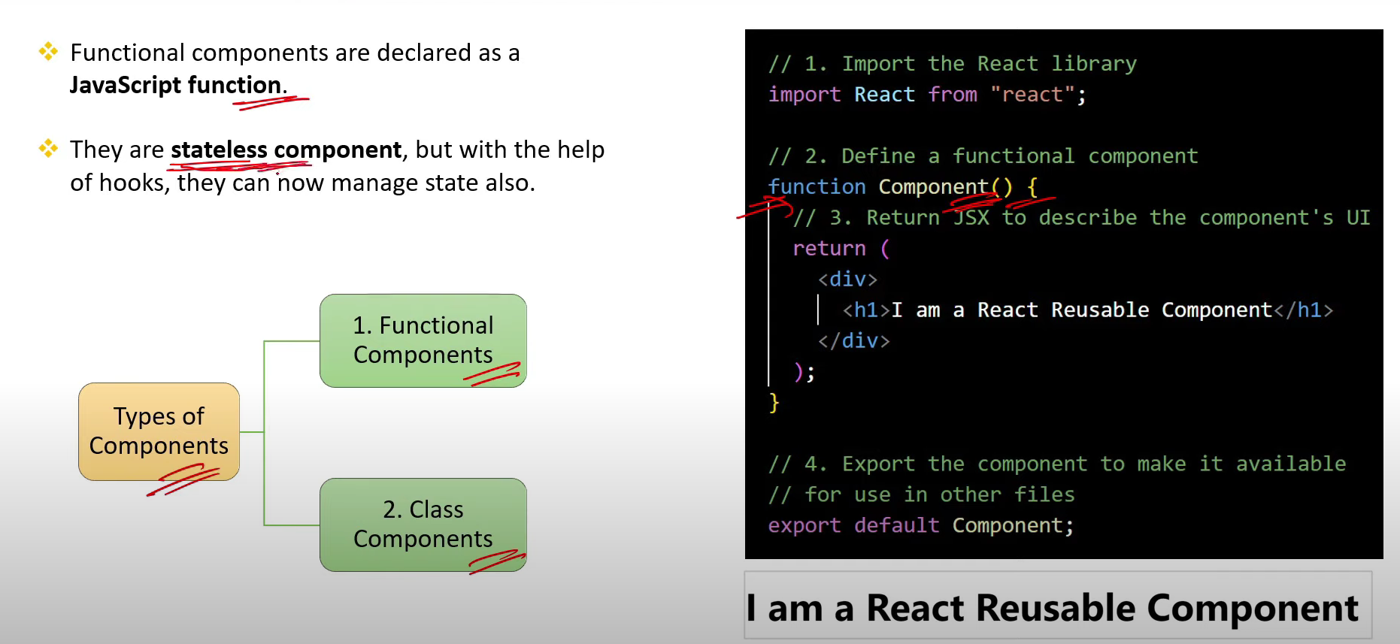

1. **How do you pass data between functional components in React?**

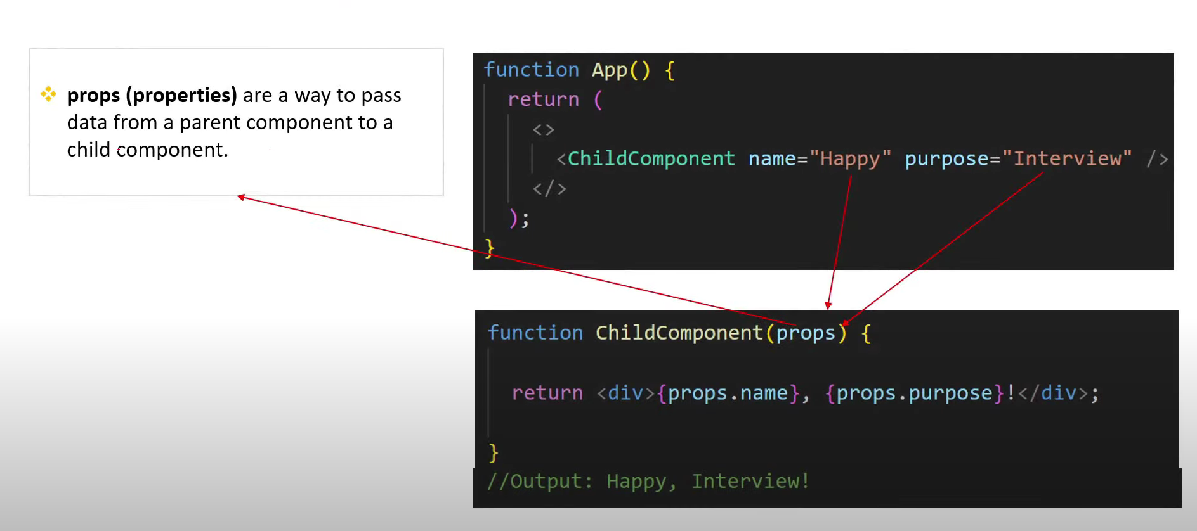

1. **What is Prop Drilling in React? [v.imp]**

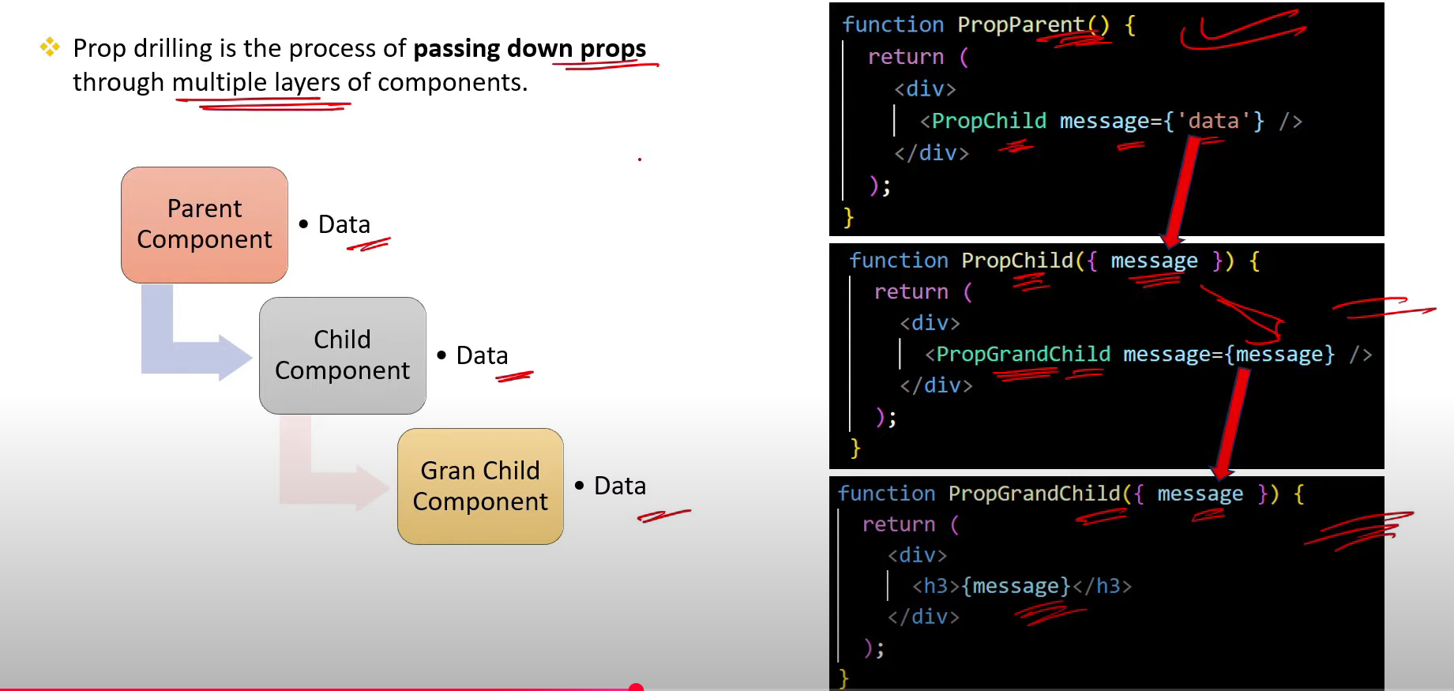

1. **Why to Avoid Prop Drilling? In how many ways can avoid Prop Drilling?[V.imp.]**

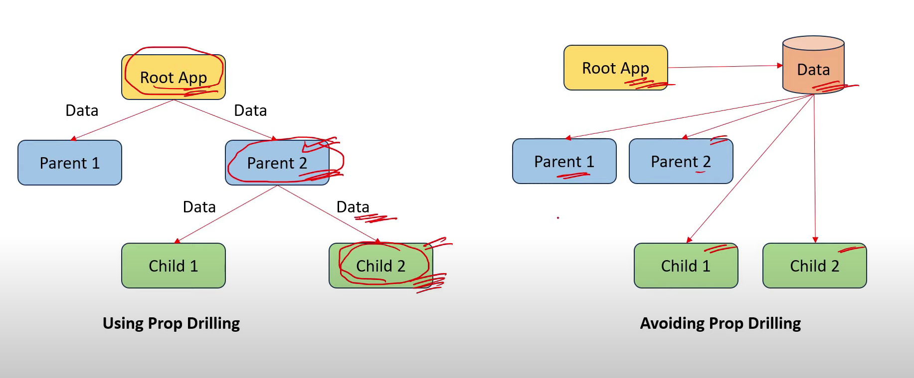

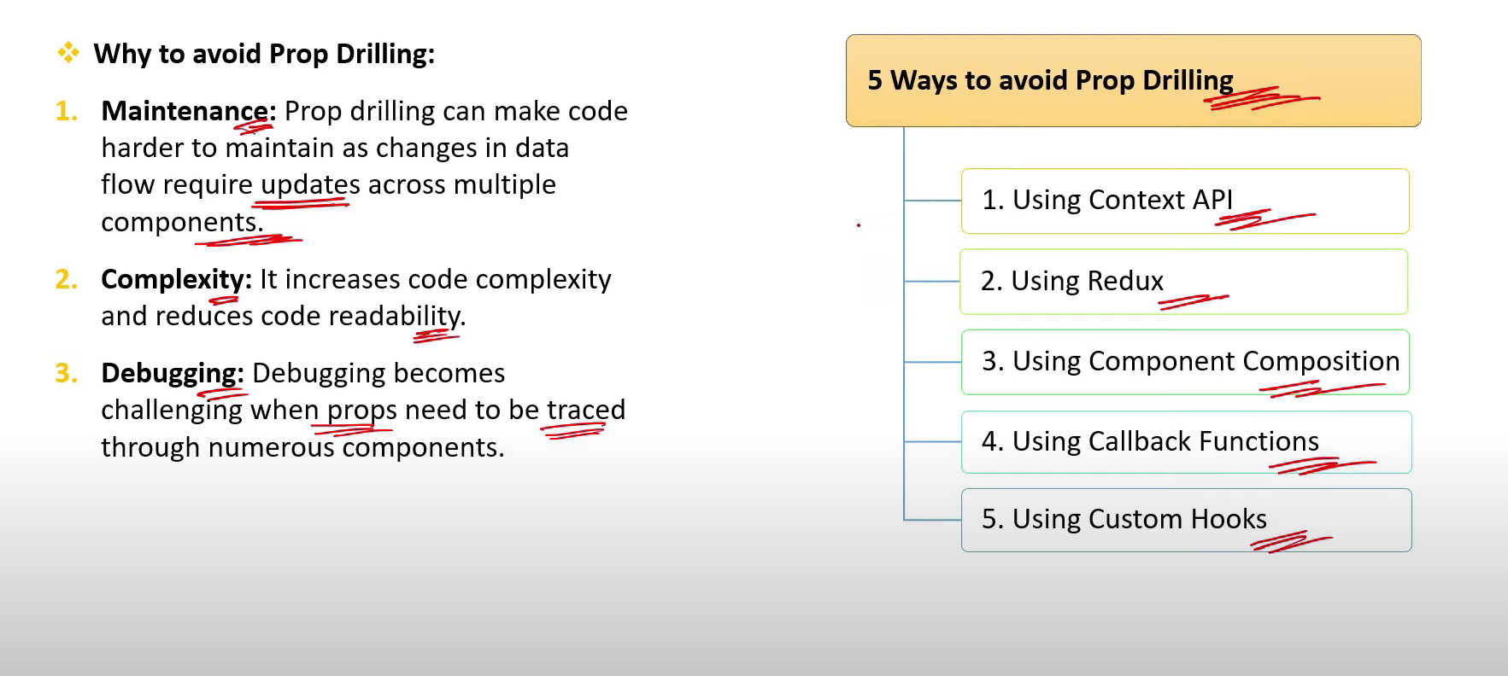

1. **What are Class Components In React?**

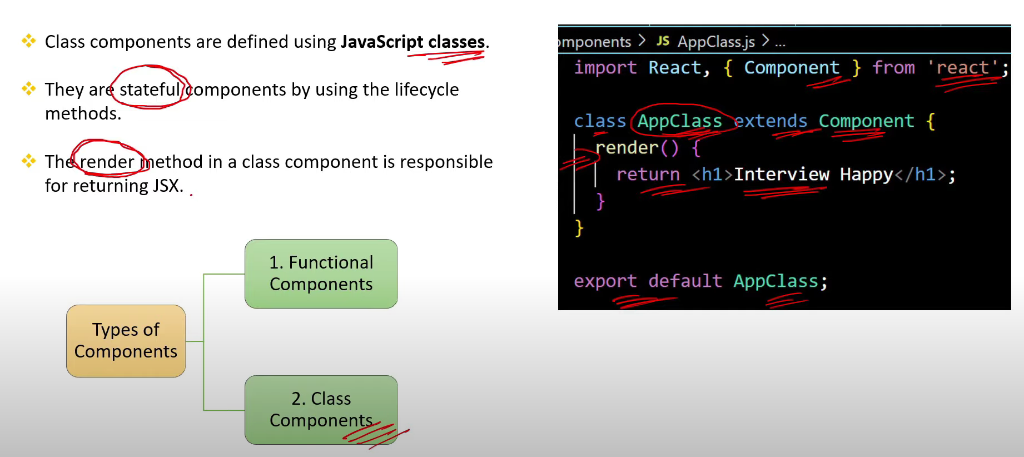

1. **How to pass data between class components in React?[v.imp.]**

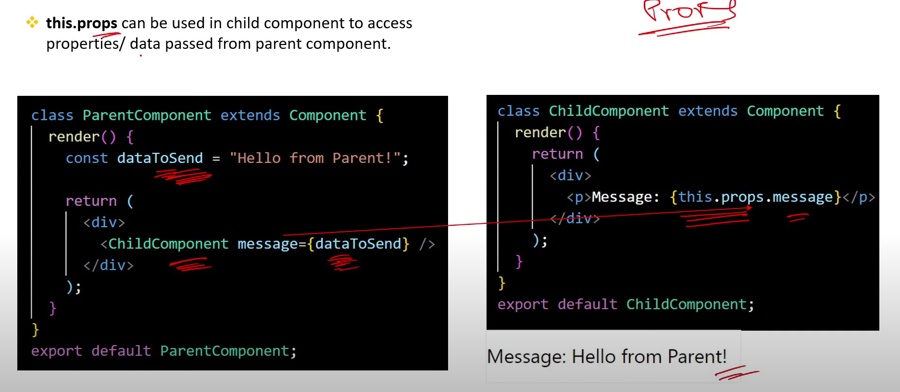

1. **What is the role of this keyword in class components?**

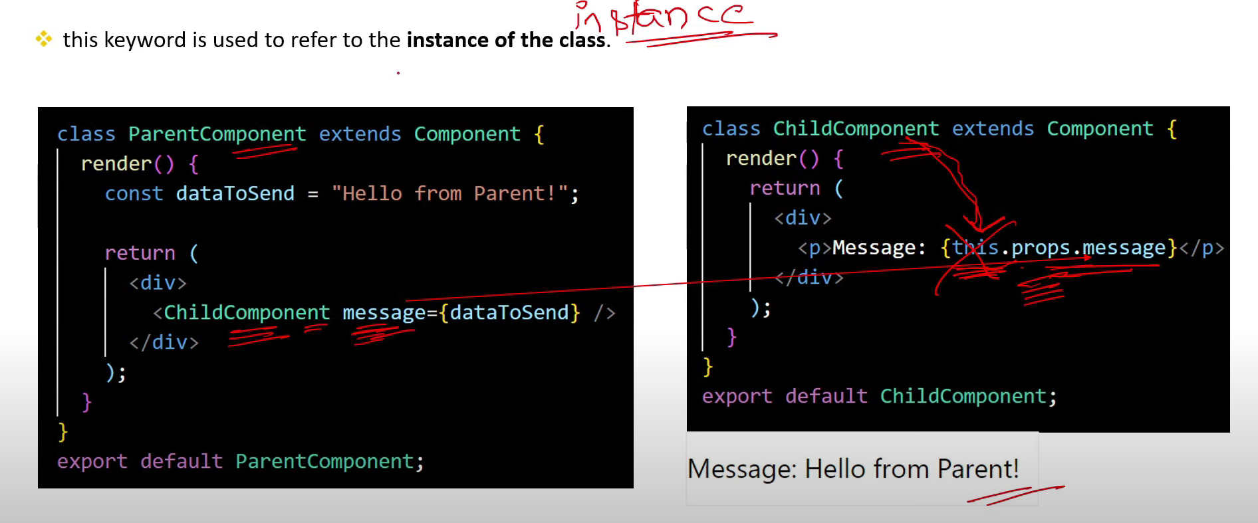

1. **What are the 5 differences btw Functional components & Class components?[v.imp]**

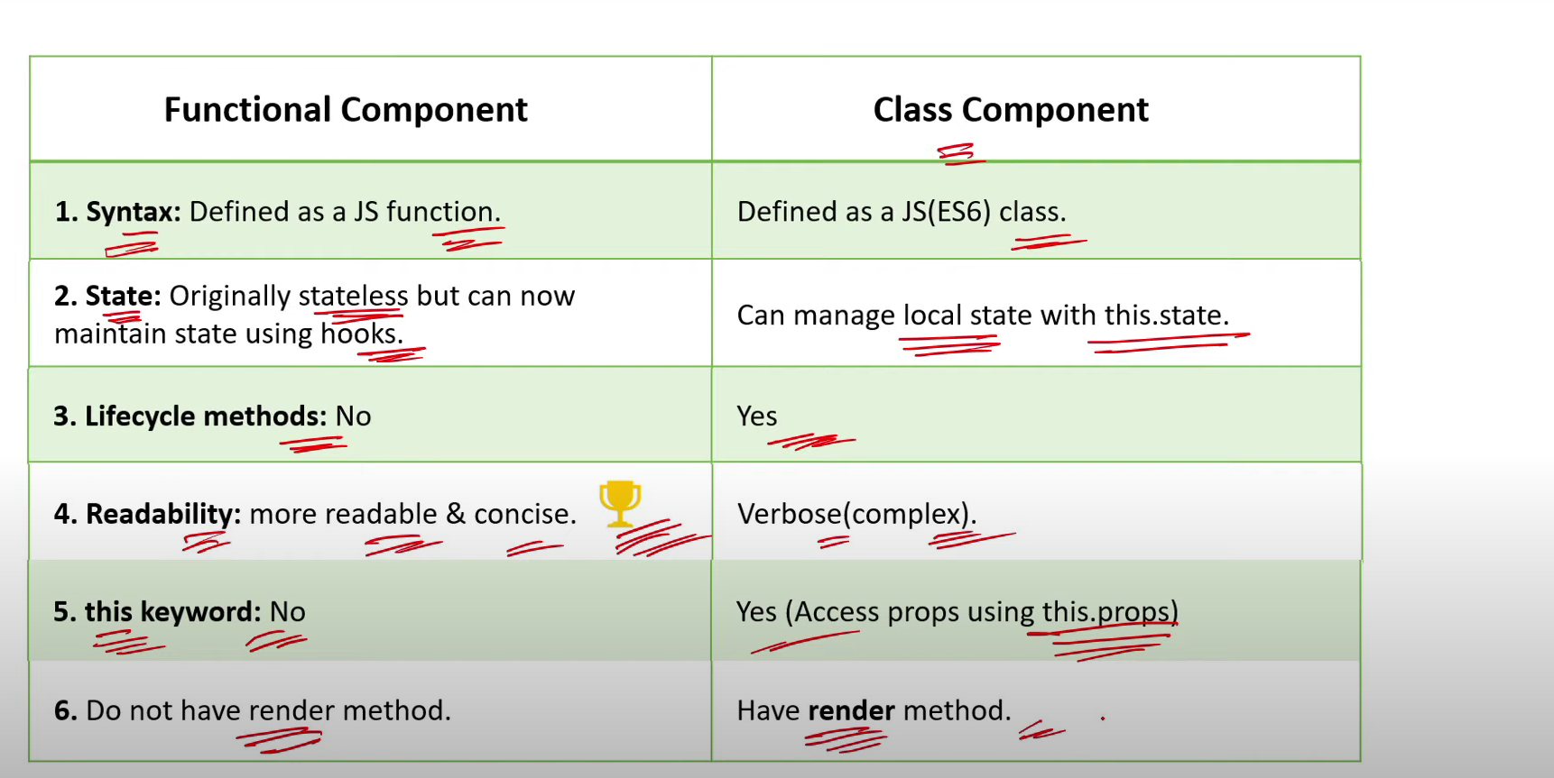

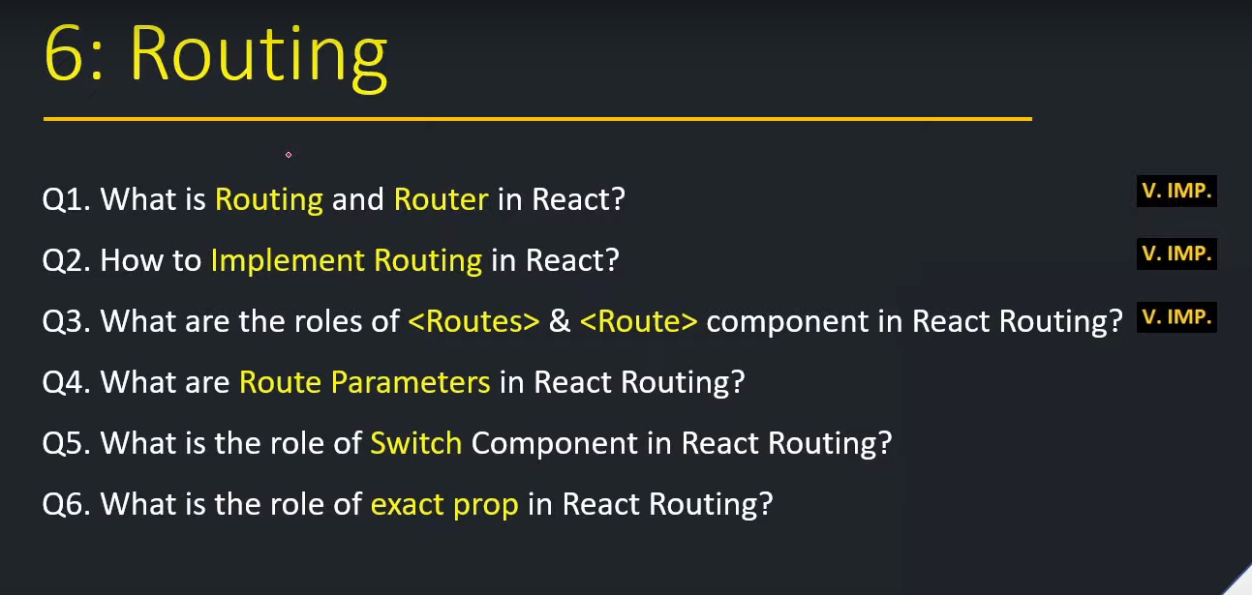

1. **What is Routing and Router in React? [v.imp.]**

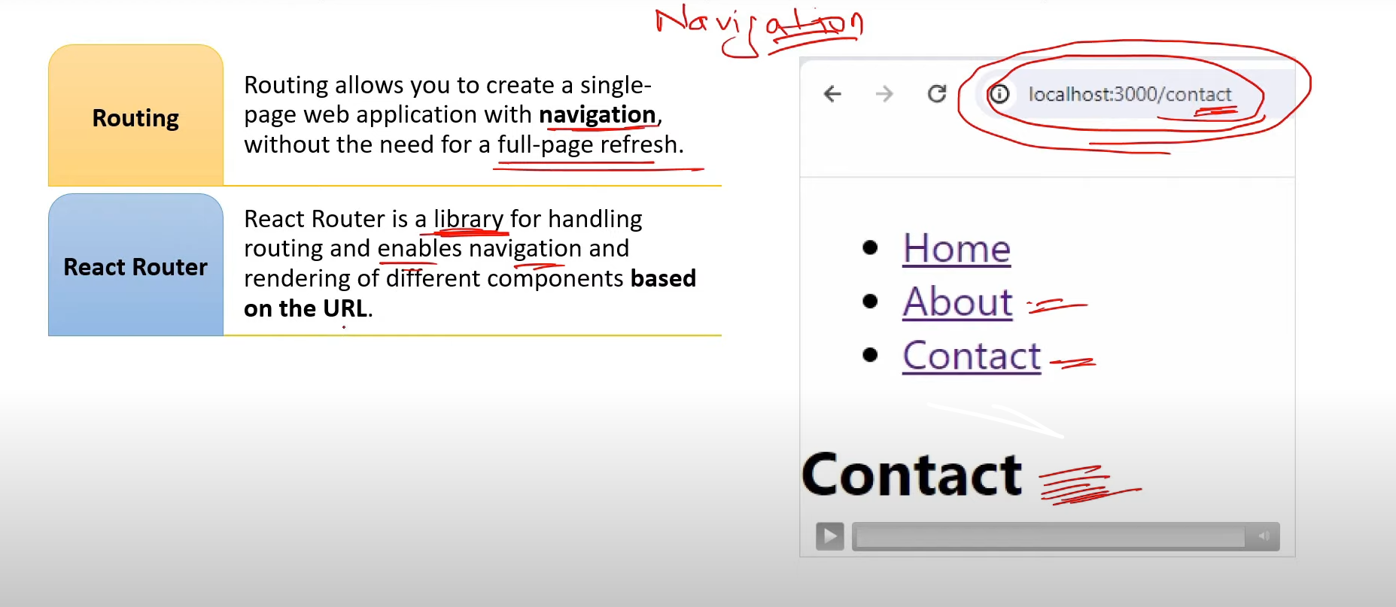

1. **How to implement Routing in React? [v.imp.]**

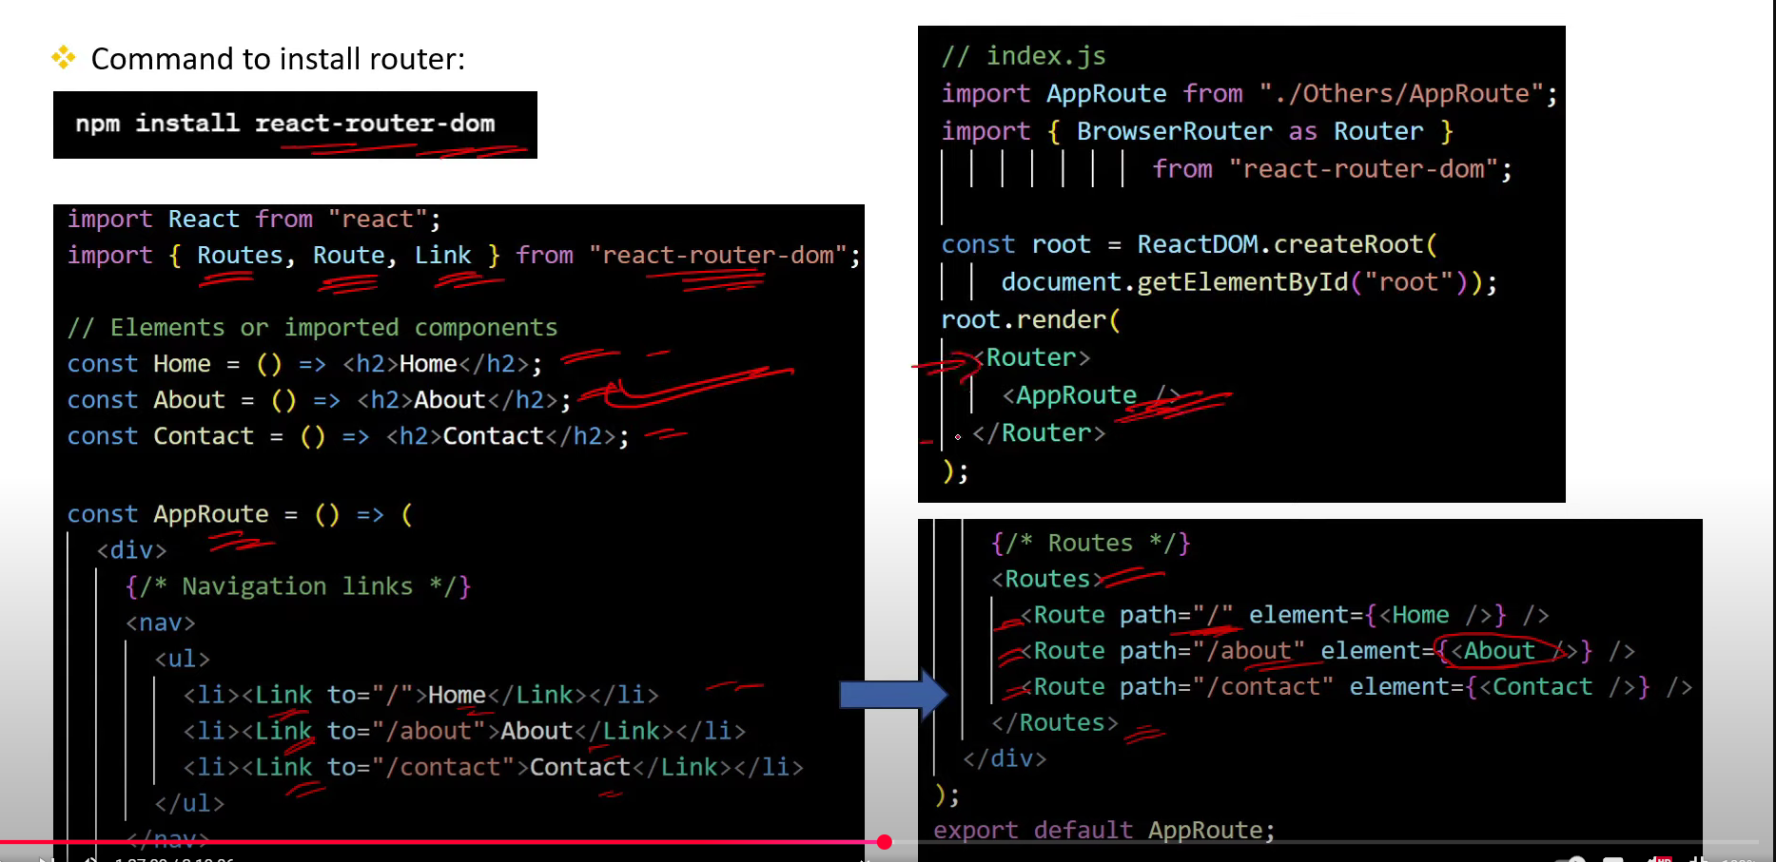

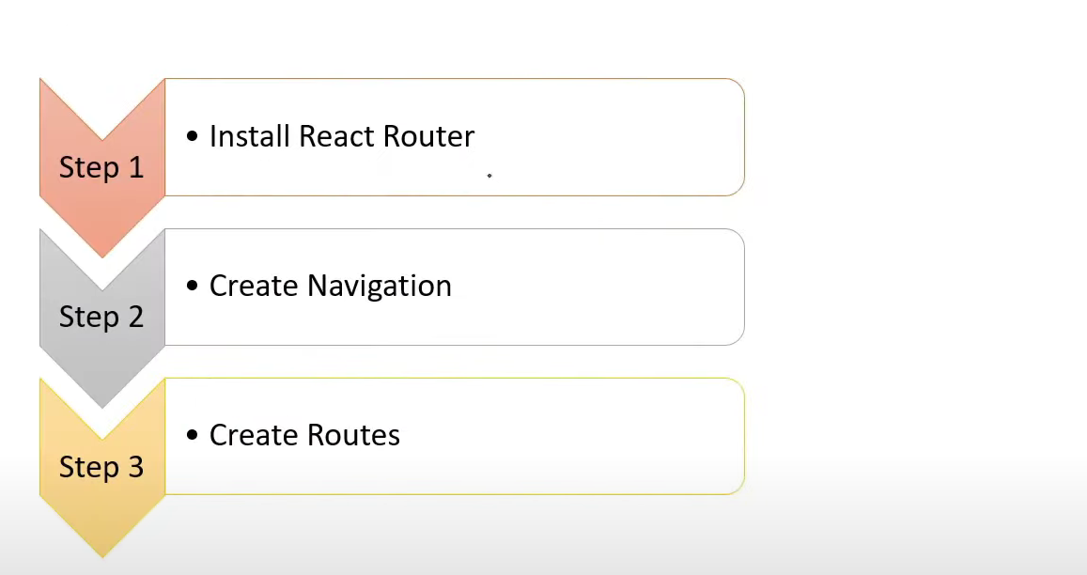

1. **What is the Role of <Routes> and <Route> component in React Routing?[v.imp.]**

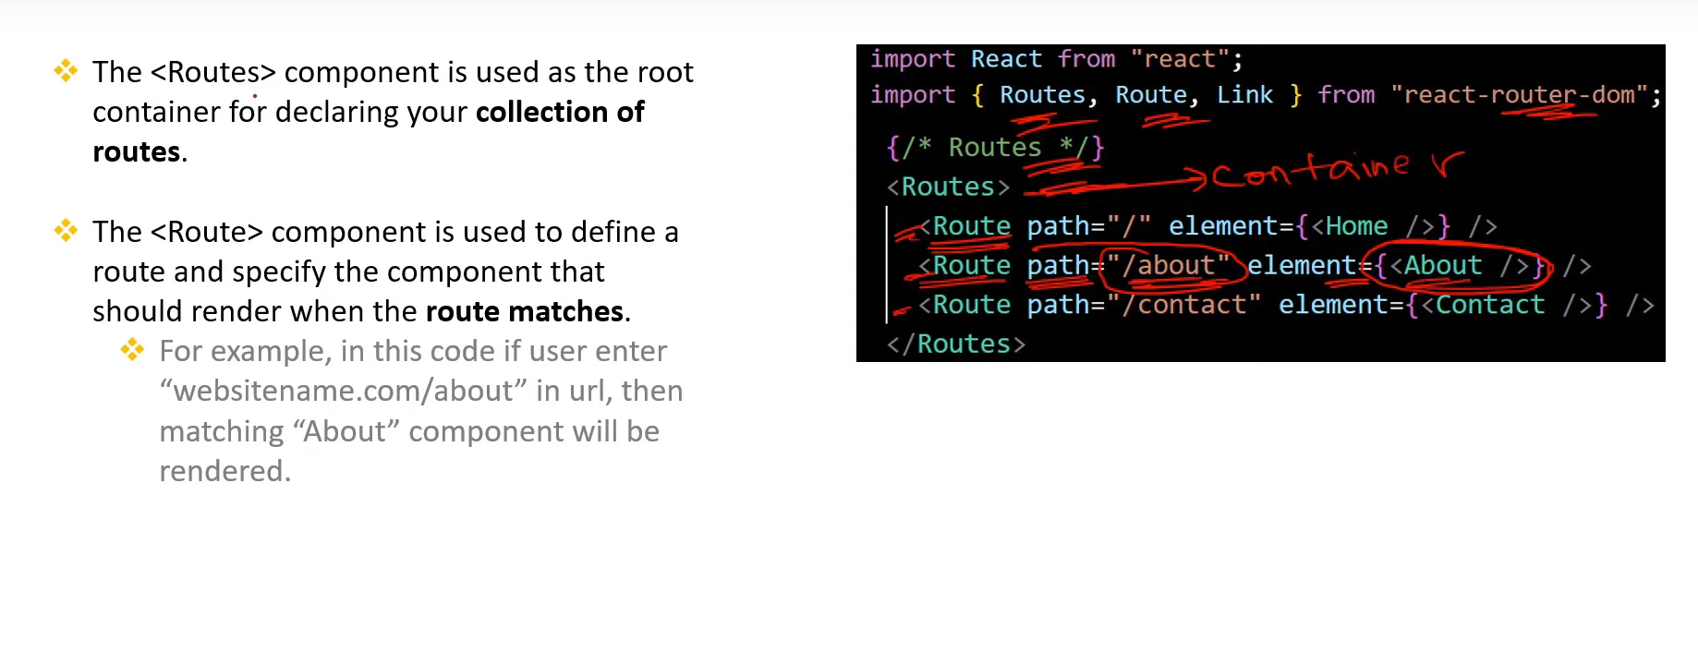

1. **What are Route Parameters in React Routing?**

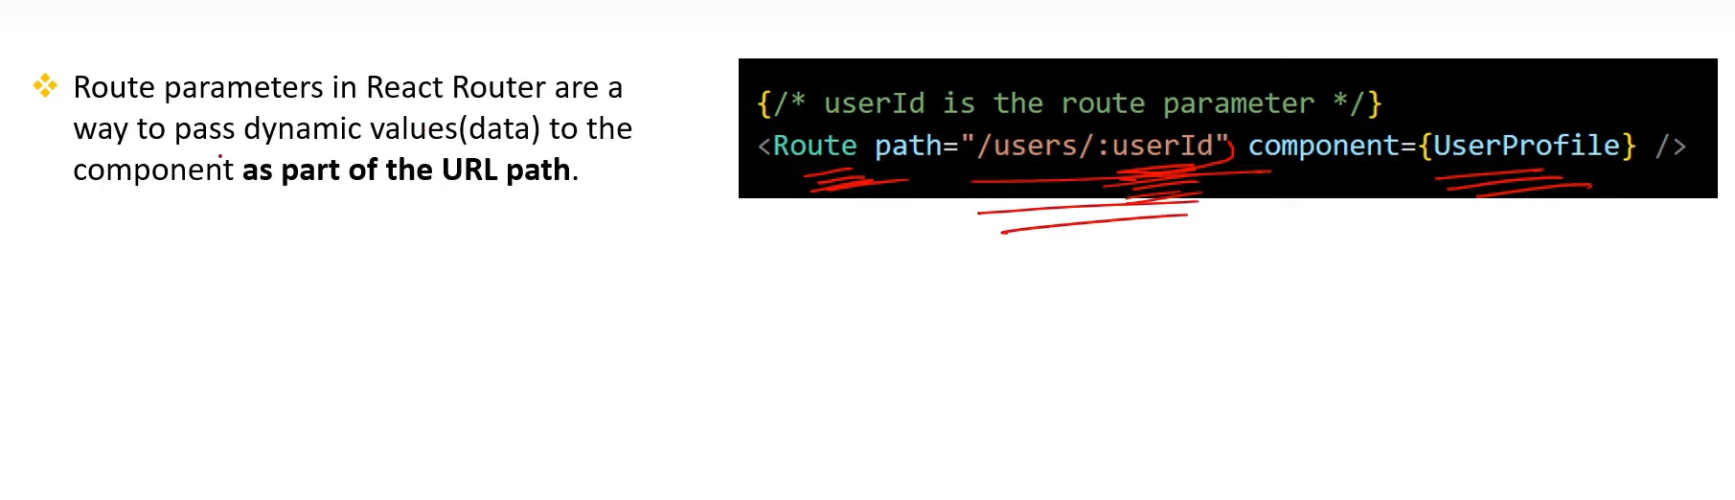

1. **What is the role of Switch component in React Routing?**

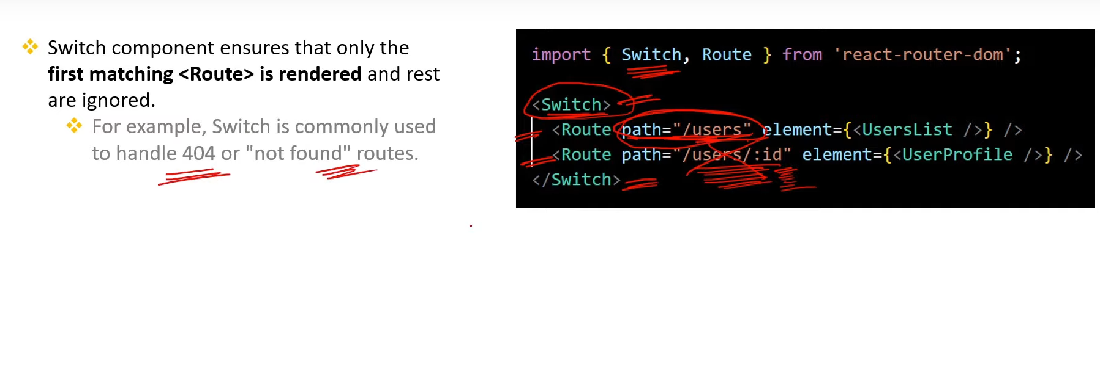

1. **What is the role of exact prop in React Routing?**

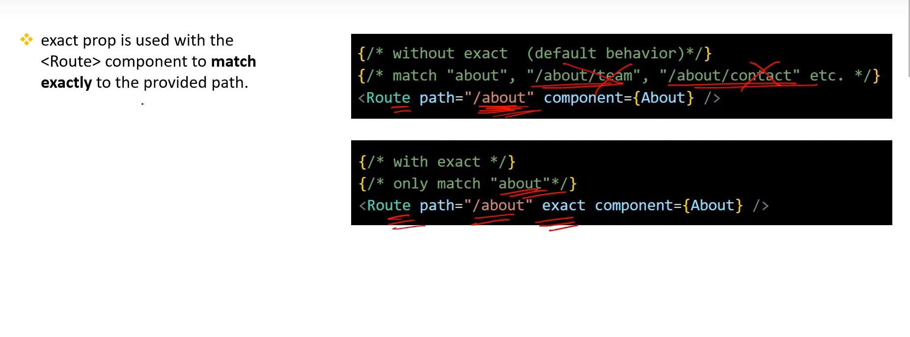

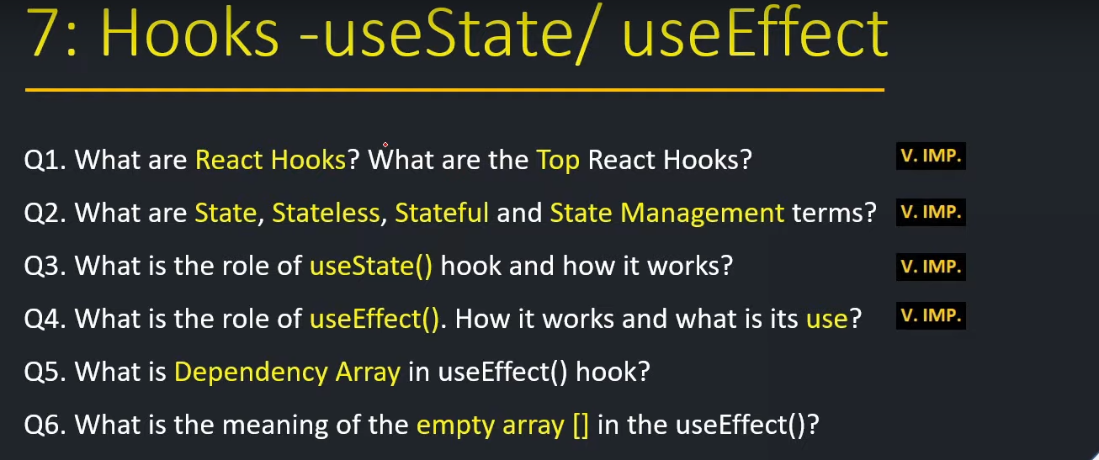

1. **What are React Hooks? What are the Top React Hooks?[v.imp.]**

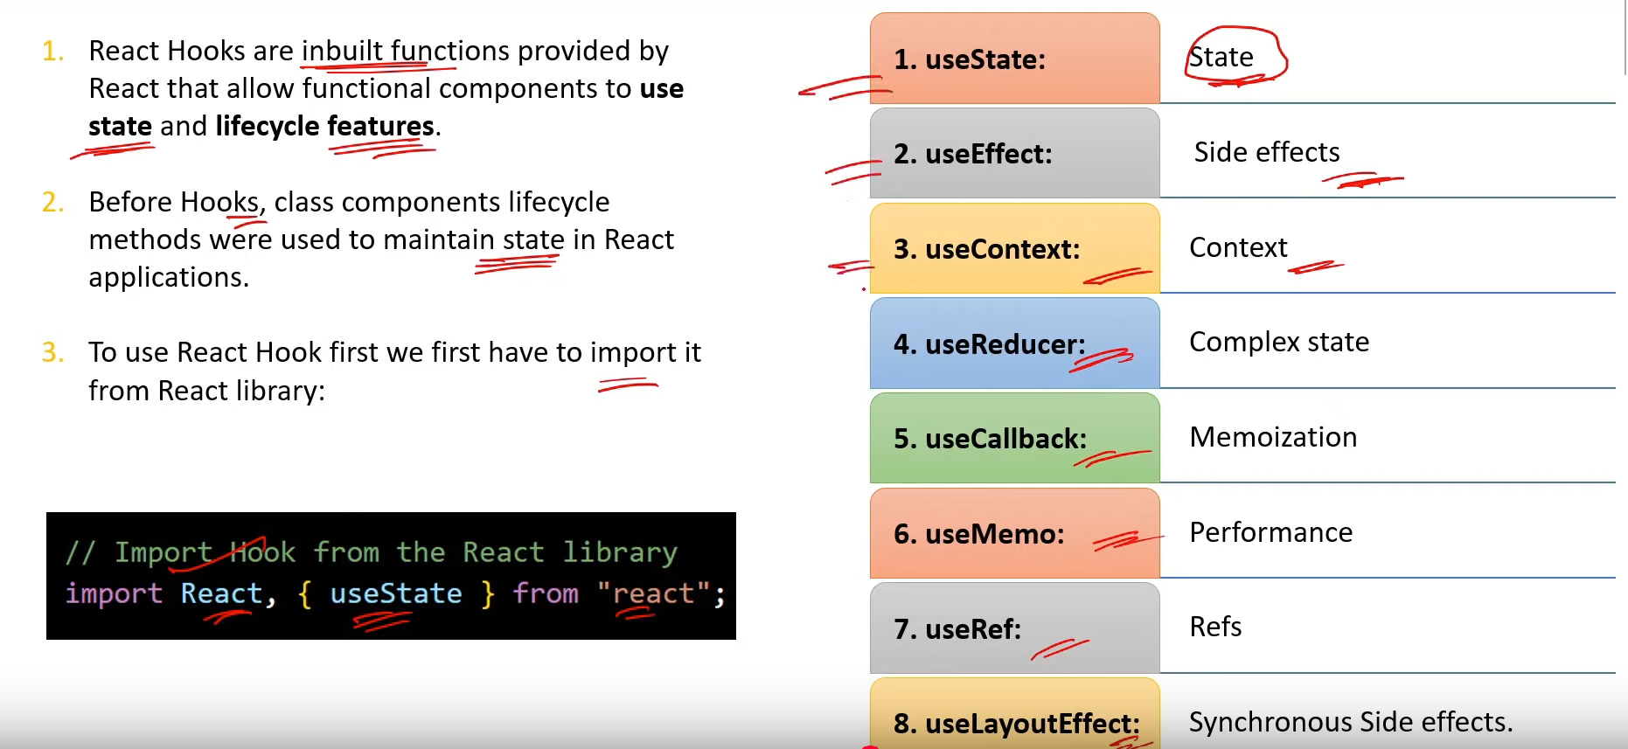

1. **What are State, Stateless, Stateful and State Management terms?[v.imp.]**

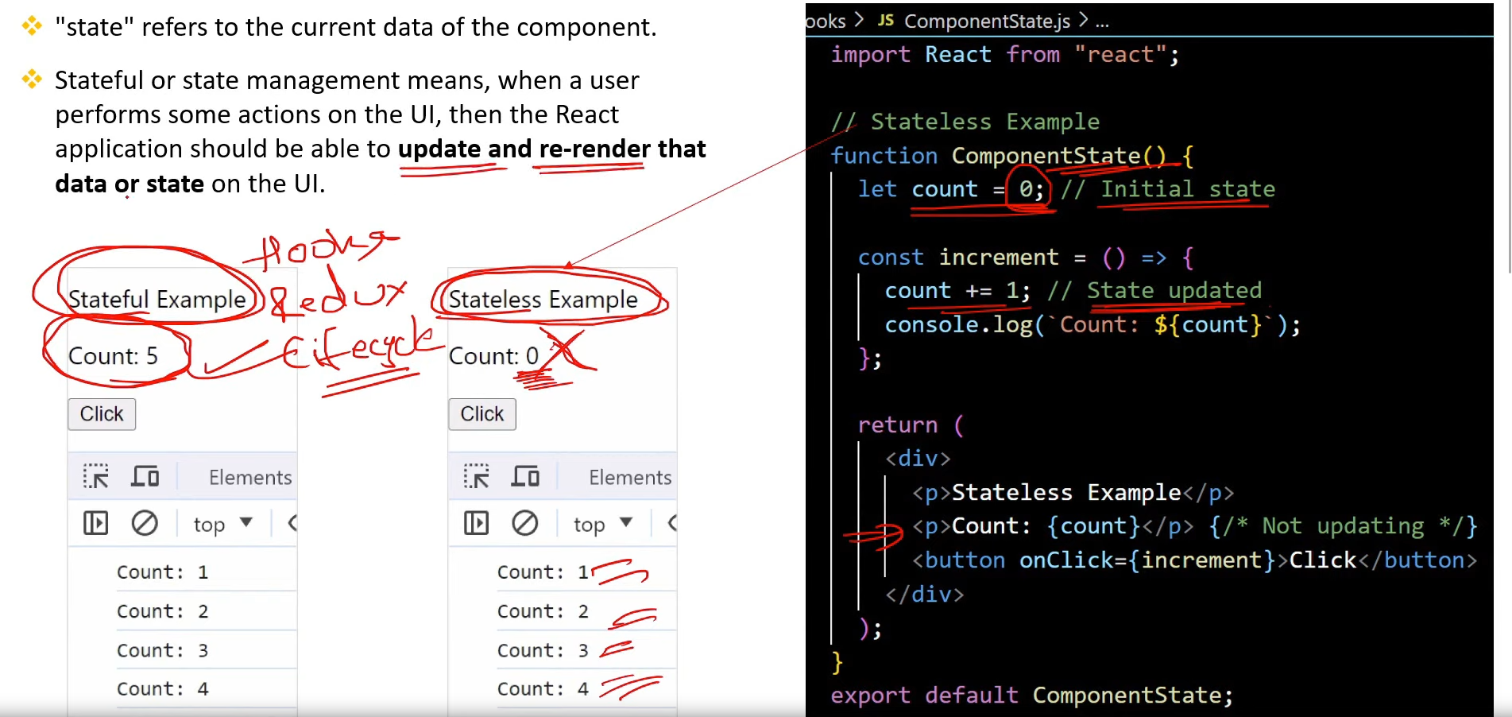

1. **What is the role of useState() hook and how it works?[v.imp.]**

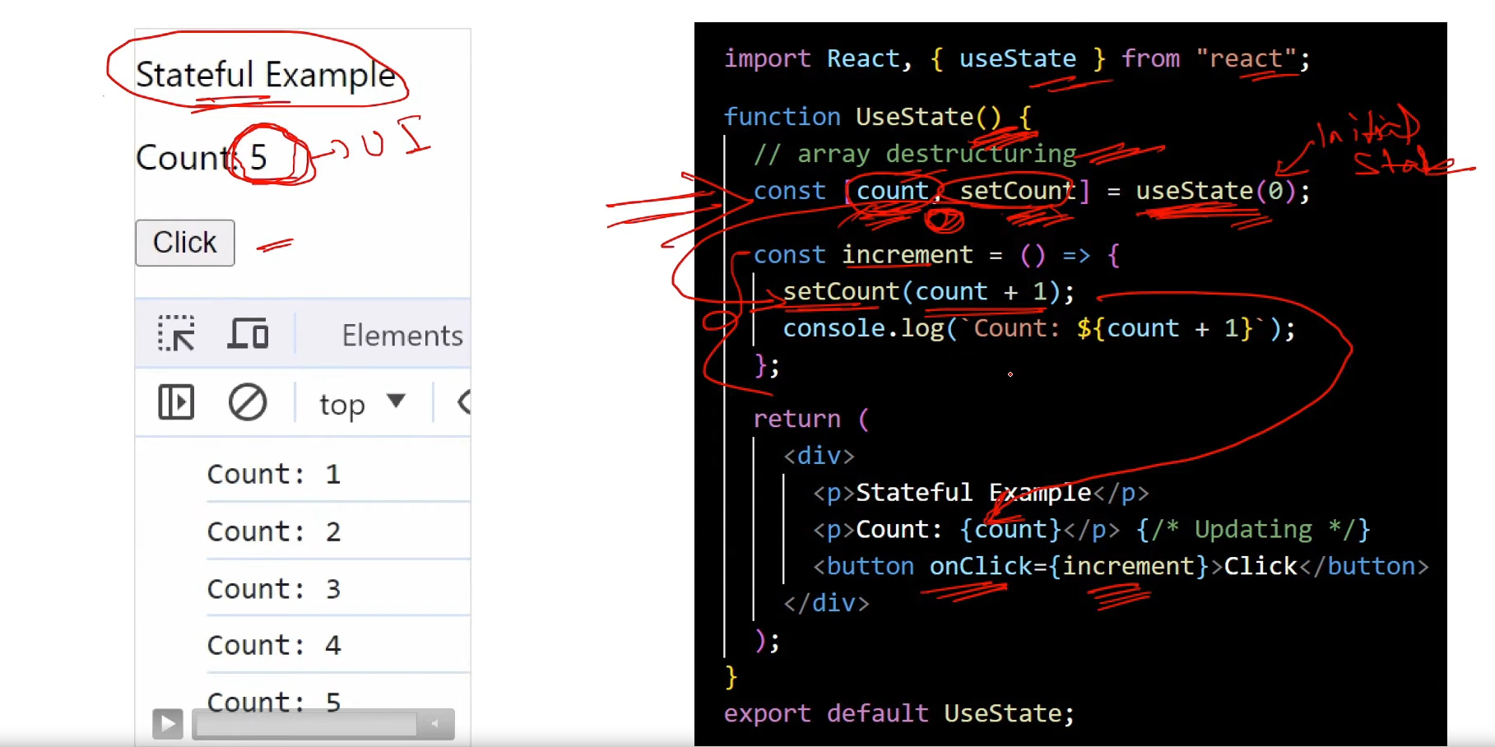

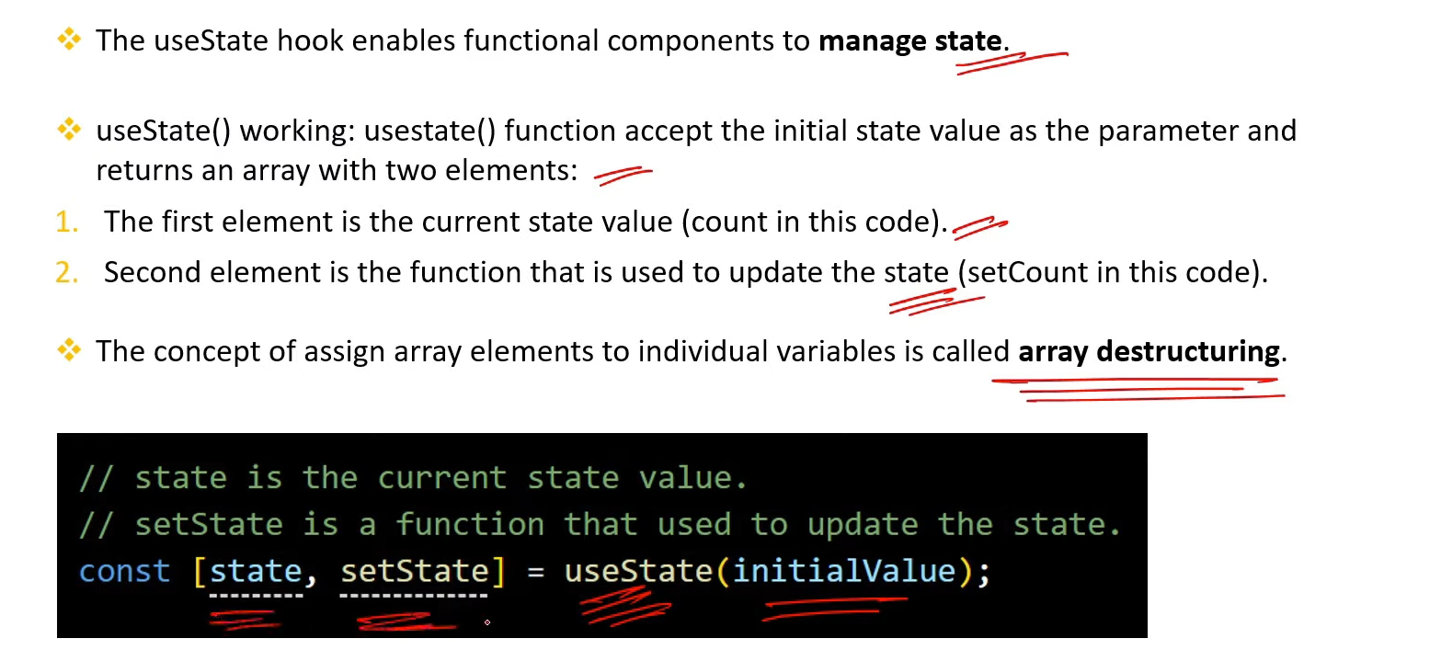

1. **What is the role of useEffect(). How it works and what is its use?[v.imp.]**

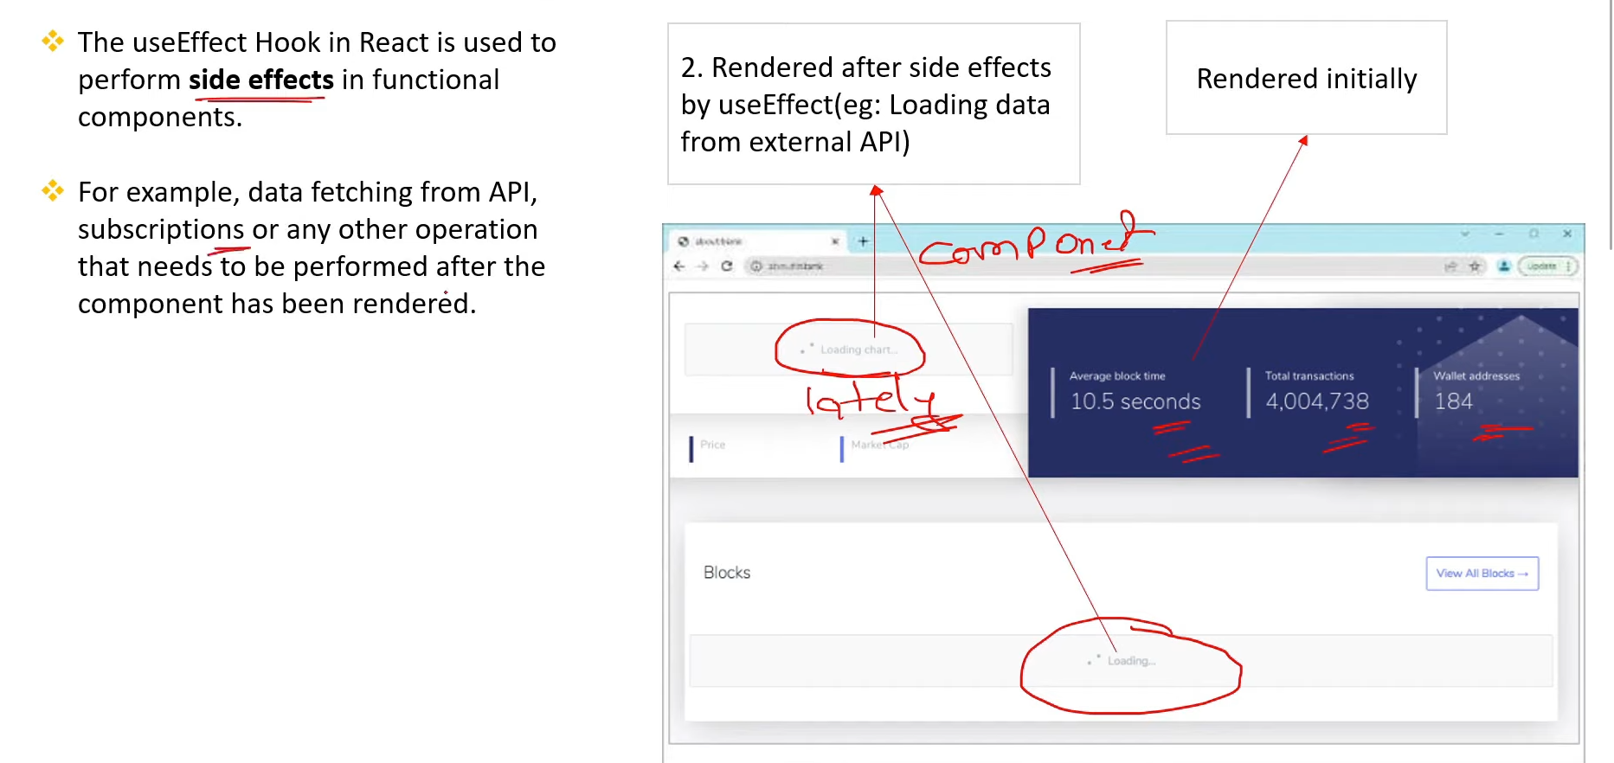

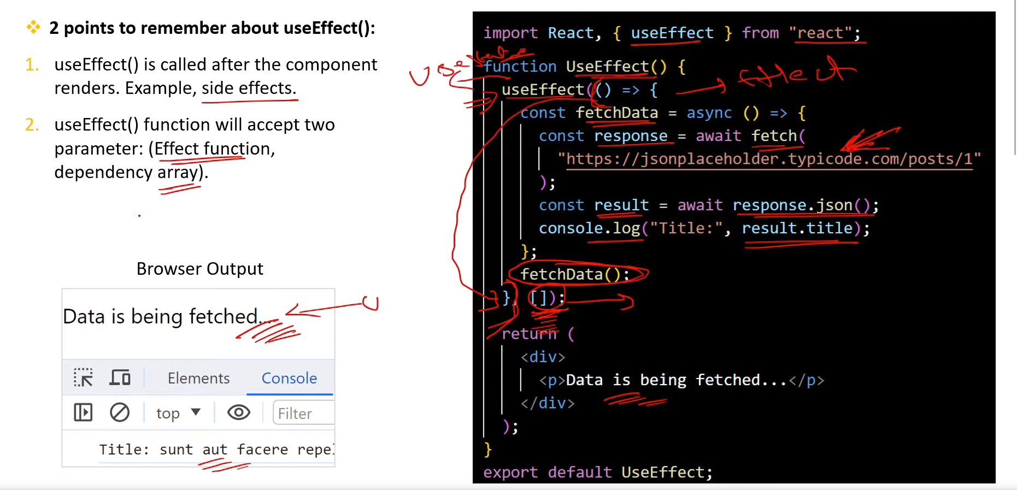

1. **What is Dependency Array in useEffect() hook?**

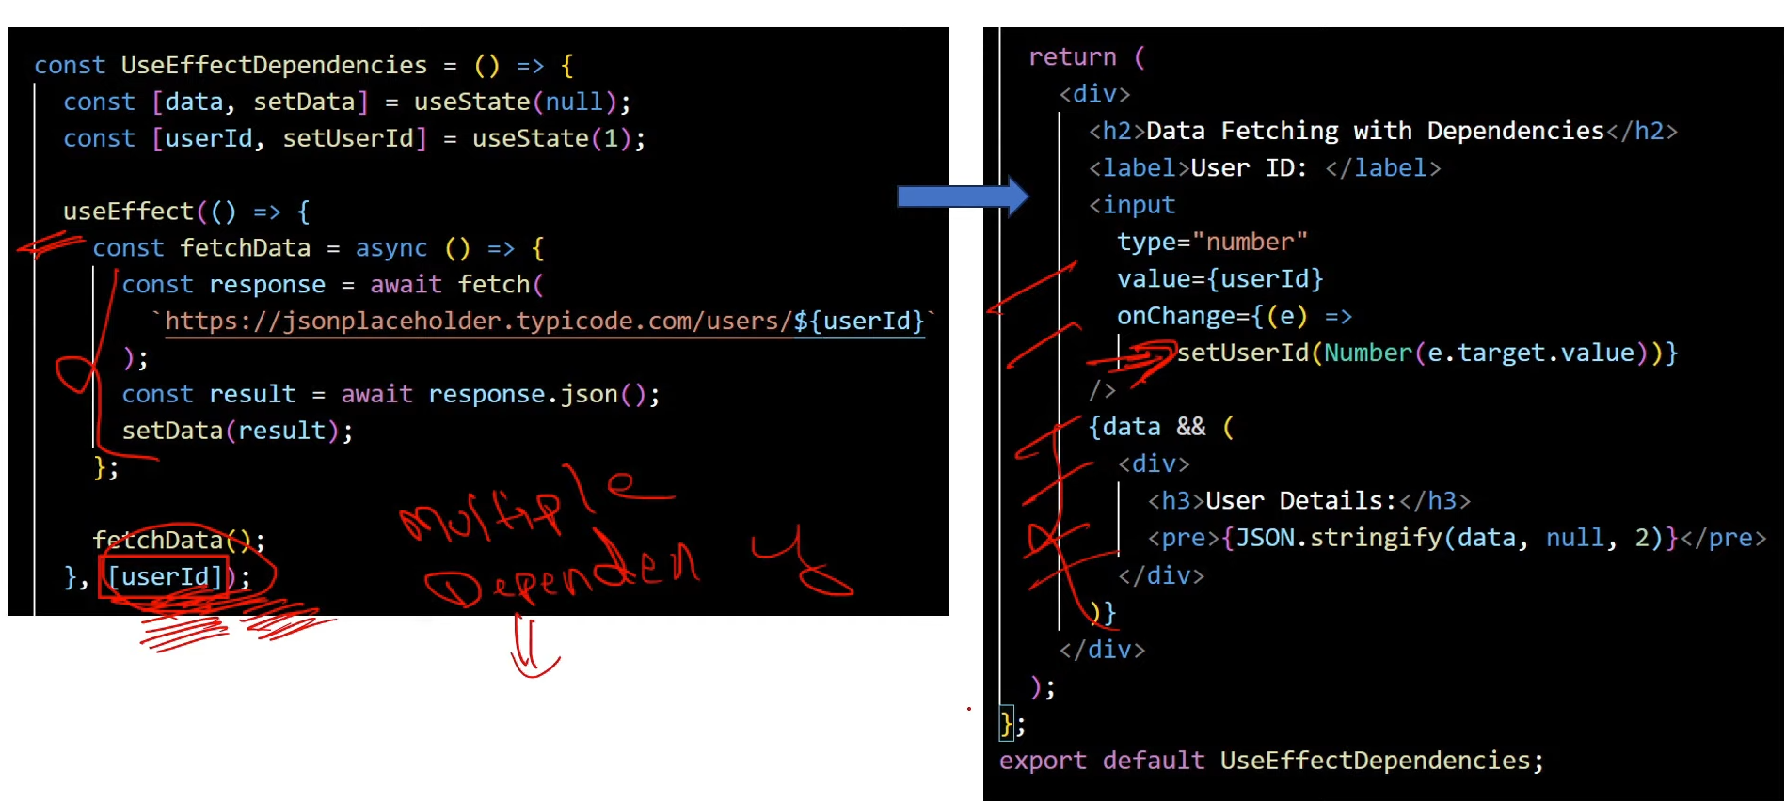

1. **What is the meaning of the empty array [] in the useEffect()?**

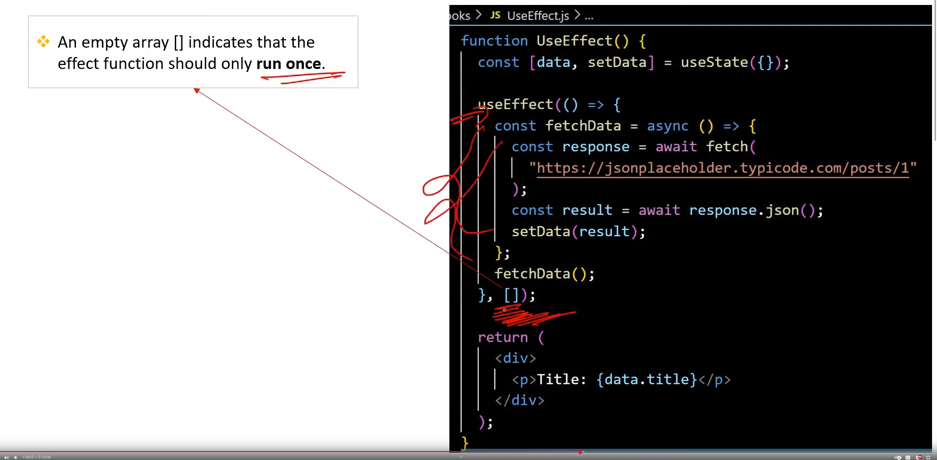

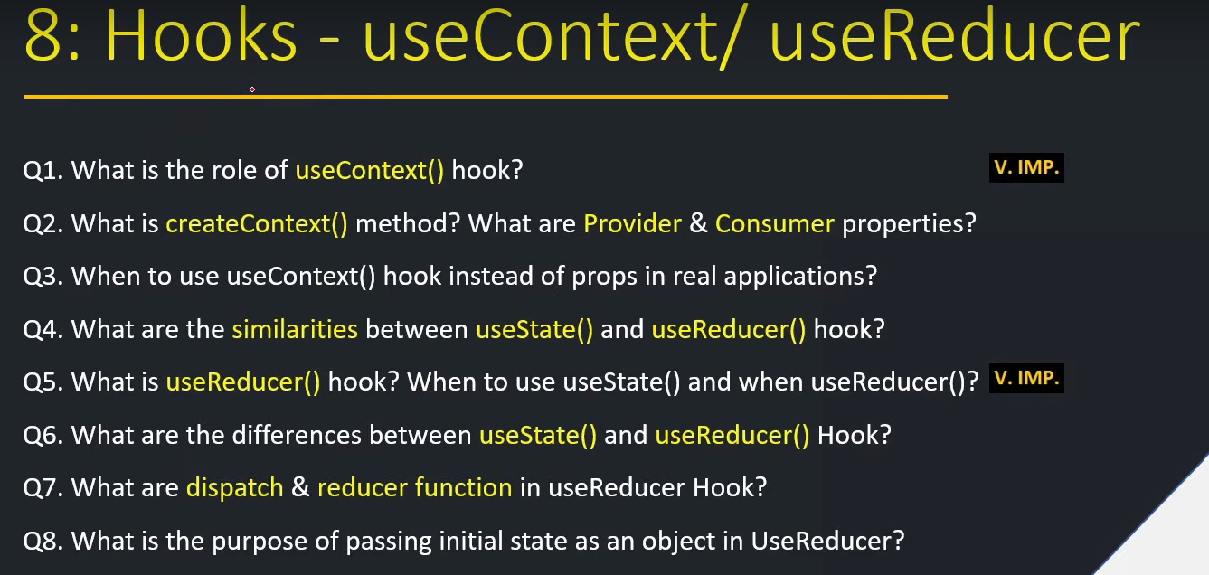

1. **What is the role of useContaxt() hook?[v.imp.]**

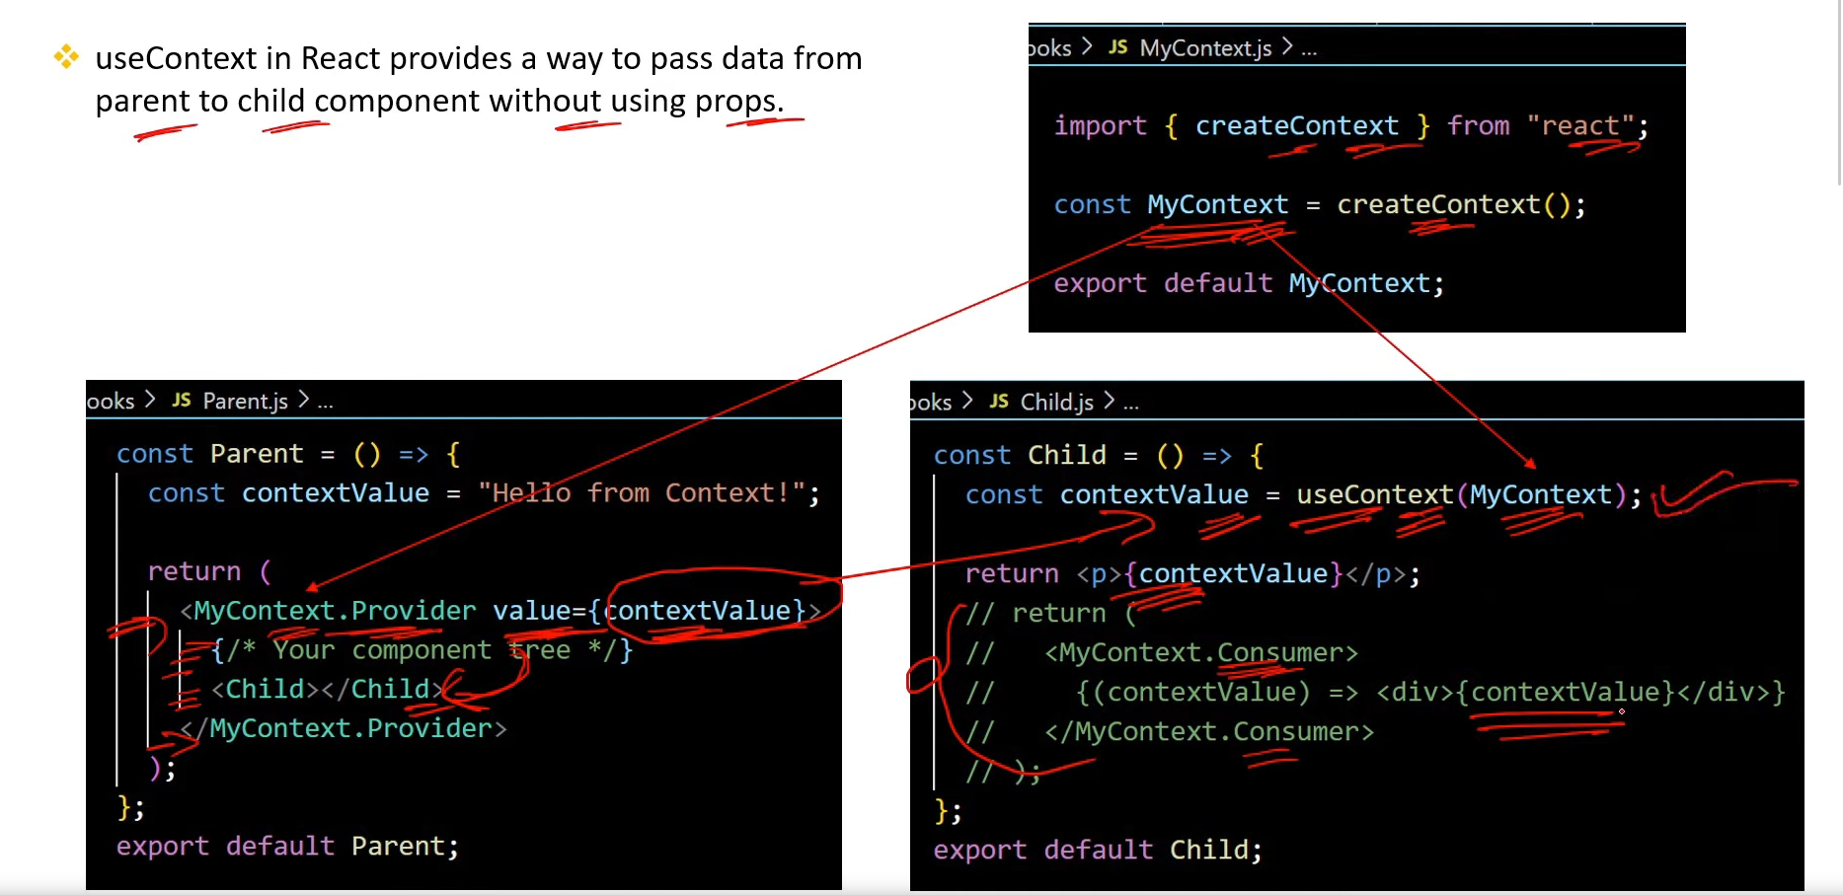

1. **What is createContext() method? What are Provider & Consumer properties?**

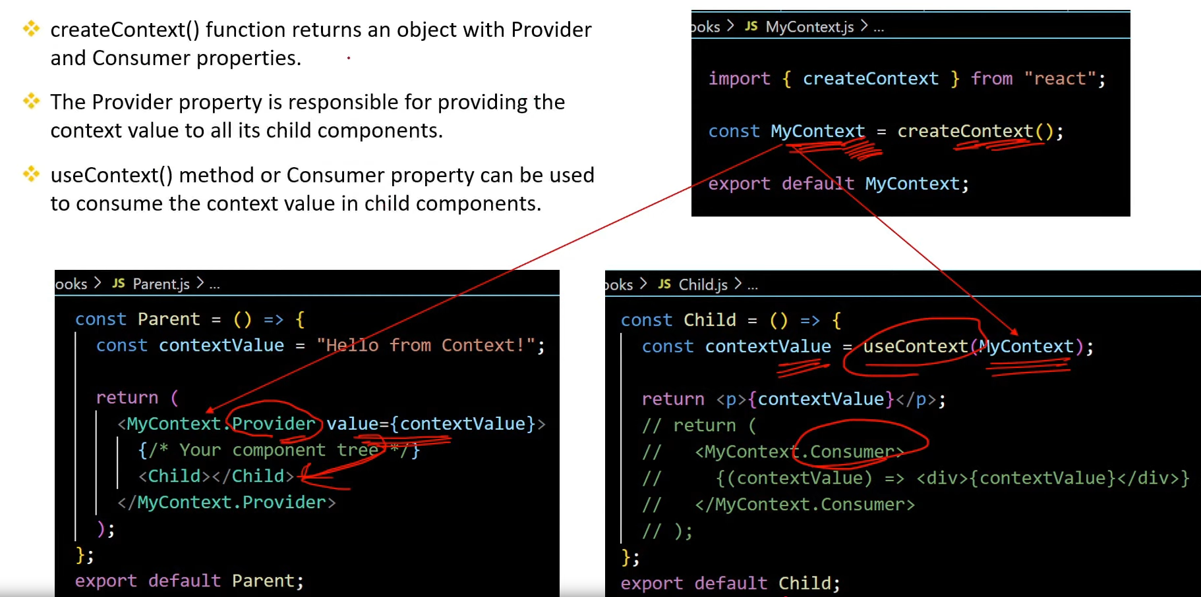

1. **When to use useContext() hook instead of props in real applications?**

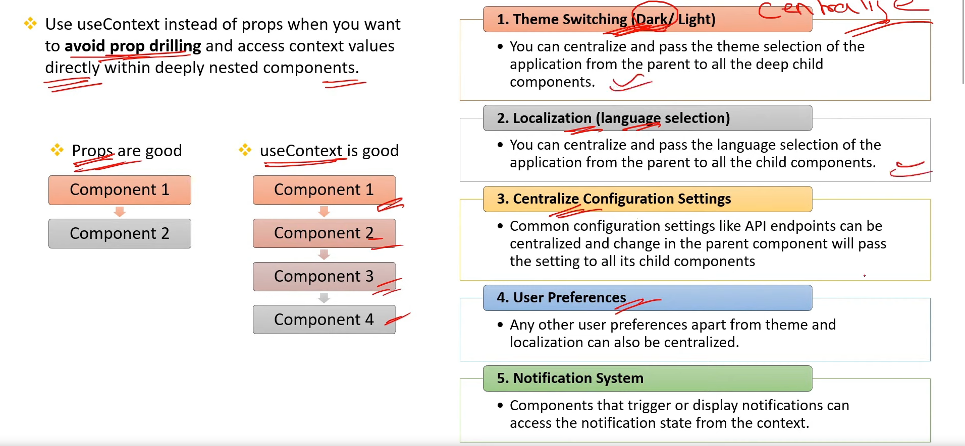

1. **What are the similarities between useState() and useReducer() hook?**

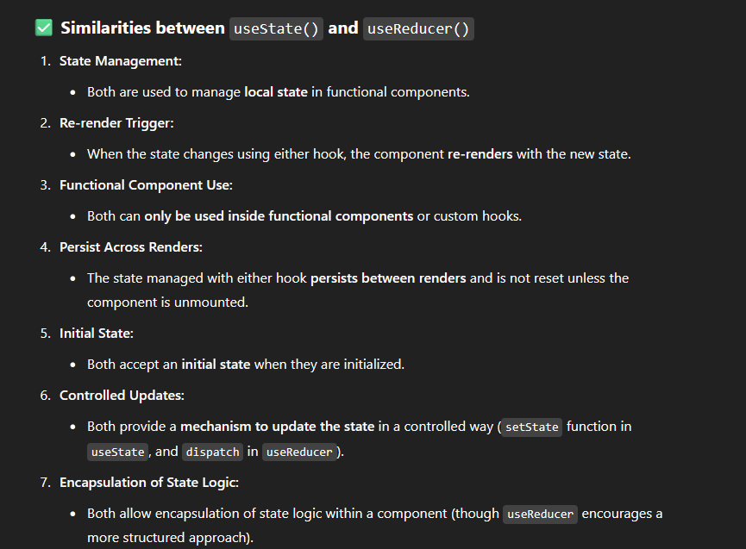

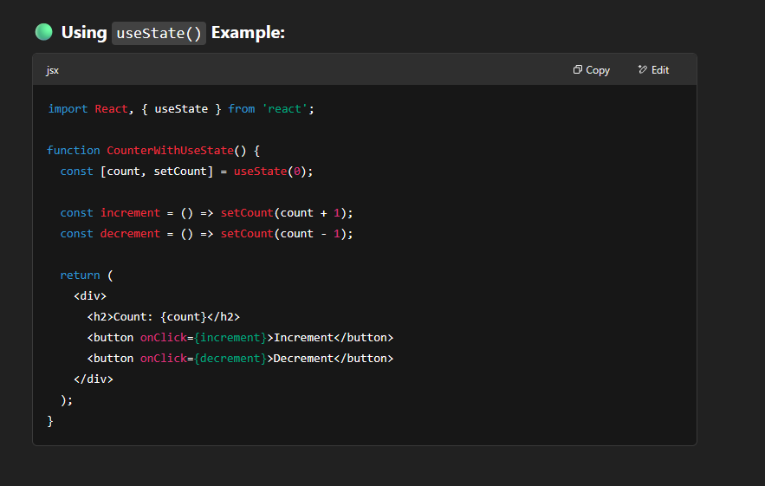

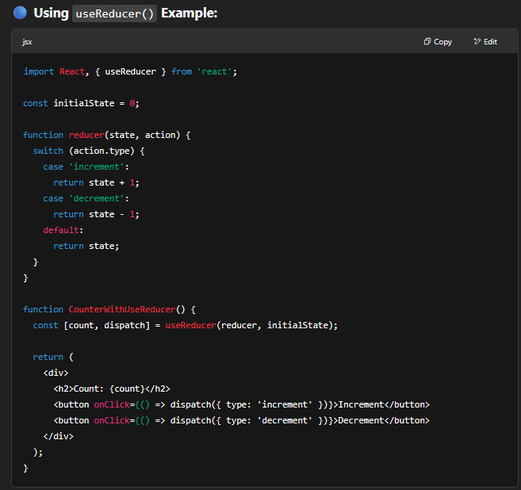

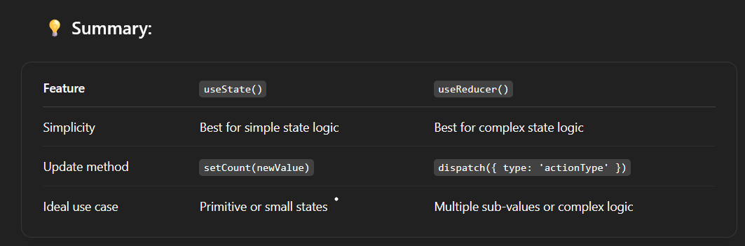

1. **What is useReducer() hook? When to use useState() and when useReducer()? [V. IMP.]**

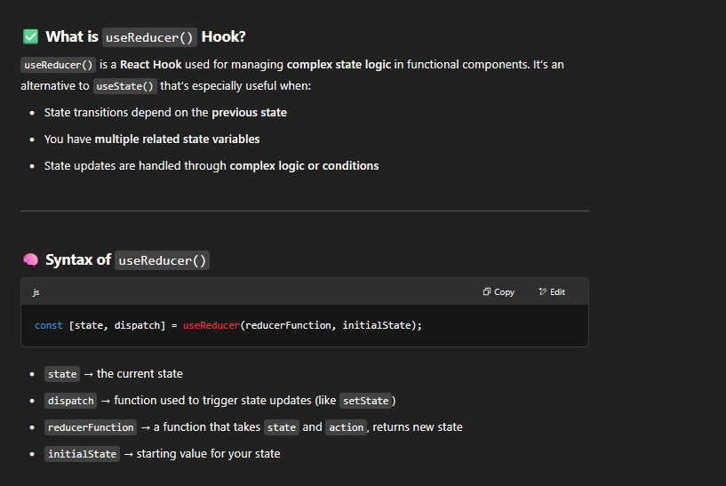

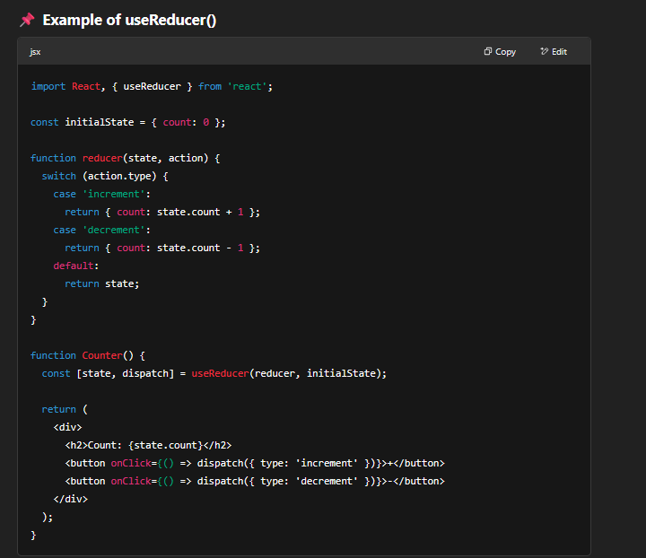

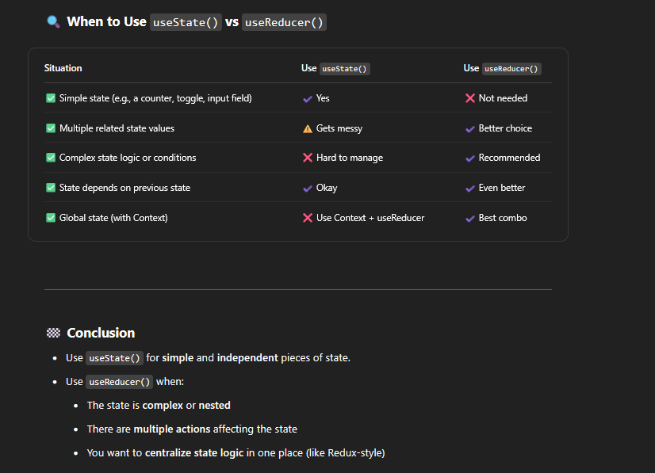

1. **What are the differences between useState() and useReducer() Hook?** 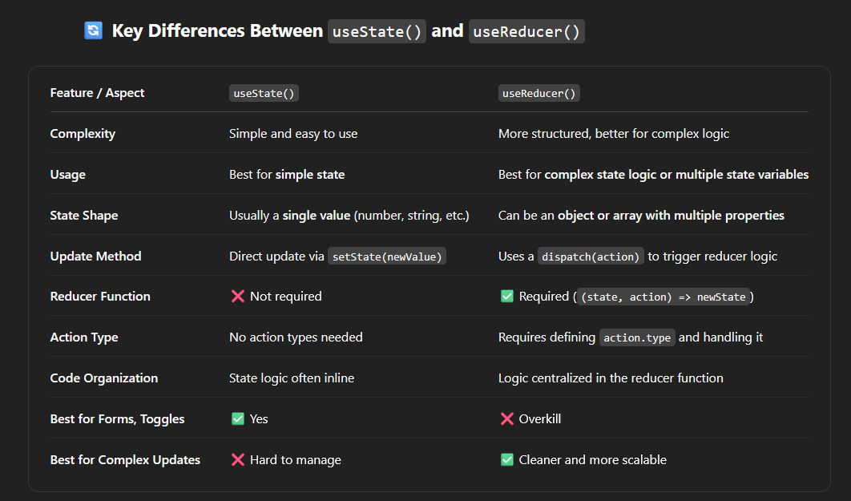
2. **What are dispatch & reducer function in useReducer Hook?**

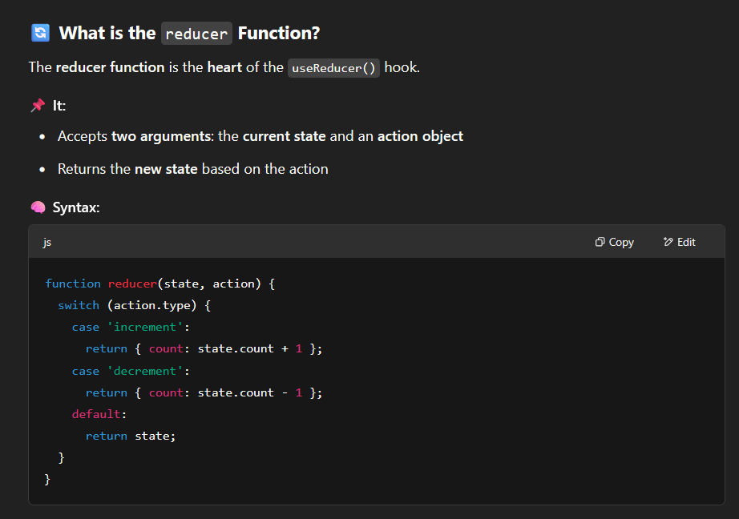

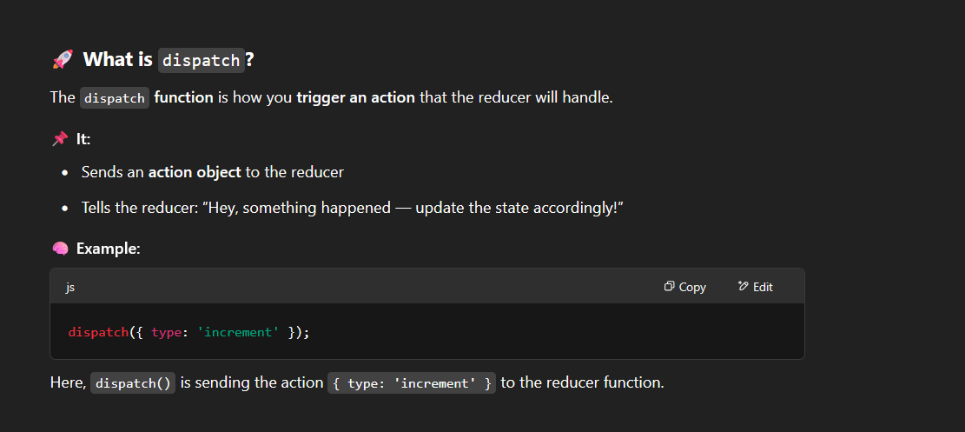

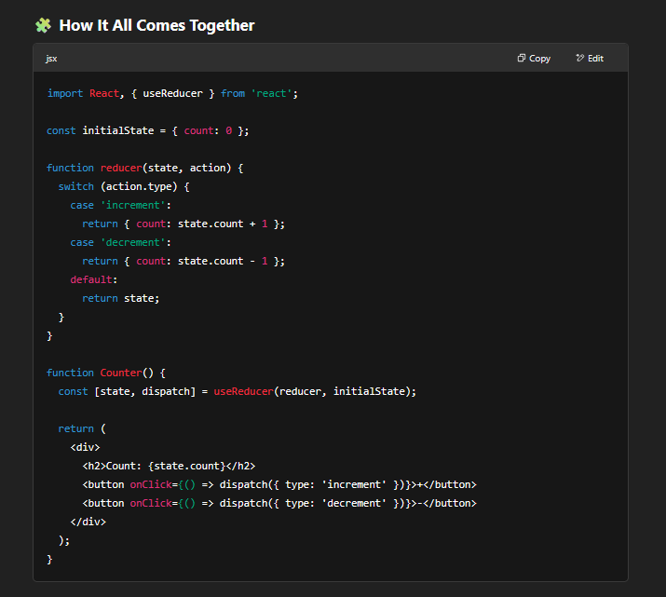

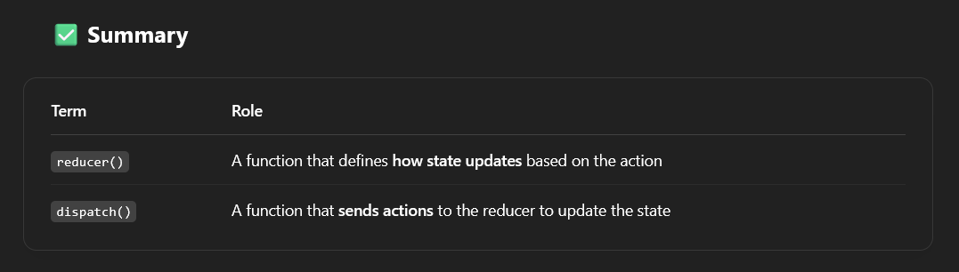

1. **What is the purpose of passing initial state as an object in UseReducer?**

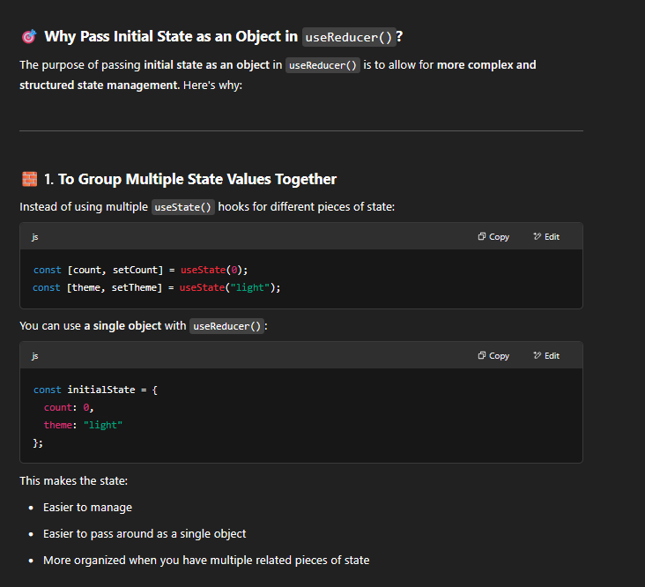

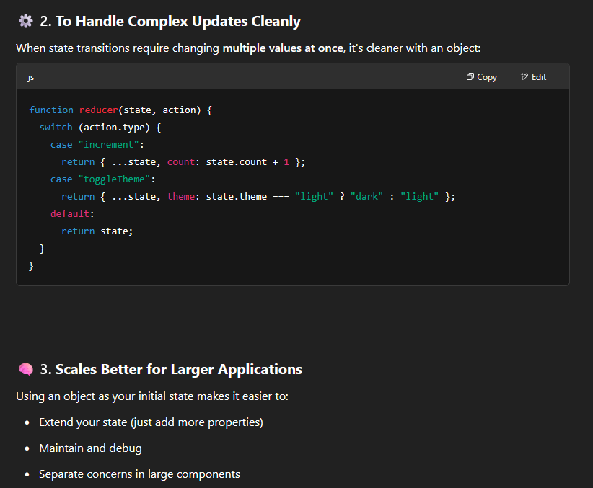

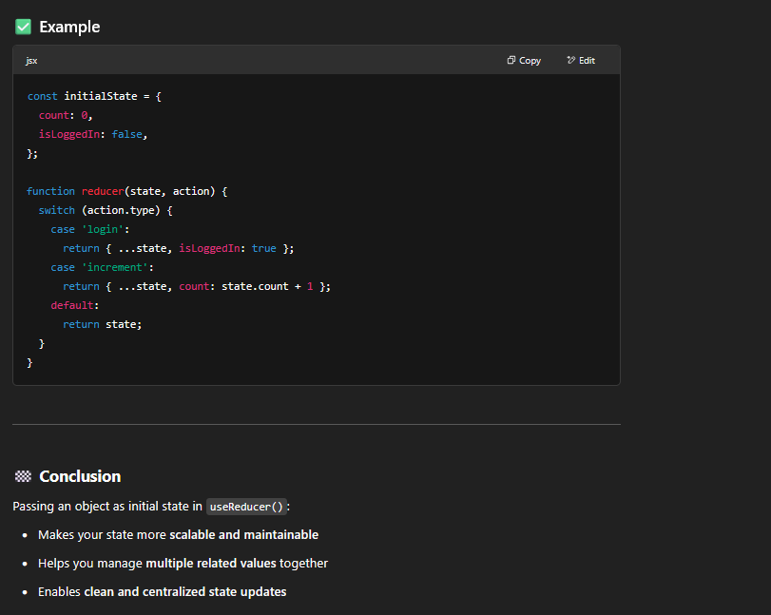

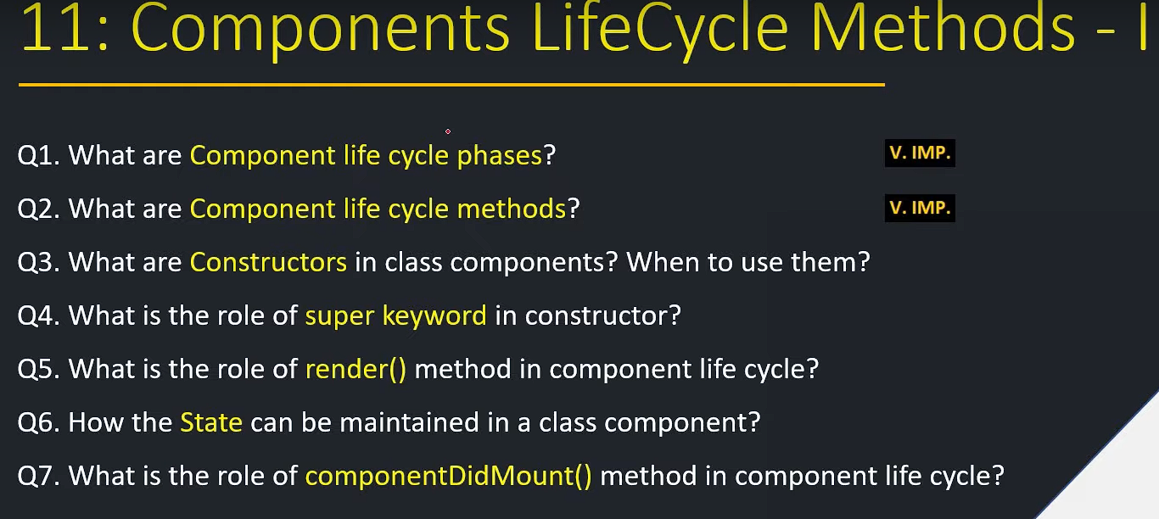

1. **What are component life cycle phases?**

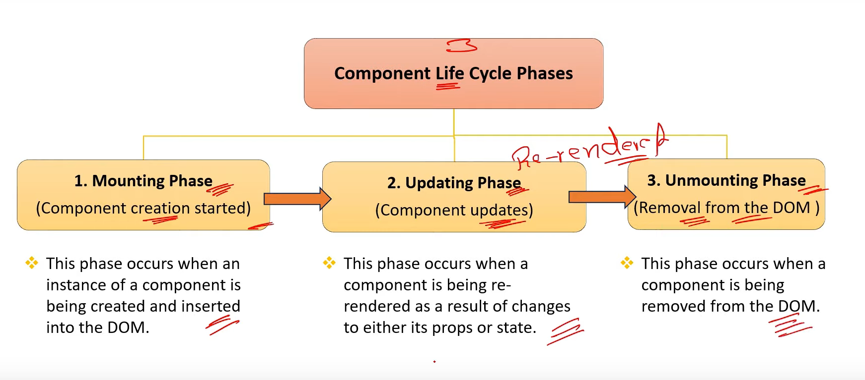

1. **What are component life cycle methods?**

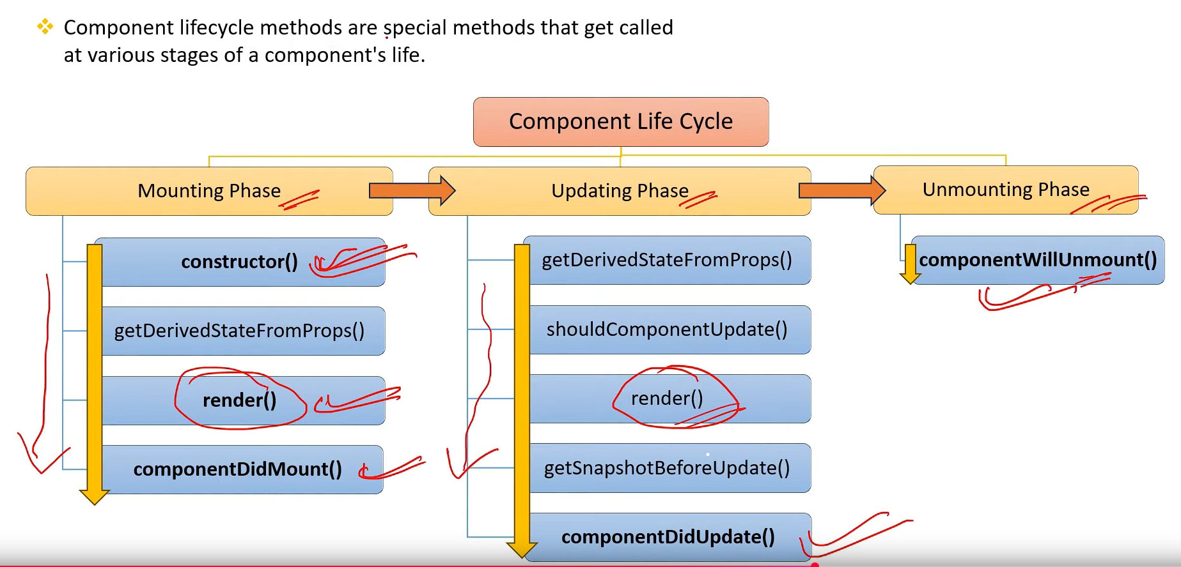

1. **What are constructors in class components ? When to use them?**

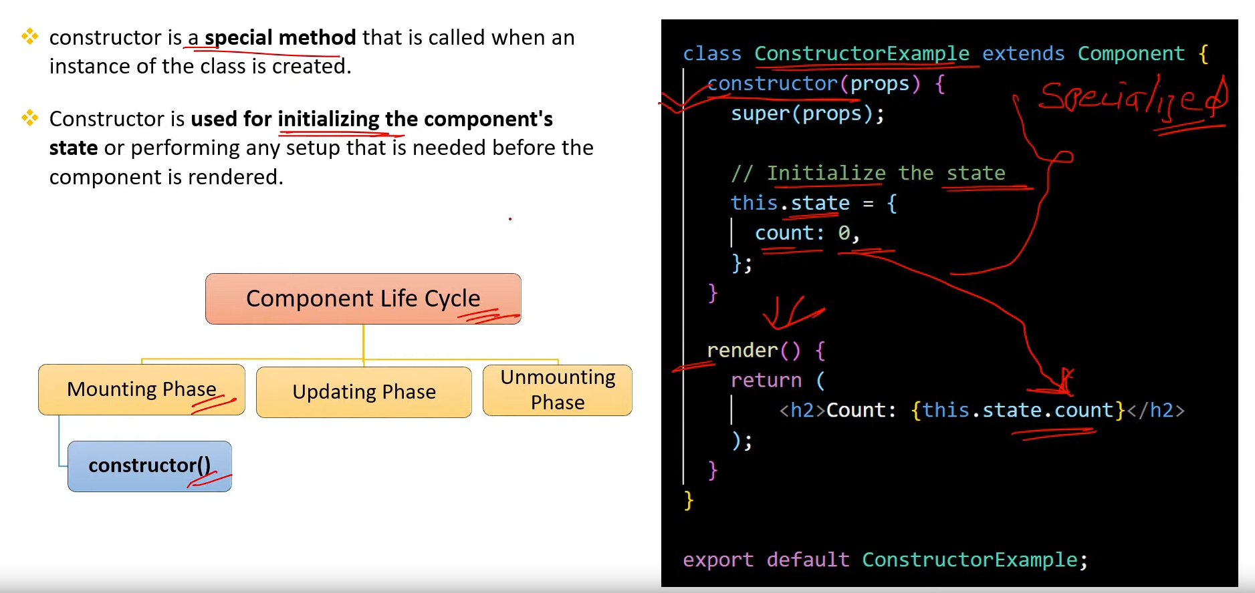

1. **What is the role of super keyword in constructor? when to use them?**

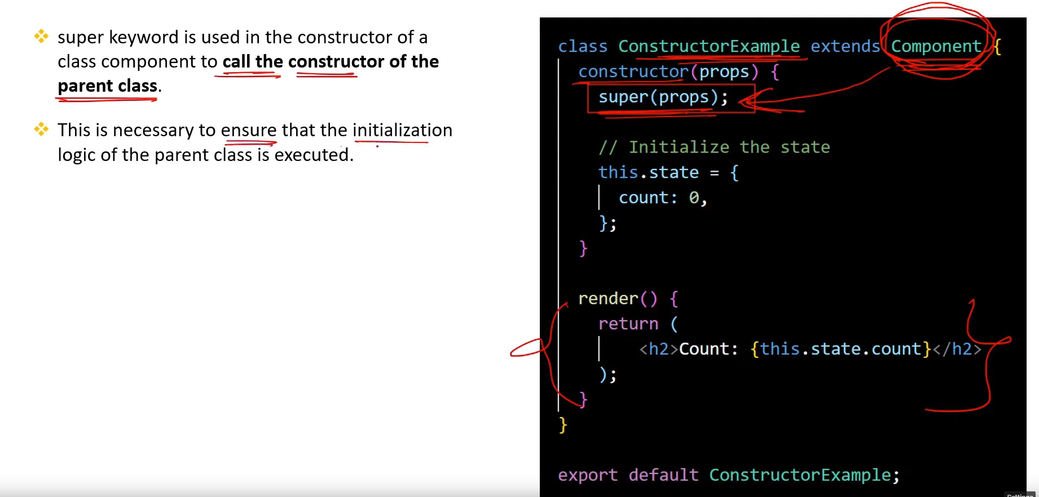

1. **What is the role of render() method in component life cycle?**

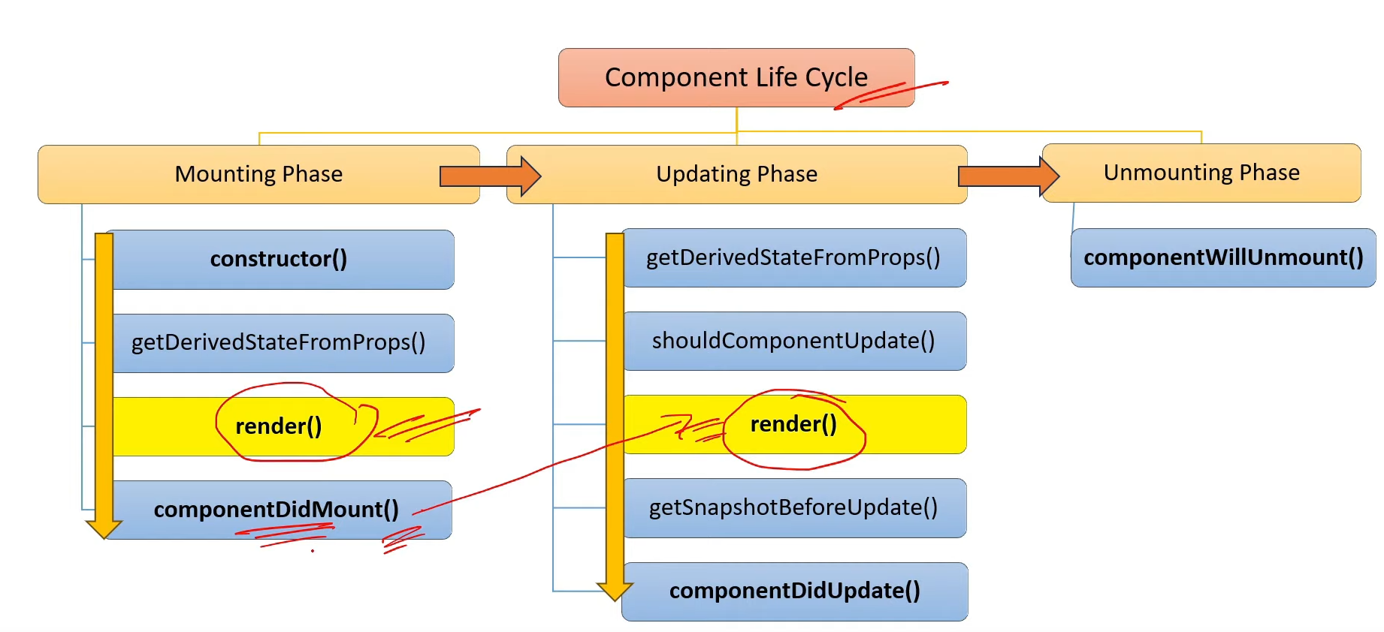

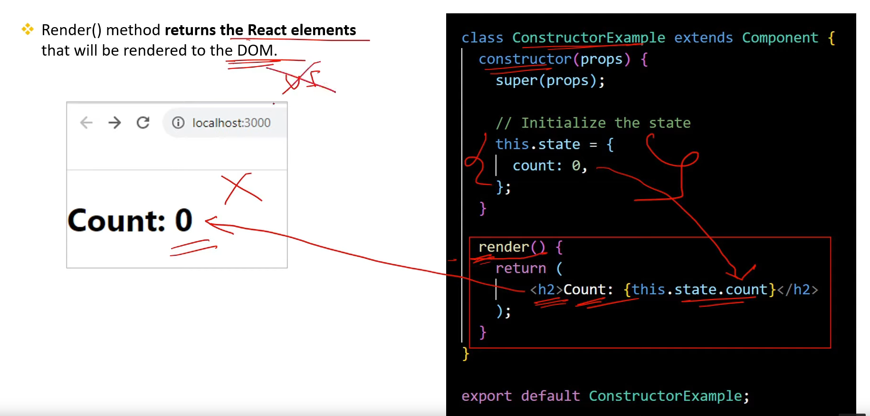

1. **How the state can be maintained in a class component? [v.imp.]**

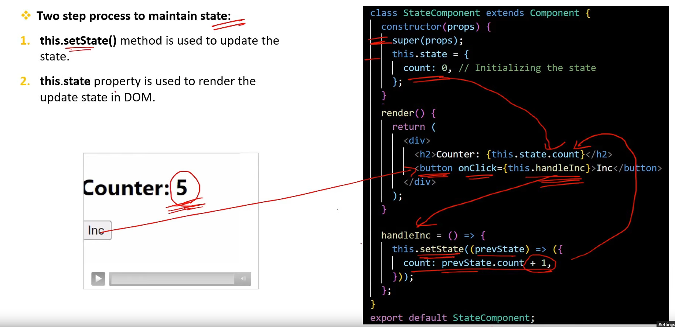

1. **What is the role of componentDidMount() method in component life cycle?**

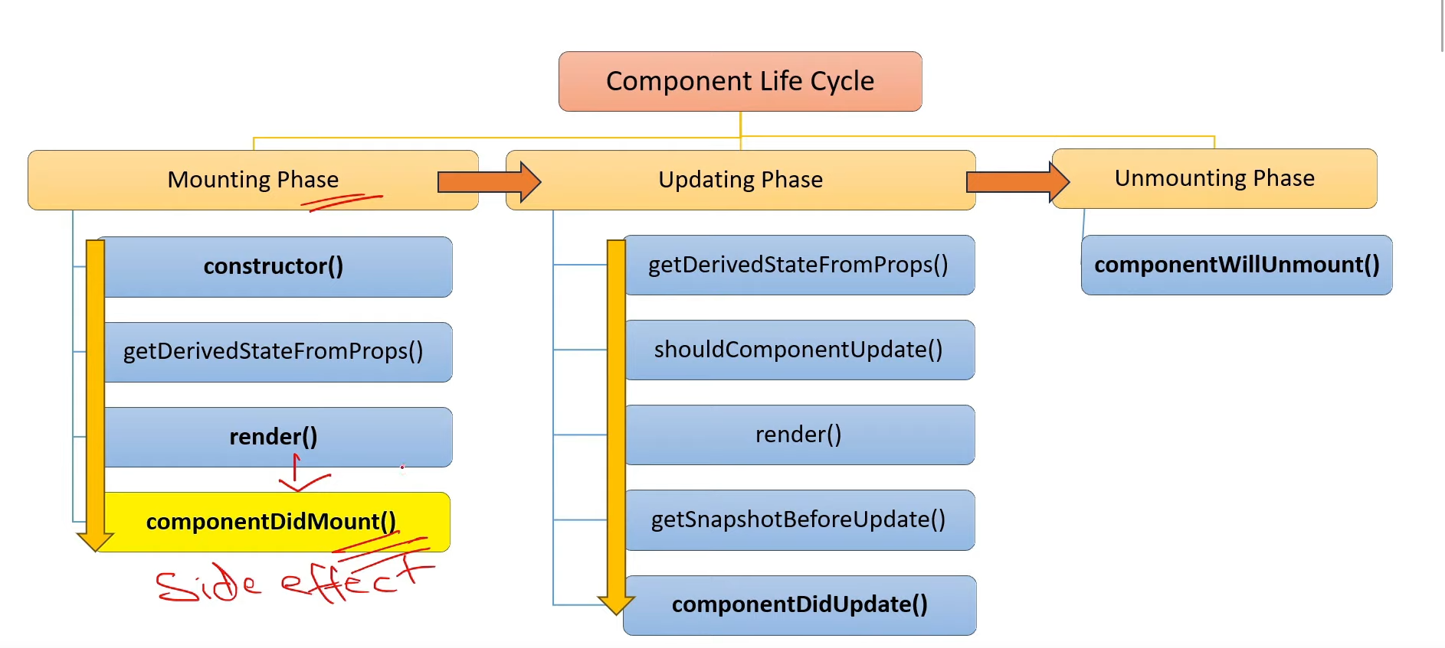

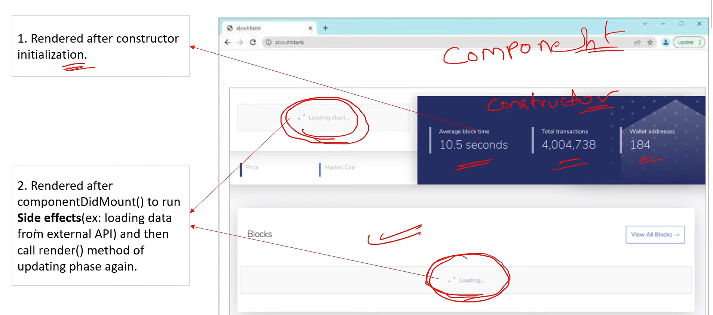

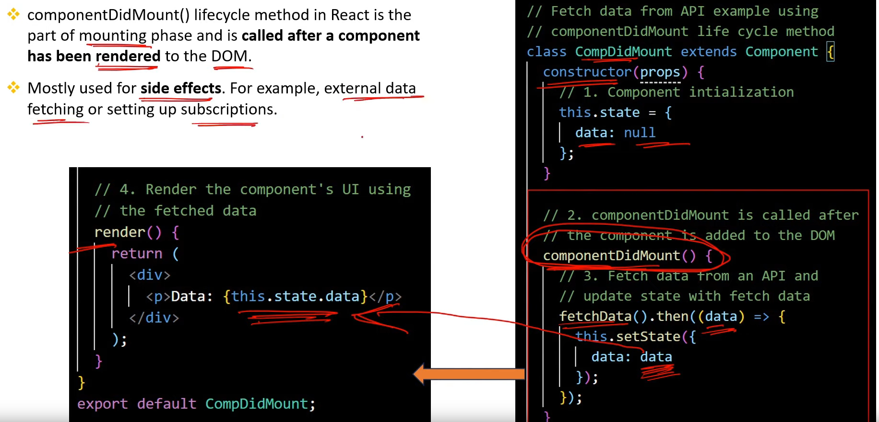

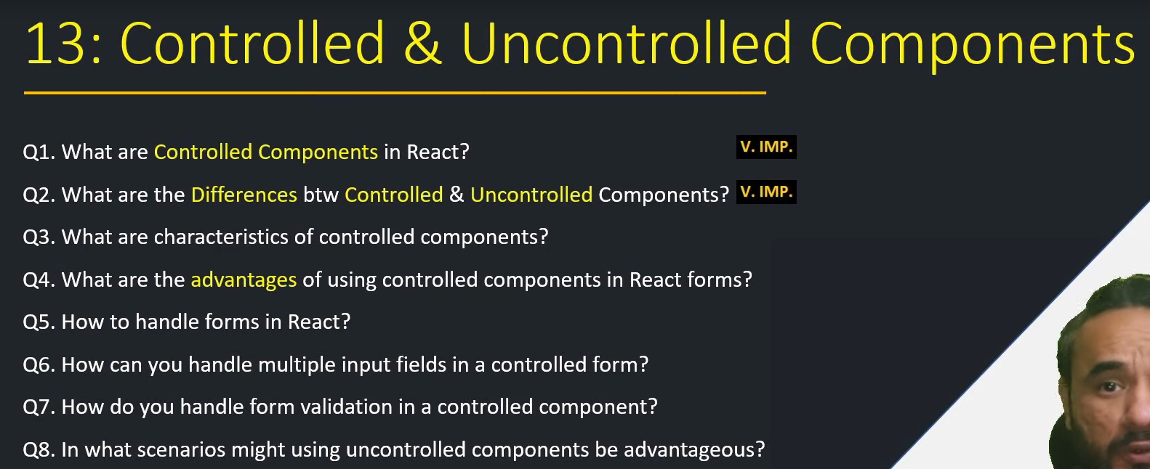

1. **What are Controlled Components in React?[v.imp.]**

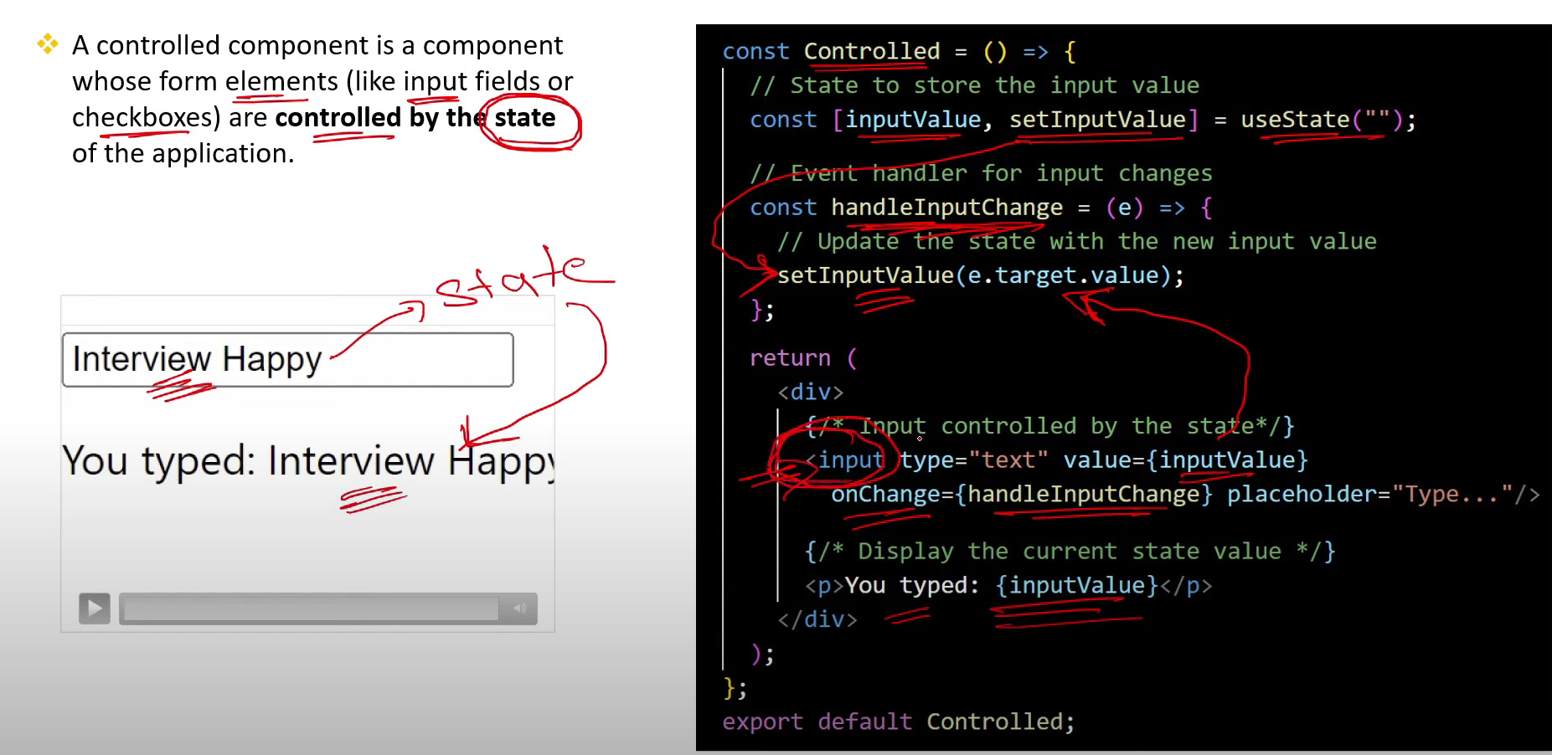

1. **What are the Differences btw Controlled & Uncontrolled Components?[v.imp.]**

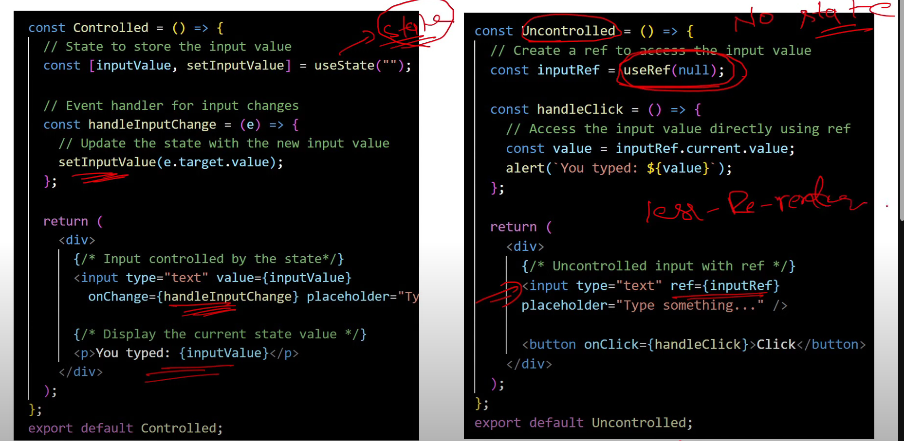

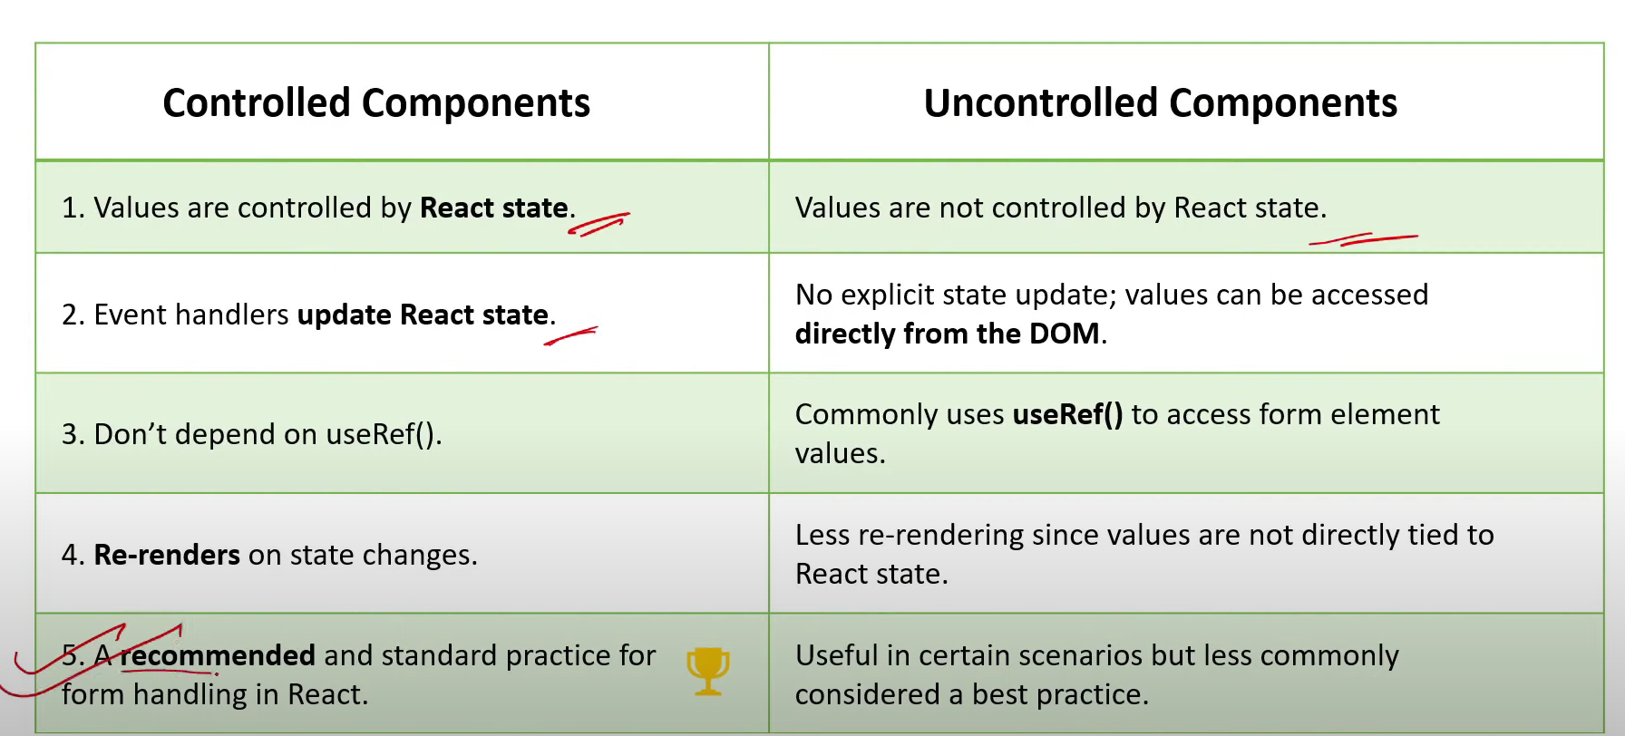

1. **What are characteristics of controlled components?**

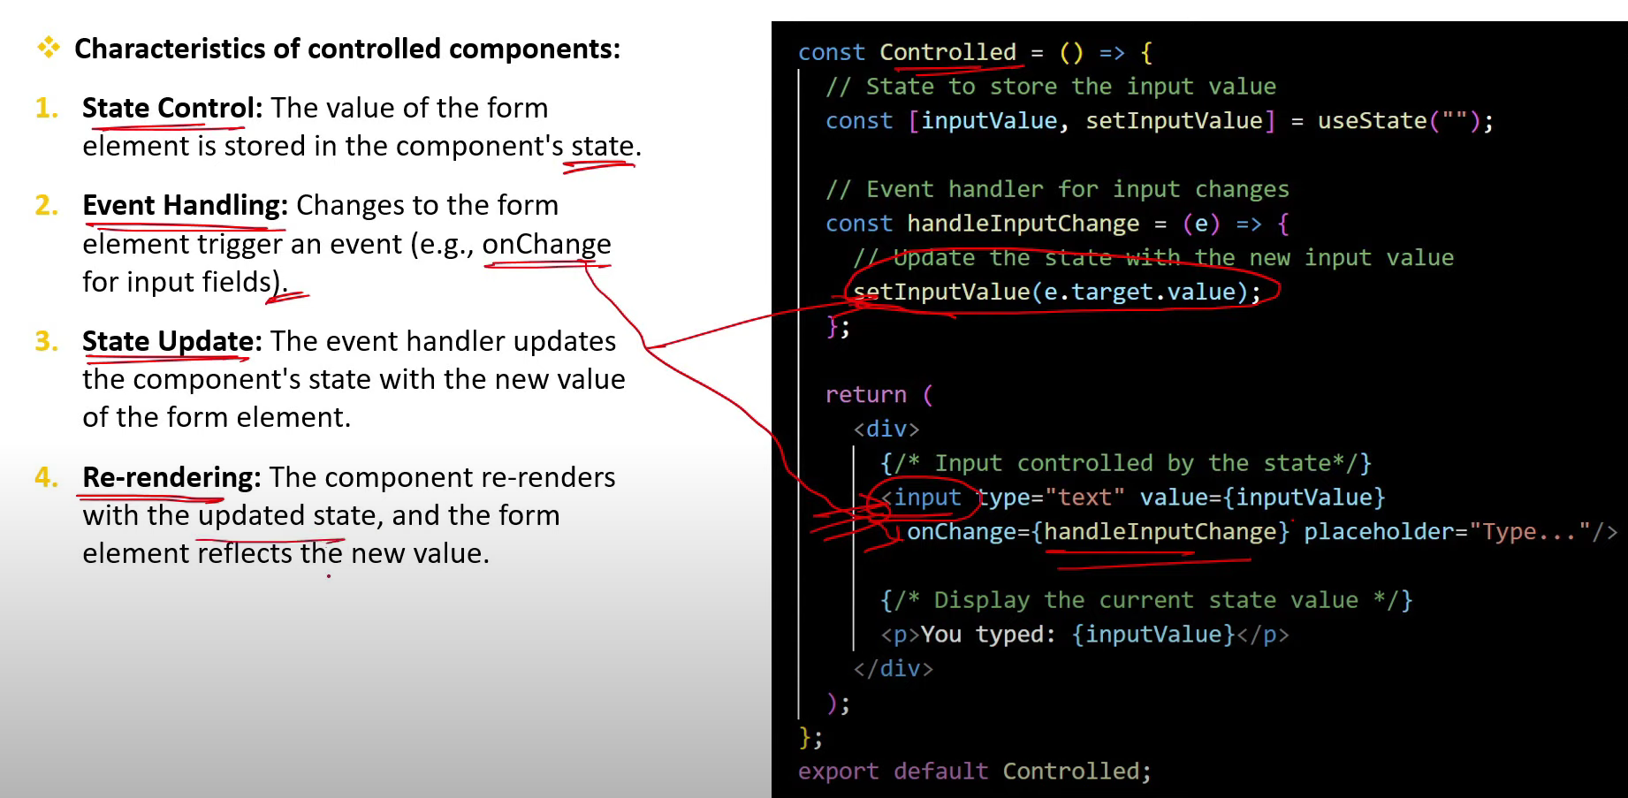

1. **What are the advantages of using controlled components in React forms?**

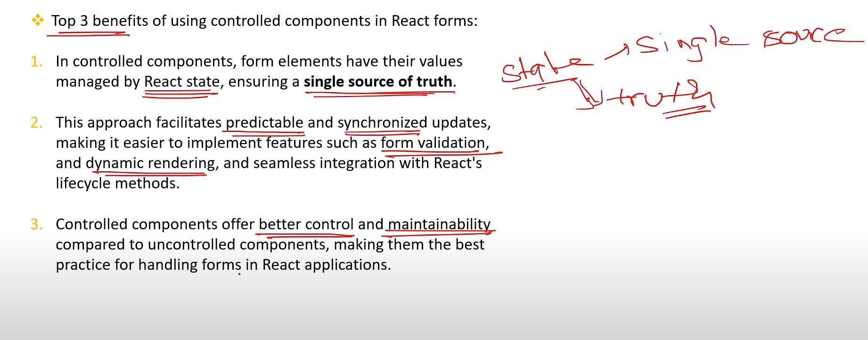

1. **How to handle forms in React?**

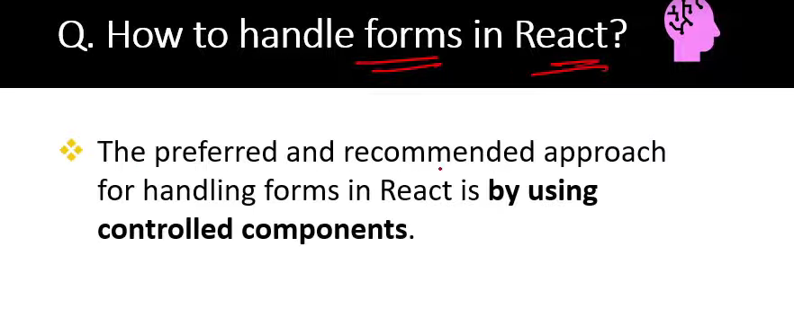

1. **How can you handle multiple input fields in a controlled form?**

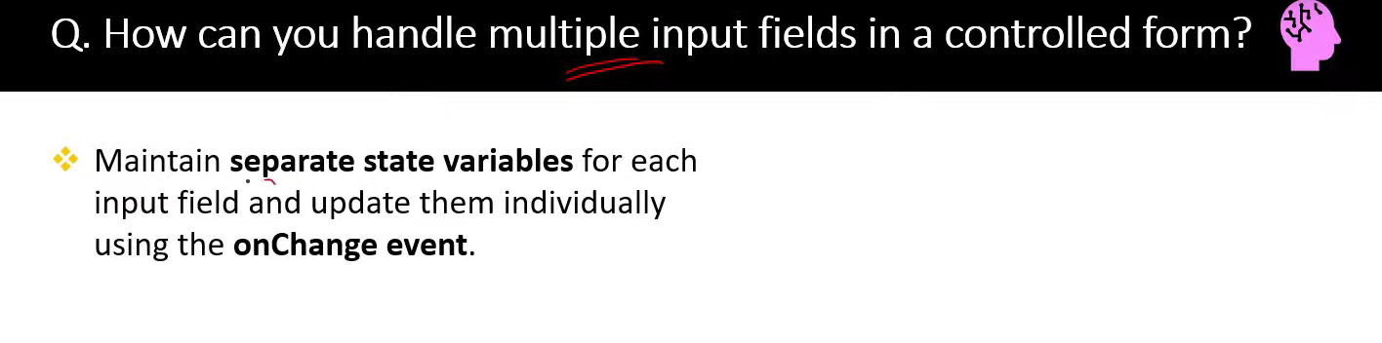

1. **How do you handle form validation in a controlled component?**

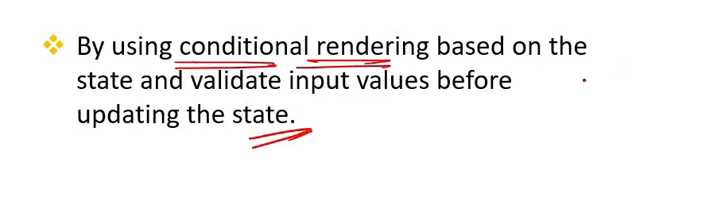

1. **In what scenarios might using uncontrolled components be advantageous?**

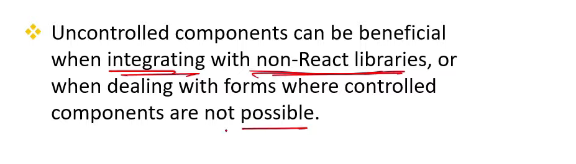

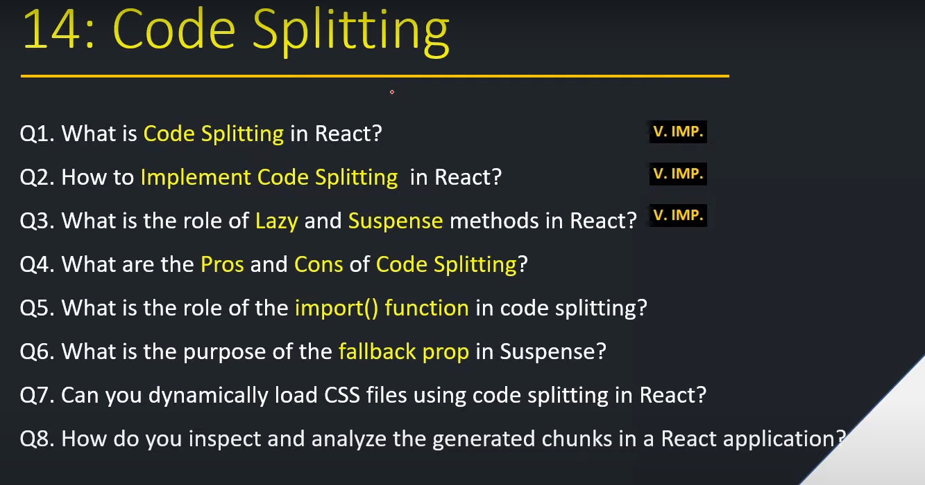

1. **What is code splitting in React?[v.imp.]**

**This is very Importent terms from the performance point of view.**

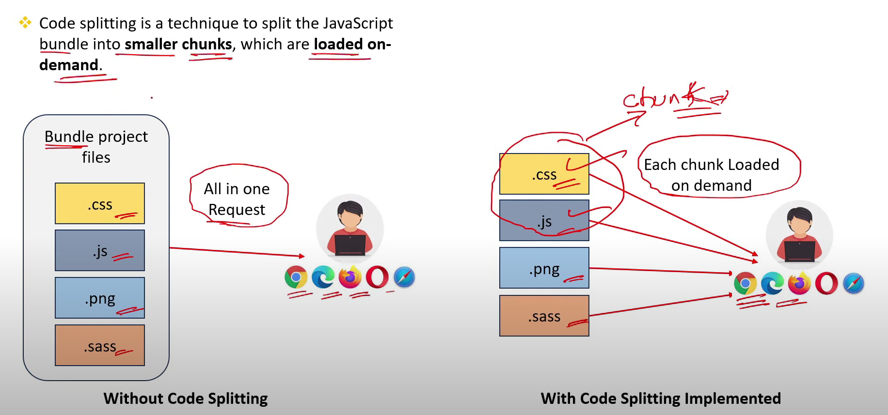

1. **How to implement code splitting in React?[v.imp]**

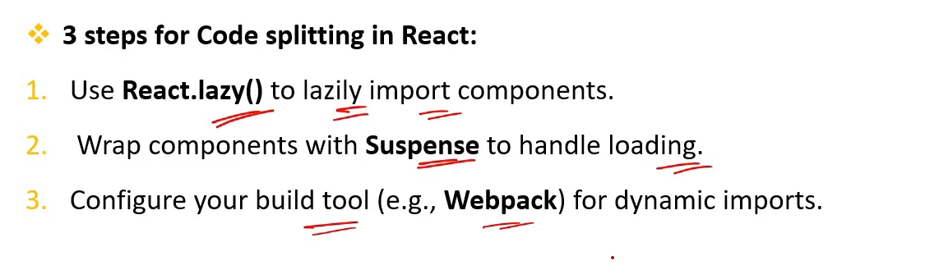

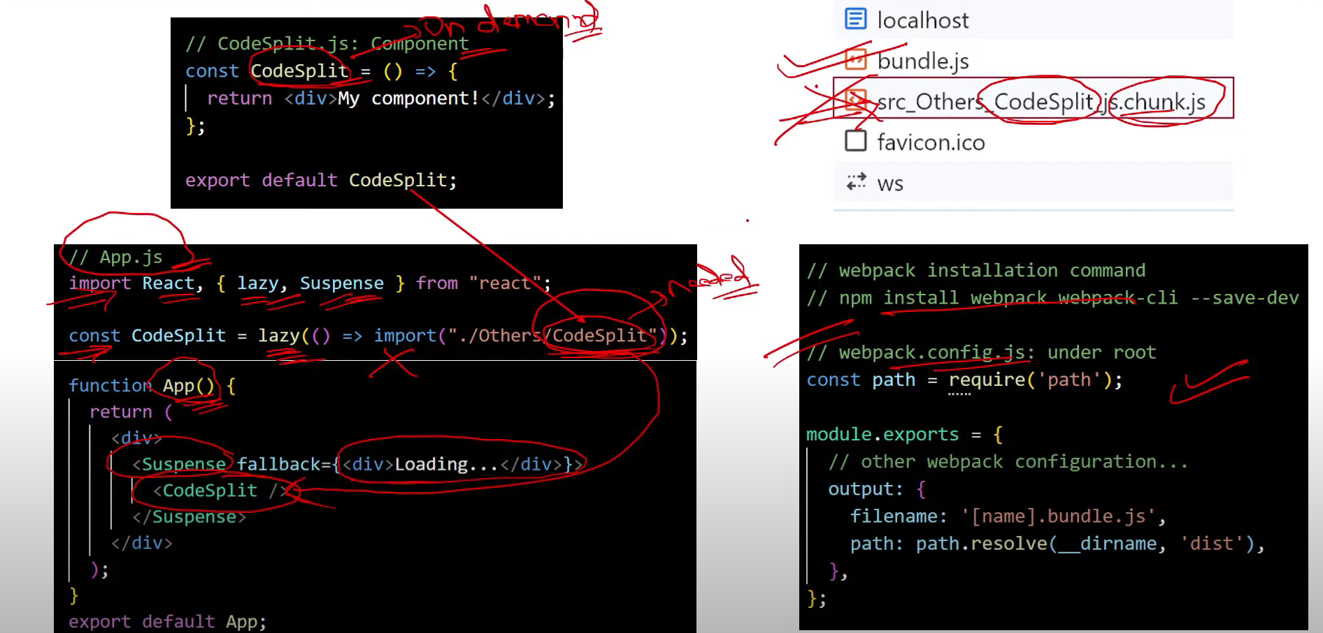

1. **What is the role of Lazy & Suspense methods in React?[v.imp.]**

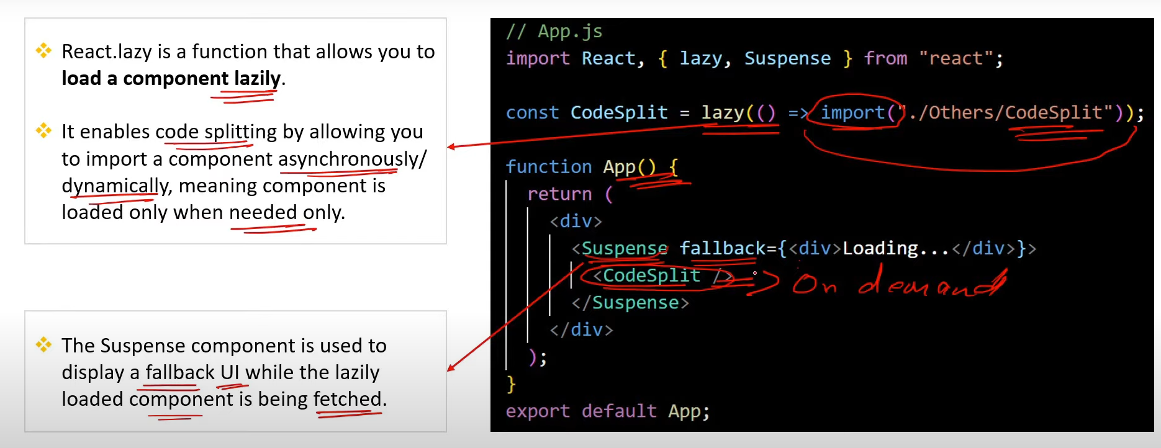

1. **What are the Pros & Cons of code splitting?**

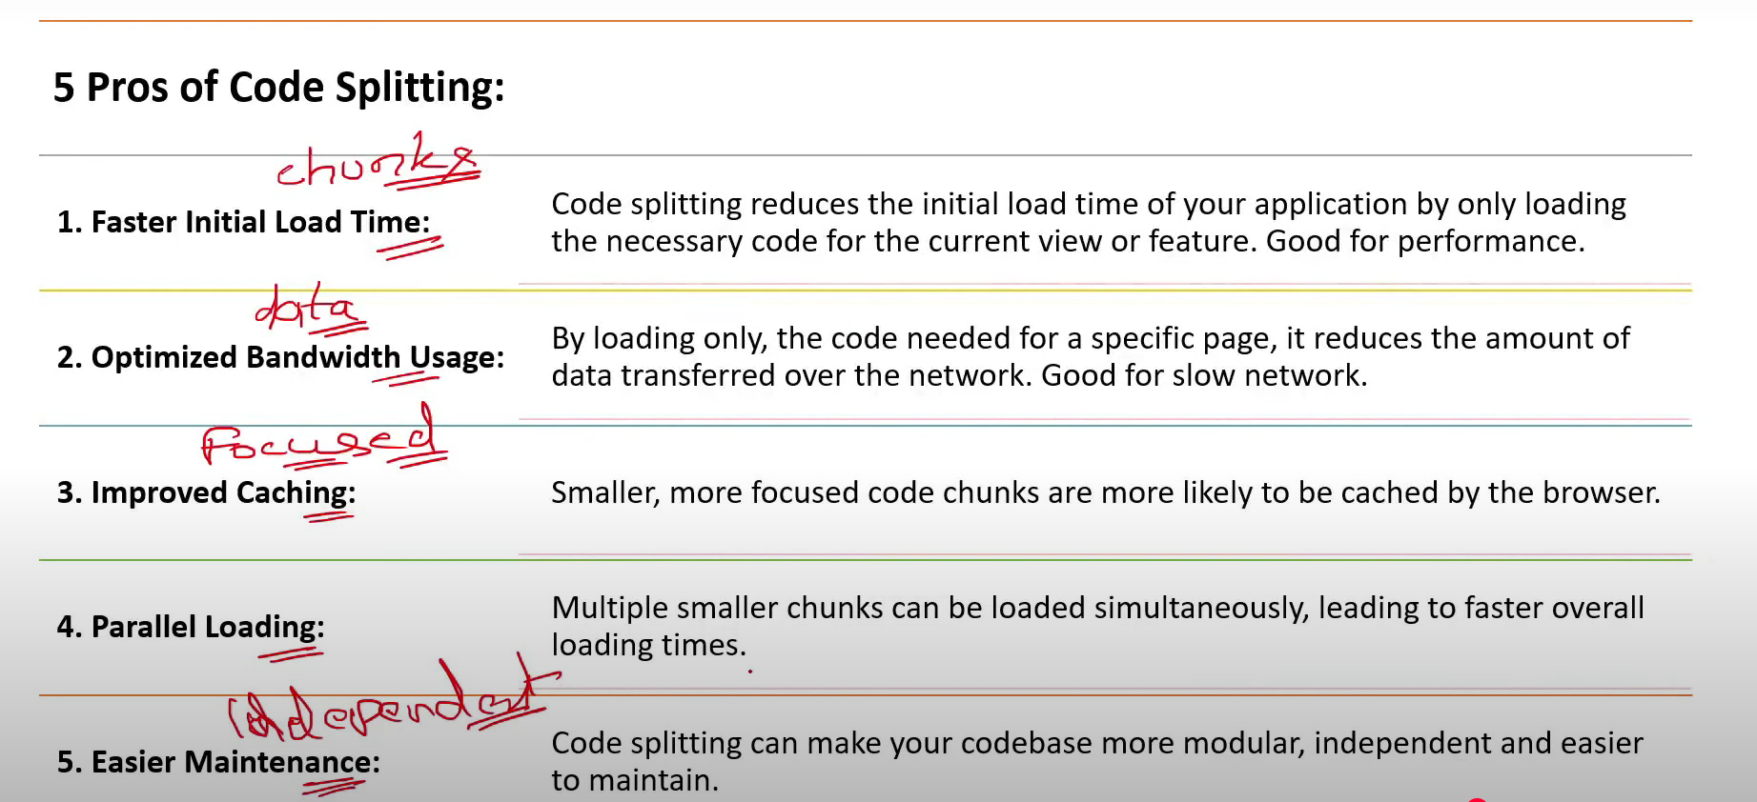

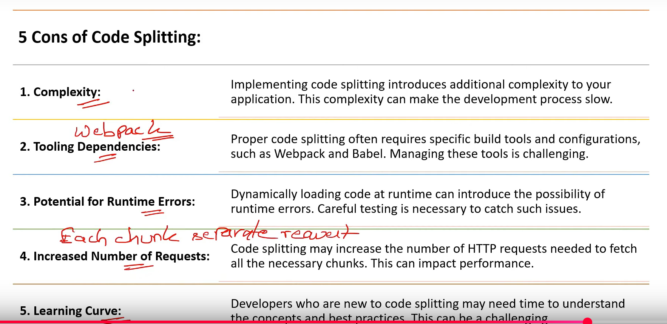

1. **What is the role of the import function in code splitting?**

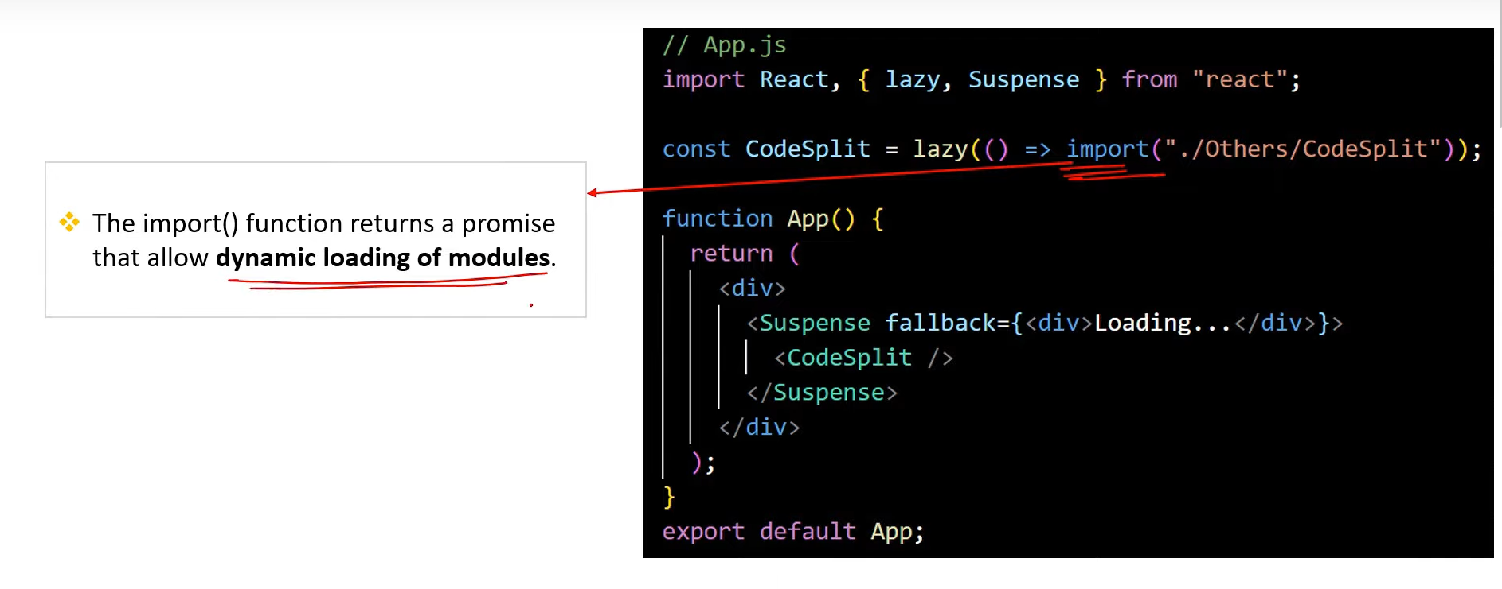

1. **What is the purpose of the fallback prop in suspense?**

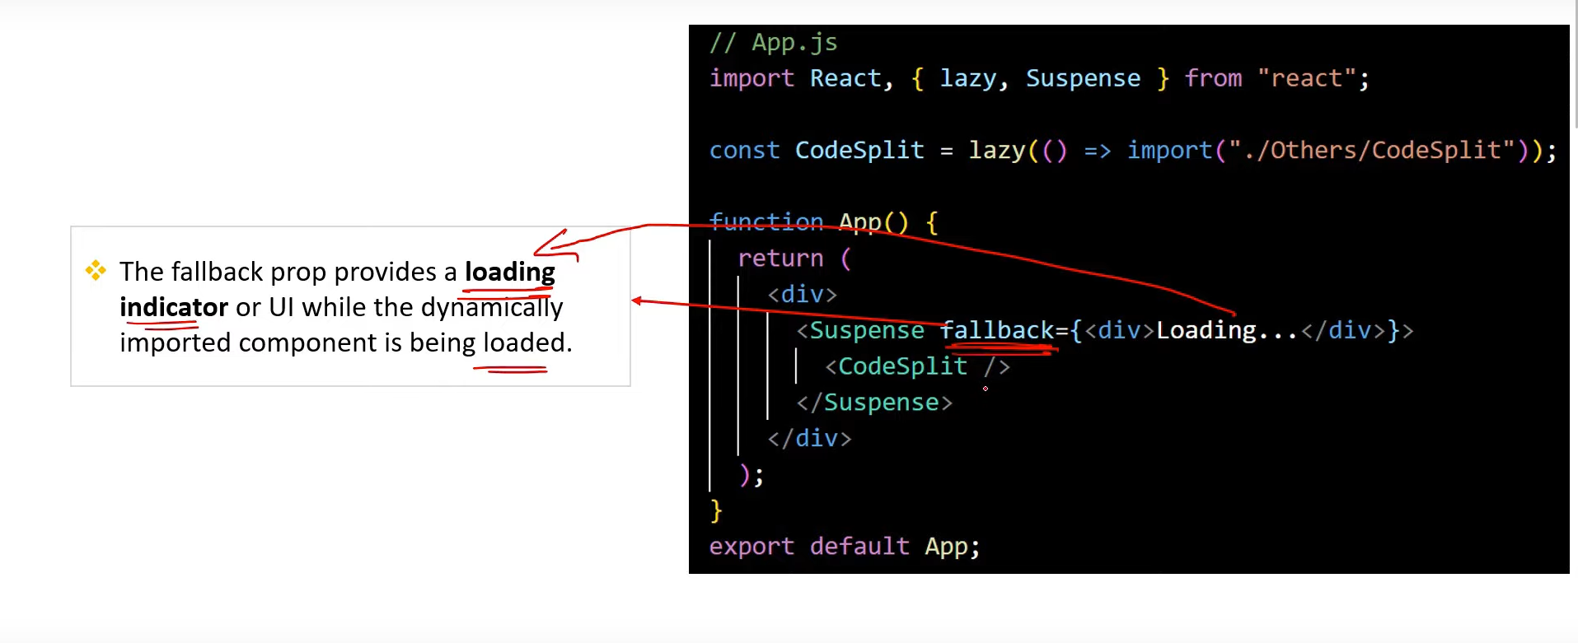

1. **Can you dynamically load css files using code splitting in React?**

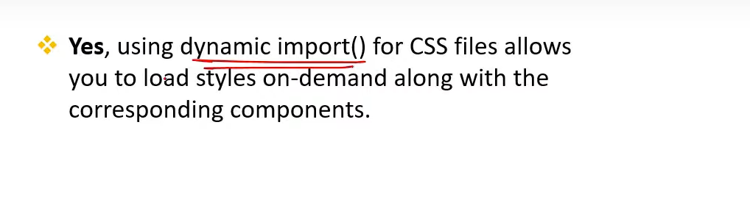

1. **How do you inspect & analyze the generated chunks in React application?**

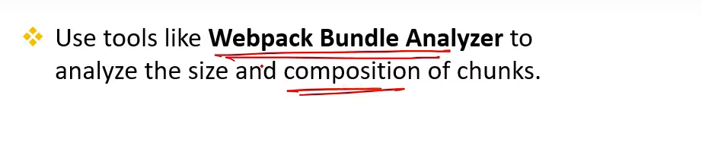

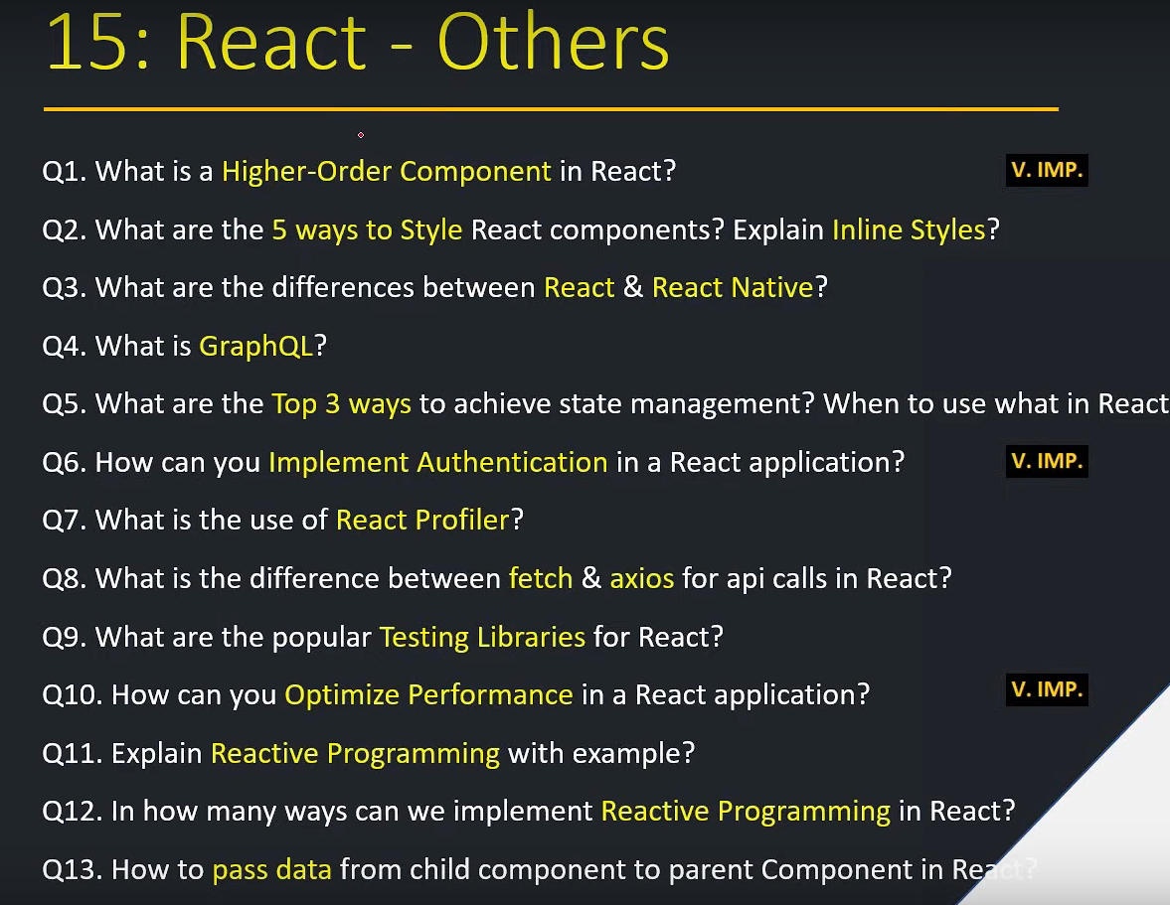

1. **What is a higher-order component in React?[v.imp.]**

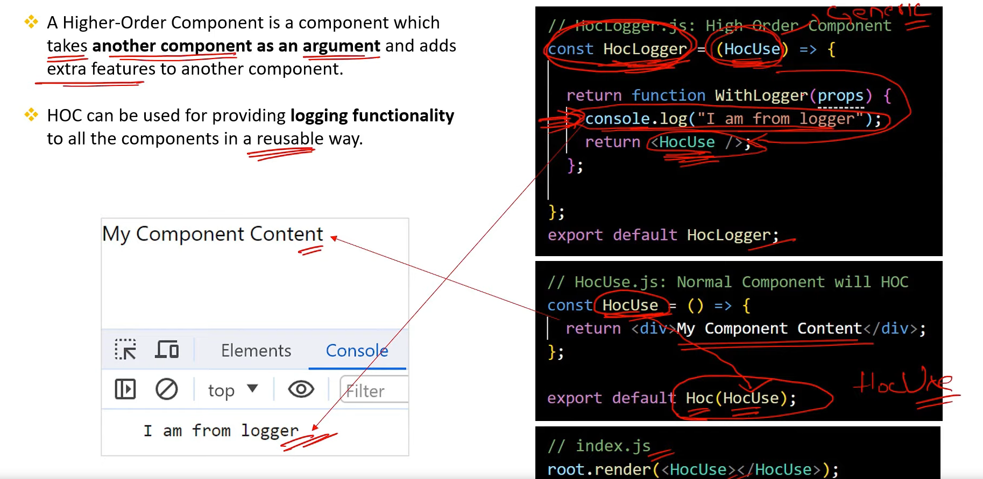

1. **What are the 5 Ways to Style React components ? Explain inline styles?**

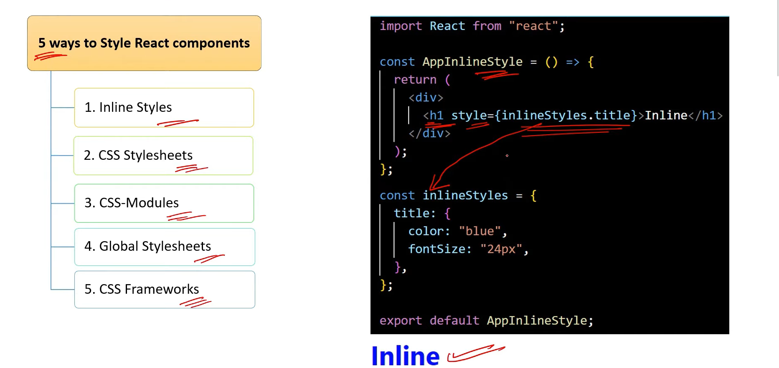

1. **What are the difference between React & React Native?**

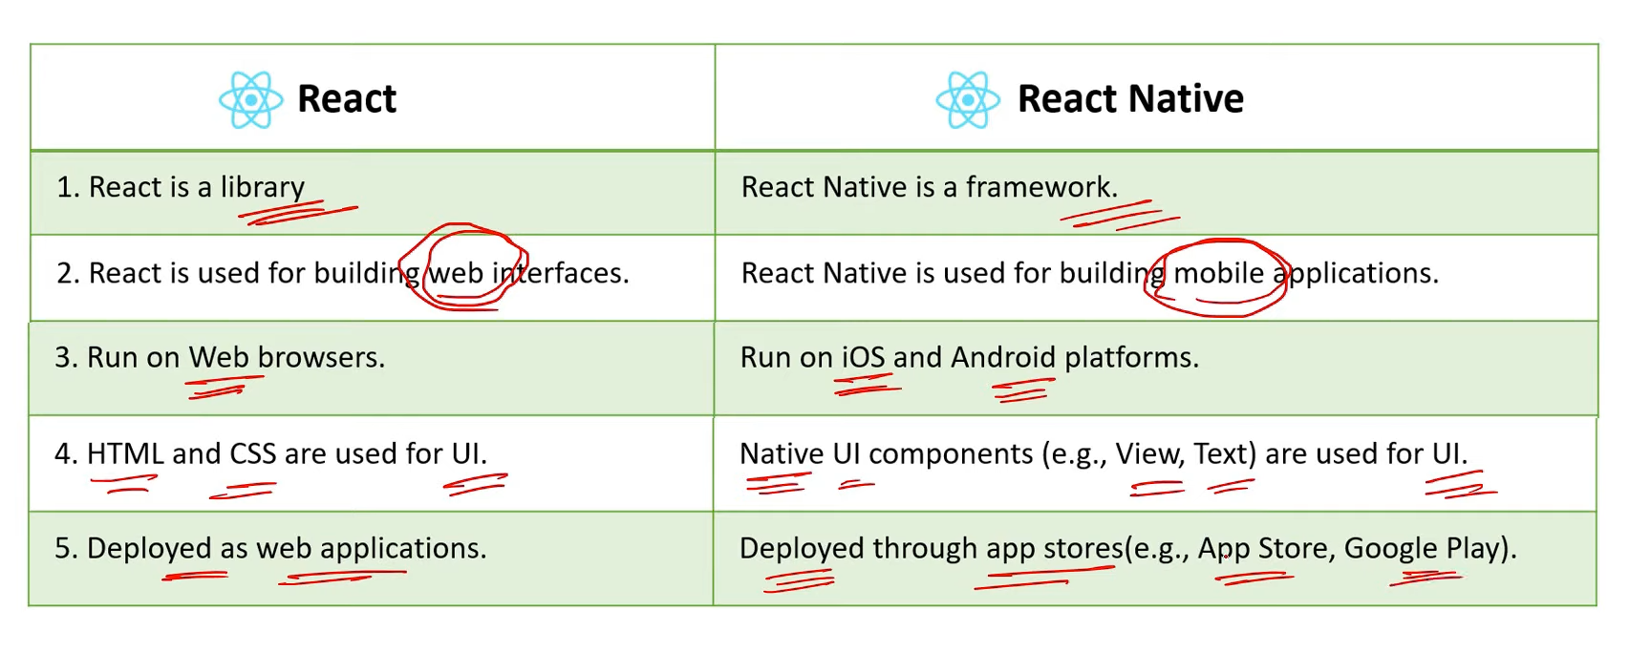

1. **What is GraphQL?**

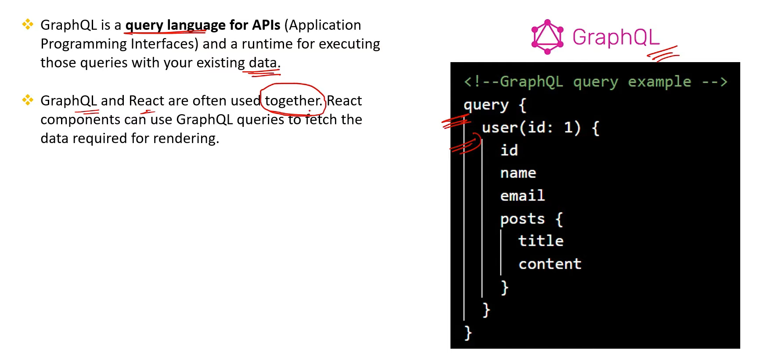

1. **What are the Top 3 ways to achieve state management? when to use what in React?**

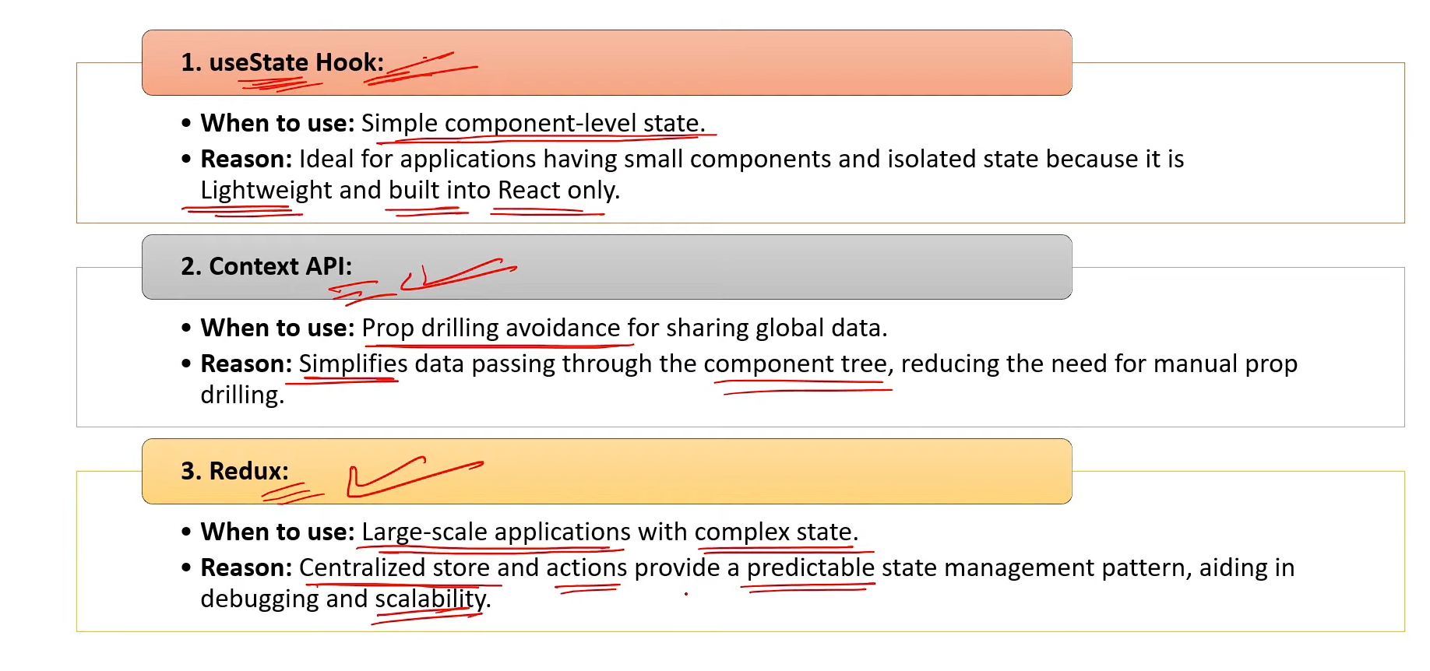

1. **How can you implement authentication in a React application?[v.imp.]**

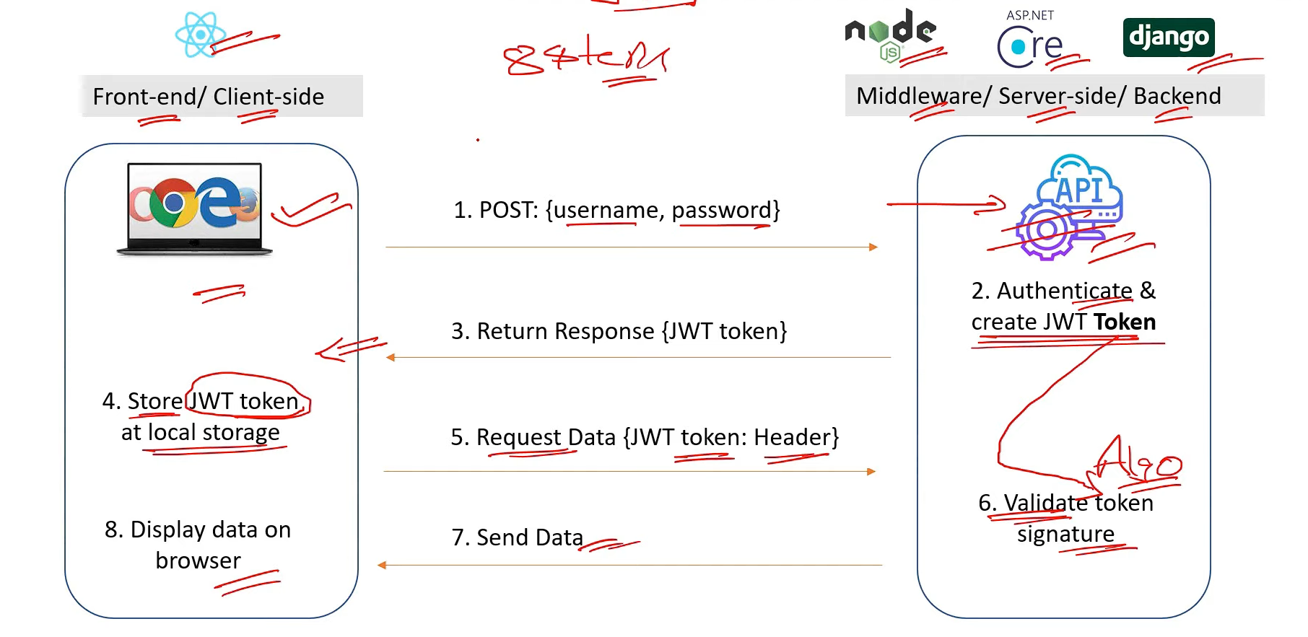

1. **What is the use of React Profiler?**

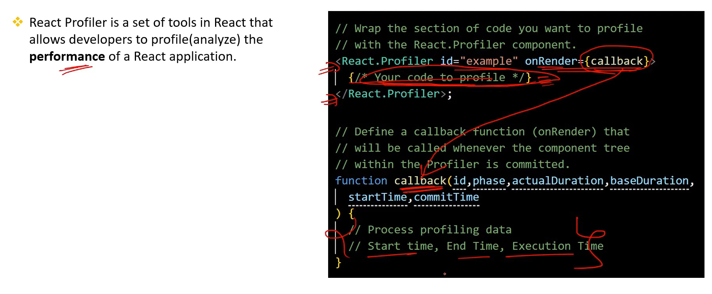

**100.What is the difference between Fetch & Axios for API calls in React?**

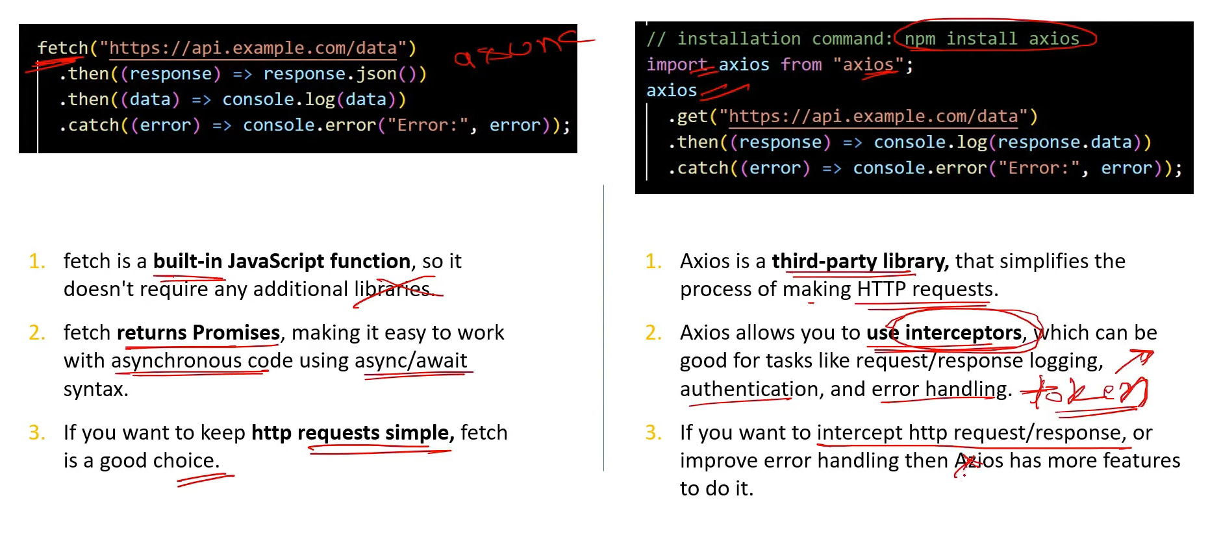

**101.What are the popular Testing Libraries for React?**

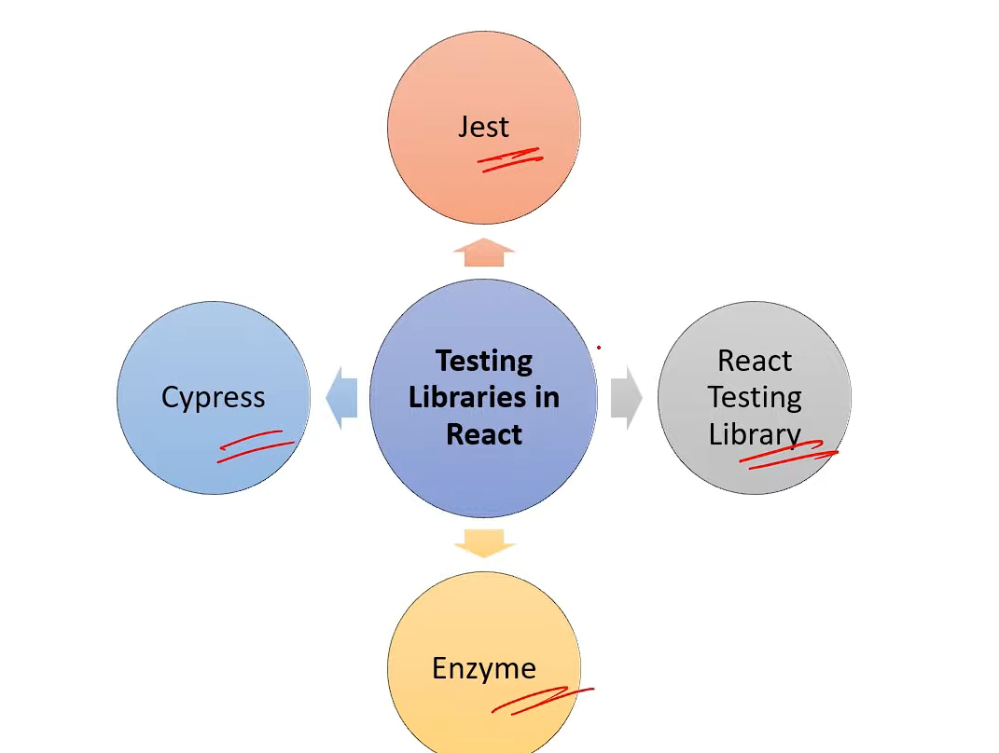

**102.** **How can you Optimize Performance in React application?[v.imp.]**

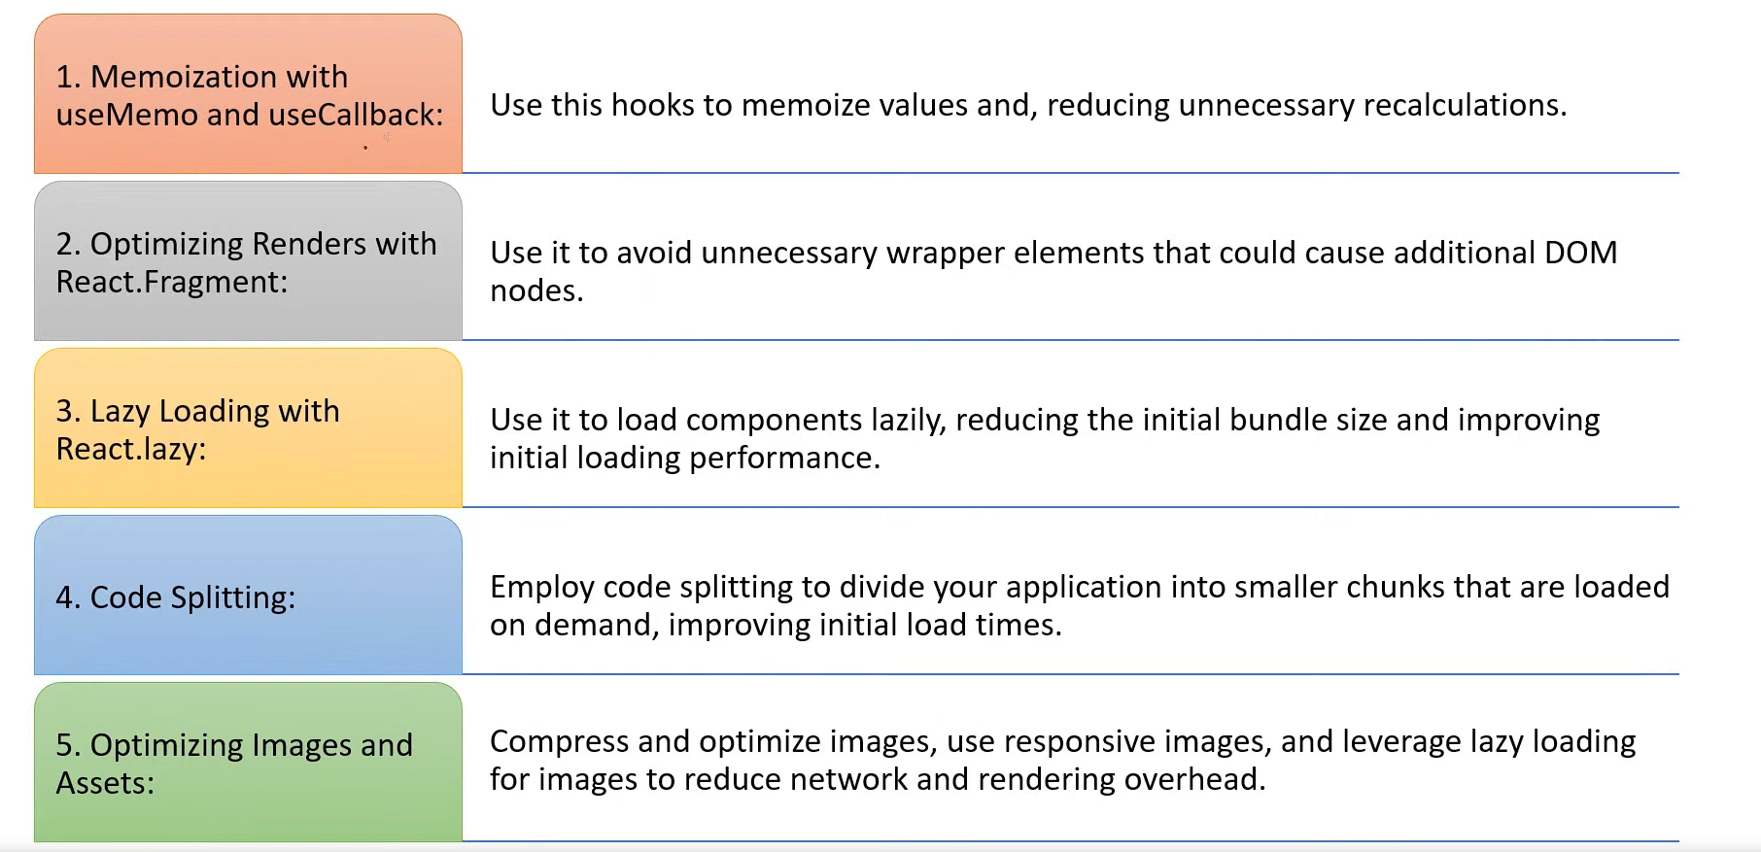

**103.** **Explain Reactive Programming with example?**

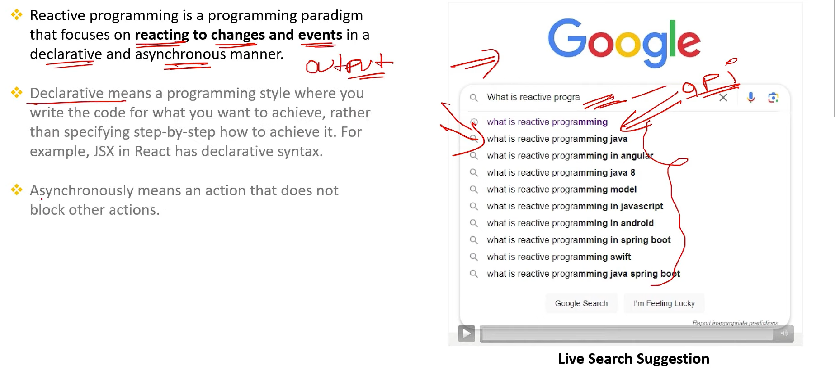

**104.** **In how many ways can we implement Reactive Programming in React?**

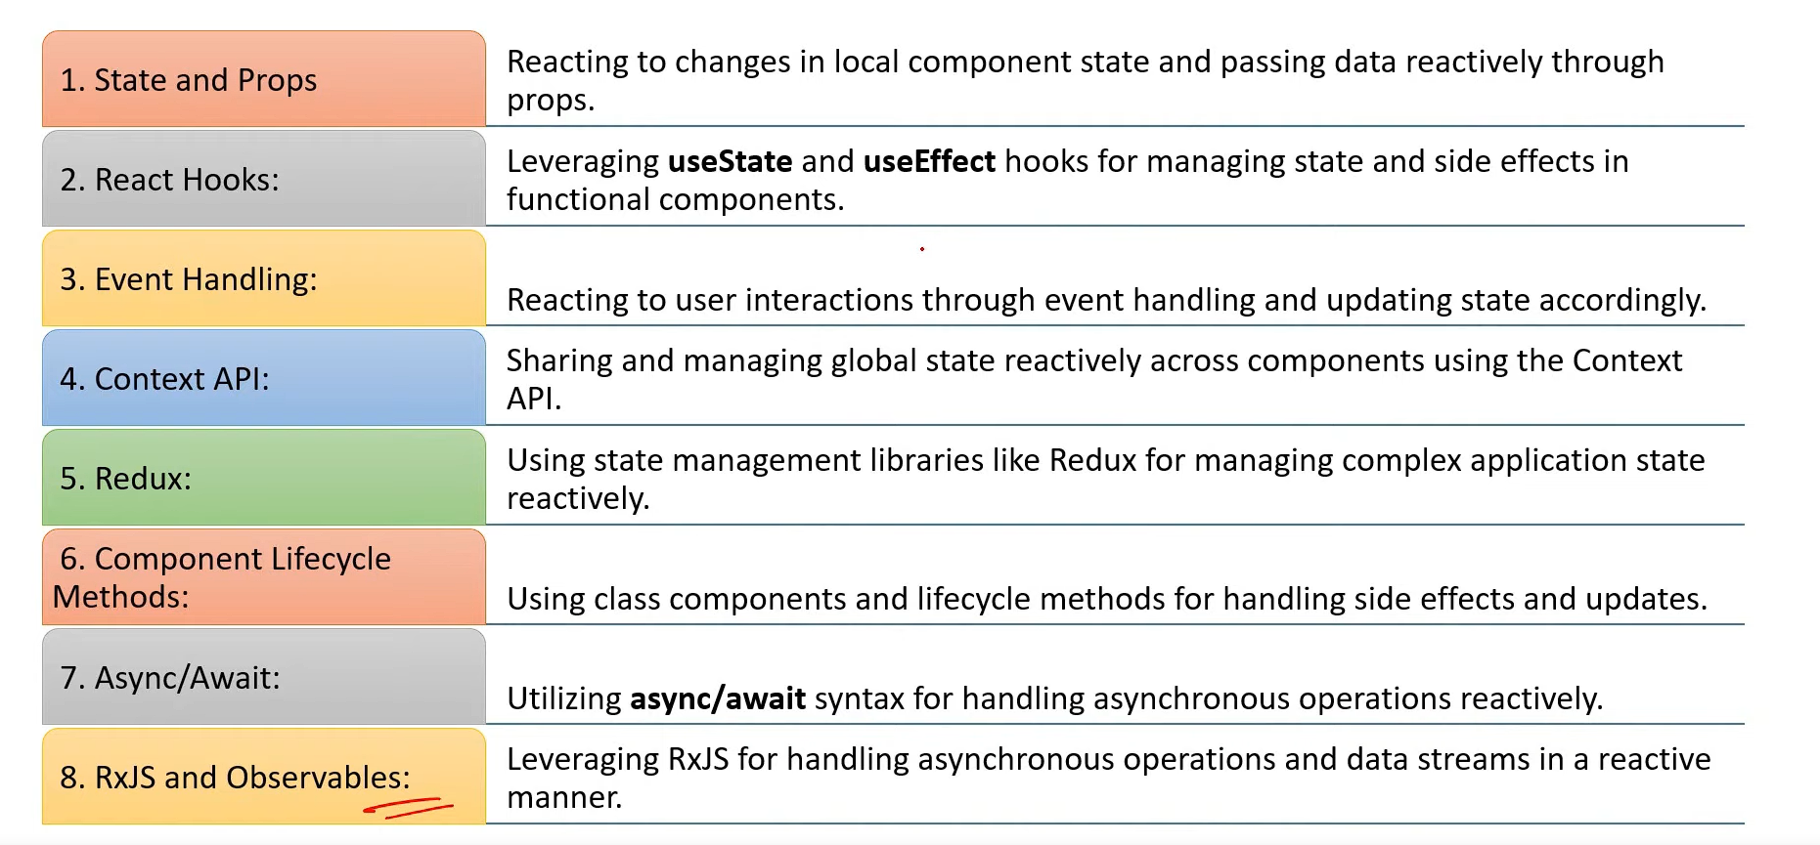

**105.** **How to pass data from child component to parent component in React?**

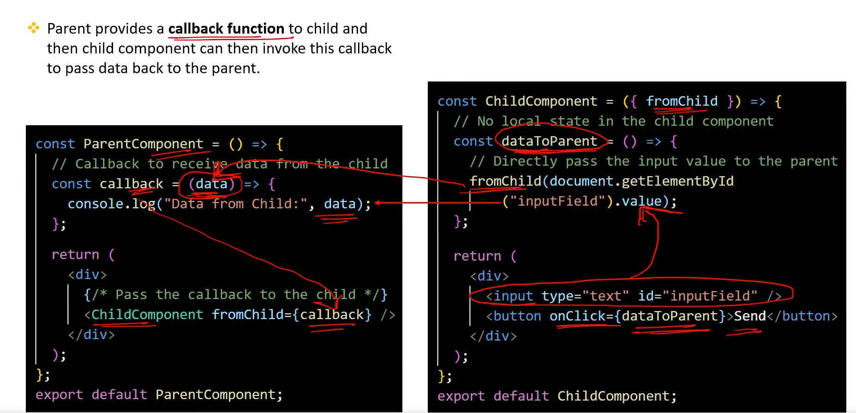

**Important things :- know all about the hooks and how we can create a custom hook in react**